GAMEPADDLE – Video Games. Empowerment. Education.
For further information more information head to www.gamepaddle.eu.

Published under Creative Commons license CC BY-SA 3.0 DE

With the support of the Youth in Action programme of the European Union. Supported by the National Agencies of Austria and Germany.

This project has been funded with support from the European Commission. This publication reflects the views only of the author, and the Commission cannot be held responsible for any use which may be made of the information contained therein.

Chapter 2 - 5
Card Game Design. Designing a Card Game about Video games
by Sebastian Ring

The objective of this project is to collaboratively create a card game that deals with video games. There are two aspects which are especially interesting: Firstly, the project is action orientated. Young people work together in groups and create something together, which manifests their success as a team and can be presented to others. Secondly, while creating their card game the youths are reflecting on one of their main interests in a critical and creative way: video games. Thereby they have to describe to their group how their favourite games work and what makes them special. By creating an own card game the participants get insight into the iterative process of game design, especially creating artwork, defining rules, beta testing and much more.
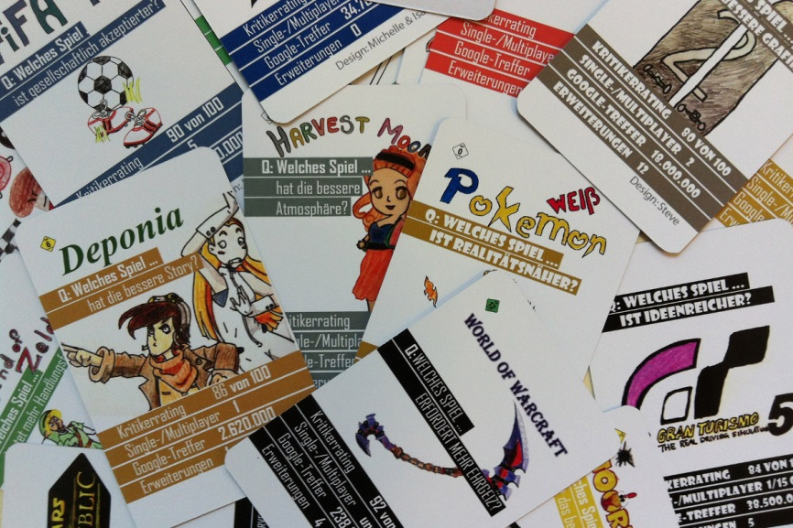
The model project took place in a lower education level school in Munich, Germany. The 25 participants were at the age of 13 to 15 years.

Prior knowledge and skills

Learners:
- Knowledge of video games
- Drawing skills
- (Using scanners or digital photo cameras, using digital image manipulation software like Photoshop or GIMP. Usually there are at least a few group members who have these skills and can share their knowledge with others; if not, the tutor has to instruct them)

Tutors:
- Moderating group work
- Knowledge of copyright laws and creative commons license
- Knowledge of online royalty-free stock image databases
- Knowledge of content rating systems like PEGI or youth protection laws
- (Using scanners or digital photo cameras, using digital image manipulation software like Photoshop or GIMP in case there are no group members who can share their skills)

Location
Depending on the size of the group there should be enough room to be able to meet all group members and discuss with them as well as enough tables and chairs for small working units of groups of maximum four people.

Time
Ca. 12 hours

Age
Depending on the kind of card game created and the video games that are to be featured in it, this project can be put into practice with children or adolescents from an age of 10 years.

Resources
- Different kinds of card games (the group members should bring their favourite card games, a great inspiration is the Metagame by game design collective Local No. 12)
- Paper and tape, post it stickers for notes (online mind mapping tools might be used alternatively)
- One laptop with internet connection for each group of four
- Drawing material (pens, crayons, paper, water colours, material for creating stencils, …)
- A scanner or digital photo cameras
- A printer and heavy weight paper (alternatively you could let the cards be printed by game card printing companies; a set will cost around 20,- EUR)
- A photo camera for documentation

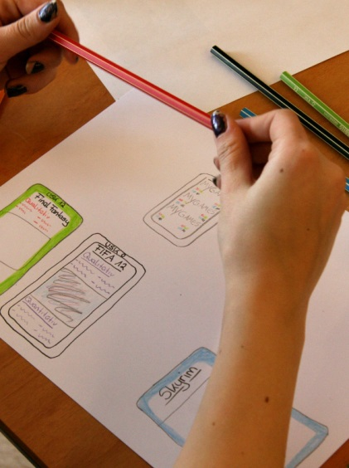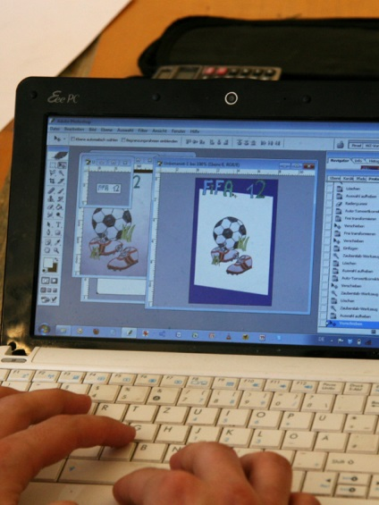

Objectives and Areas of Media Competence

General objectives
- Reflection on video games
- Learning about game design
- Working in teams

Specific objectives
- Presenting favourite video games
- Creating a card game
- Presenting the game to others and playing it

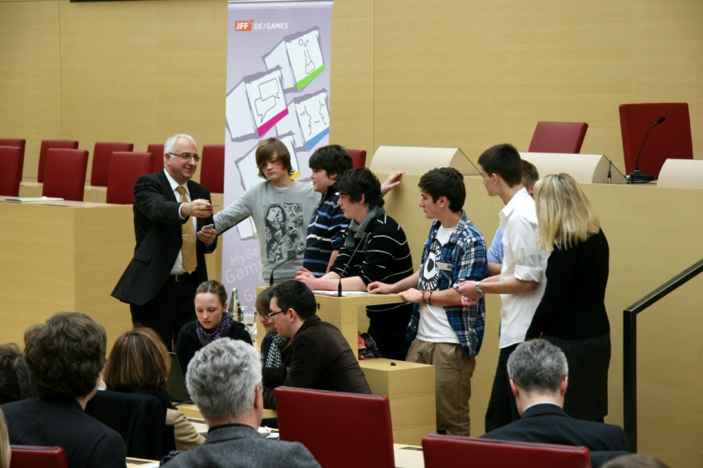

Module 1 - Discussion on Video Games (Time: 2,5h)
Media competence areas to be developed | Reading | - Know genres of games  - Be able to differentiate, reflect on and describe narratives and rules of (video-)games  - Be able to reflect on and describe connections to other media (social web, other narratives)
 | Critical/Social | - Knowledge of content rating systems like PEGI or youth protection laws  - Being able to reflect on economic issues
 | User/Consumer | - Reflect on personal use (time spent playing the game?; playing with others?)
Objectives | - Reflect on gaming preferences  - Describe video games to others, classify them by genre  - Discuss about content rating systems like PEGI or youth protection laws
Activity and products | - Introduction to the project and its specific objectives  - Every group member (max. 10 people per group) describes his/her favourite games and writes them down onto the wall map; they should be sorted by genres or PEGI/USK ratings; the presenter as well as other group members can add special facts or information on the game;  - Playing of different card games in small groups, describing their rules  - Group discussion on best rules and contents for the own card game to be created
Lessons learned | - The groups should really not be too large, so everyone stays involved and gets the chance to fully explain his or her favourite game.  - The presentation of the participants’ preferred games also bears the chance of giving background information, discussing problems and giving room for peer-learning.  - The discussion can also lead to defining criteria for game review. It would also be possible to create multimedia game reviews for the purpose of presenting the game in front of the class, as well as playing games together. Youth protection laws have to be respected.
Equipment | - Different kinds of card games (the group members can bring theirs)  - Paper and tape, post it stickers for notes (alternatively online mind mapping tools might be used)

Module 2 - Creating a Card Game (Time: 12,5 h)
Media competence areas to be developed | Reading | - Know to read and judge online platforms for video game critics, information on games
 | Writing | - Know online resources for royalty free or creative commons material  - Know the concept of authorship  - Know the concept of communicative intentions  - Digital imaging skills  - Know the concept and steps of iterative design process
 | Critical/Social | - Be able to analyse and categorize known card games and video games  - Be able to consider the effects on the audience  - Know the concept and be able to reflect on of ethical issues, e.g. responsibility
Objectives | - Create a card game  - Iterative game design process  - Describe the rules in an easily comprehensible way  - Reflect on copyright laws; Learn to know online resources for royalty free or creative commons licensed material
Activity and products | - Define the rules of play  - Define categories (In our project, we created a game of pairs with qualitative and quantitative categories)  - Create a prototype, beta test and redesign where necessary/useful  - Create artwork (by hand or via digital imaging)  - Layout the game cards (front and back) on the PC  - Decide for a license model (copyright, cc)  - Find a name for the game  - Prepare for online printing or print on heavy weight paper  - Make photos for a documentation

Lessons learned | - Especially the discussion on qualitative categories of judging games bears great potentials for reflecting on gaming experiences. If you have the feeling that a topic is missing in the discussion, feel free to propose a category.  - To get deeper insight in the process of game design, more time might be useful.
Equipment | - One laptop with internet connection for each group of four  - Drawing material (paper, pens, crayons, water colours, material for creating stencils, …)  - Scanner or digital photo camera  - Printer and heavy weight paper (alternatively you could let the cards be printed by game card printing companies; a set will cost around 20,- EUR)

Module 3 - Presentation (Time: 2h)
Media competence areas to be developed | Reading
 | Writing | - Reflect on one’s media communication and its effects
 | Critical/Social | - Ability to lead discourses on video games
 | User/Consumer | - Know how to use tools to present in front of a bigger audience
Objectives | - Present the game to others  - Get feedback by others and make the success visible, get recognition for the work
Activity and products | - Present the game, play with others  - Get feedback on the game  - Feel proud, have fun
Lessons learned | - Make sure the creators of the card game present their game and explain the rules.  - You might want to create an event where all the attendants can really play the card game. Depending on the concrete outcome of the project take care of enough room, card decks and time to experience the game.  - Use the game for initiating dialogue on video games among generations or gamers and non-gamers.

