GAMEPADDLE – Video Games. Empowerment. Education.
For further information more information head to www.gamepaddle.eu.

Published under Creative Commons license CC BY-SA 3.0 DE

With the support of the Youth in Action programme of the European Union. Supported by the National Agencies of Austria and Germany.

This project has been funded with support from the European Commission. This publication reflects the views only of the author, and the Commission cannot be held responsible for any use which may be made of the information contained therein.
Chapter 2 - 2
Cooperation in Minecraft
by Tobias Härnvi

Using the Game Minecraft to Learn Basic Project Management with a Scrum-like Approach
Cooperation and project oriented work is constantly getting more common in schools, companies, organization and even in family life. The ability to organize and take part in smaller or larger project is a skill that could be honed in cooperative multiplayer games. Many, if not to say most, young people of today have experienced cooperative multiplayer games and many play frequently. After taking part in this activity they can apply what they learned hands on in the games on a modern project management technique.
There is a version of Minecraft developed especially for schools, MinecraftEDU (http://minecraftedu.com). You can get educational discounts on the game at their site. There is also a server manager with extra functionality for teacher available that dramatically flattens the learning curve for new users.

Prior Knowledge and Skills

Learners:
Some knowledge of movement and orientation in virtual worlds with WASD and mouse. To familiar the participants with Minecraft there could be an extra activity that we tested. In the MinecraftEDU package there is a tutorial world. The world consists of a track with instructions for movement and some challenges to solve. The track challenged the players with obstacles and gates and gave instructions on boards in game how to solve the challenges. We tested this with participants that had no prior knowledge of Minecraft and the outcome was positive.

Tutors:
Install Minecraft, client and server. The game content and mechanics of Minecraft. Start a new world. Maintenance of the server with backups. Basic knowledge of project management with the iterative model Scrum. With the MinecraftEDU package the server management is greatly facilitated.

Location
Any location with network access works. The activities in the game could even be carried out of-site. A good place for meetings is essential.

Time
Two sessions per week, one hour each, for six weeks.

Age
Depending on the level of the theoretical content regarding Scrum but the activity should easily fit any one from the age of ten. We have tried it with adults (teachers) and 16-year old students.

Resources
One networked computer per participant, one networked computer for the tutor/tutors and one networked computer for the server. The server program could be hosted on one of the client computers. One license for Minecraft for each participant and tutor.

Key Competences Developed
• Digital competence
• Sense of initiative and entrepreneurship

Objectives and Areas of Media Competence

General Objective
To be a better team player and organizer.

Specific Objectives
To learn the basics of the iterative project management method Scrum.
To learn that gaming can develop real life skills.
To reflect on gaming activities and achievements

Structure of the Activities

Sub-Modules
Week one: Introduction to the activity and the functions in Minecraft
Week two: Examples of buildings and constructions in Minecraft and time to practice building. The week ends with the rules and the task for the coming weeks. A suitable task is to order a small village with a house, a shop and a connecting road.
Week three to five: One scrum, evaluation and planning meeting, per week and between them they build their constructions in Minecraft according to the assignment and the planning from the last scrum.
Week six: Evaluation and report from the project.

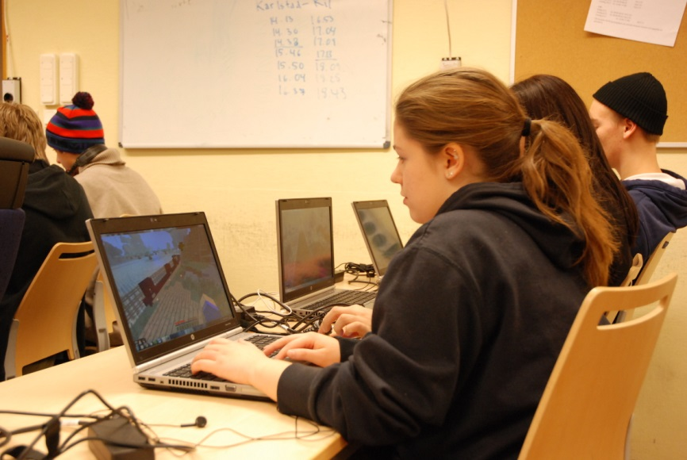

Assessment and Evaluation of the Activities, i.e., the Product

Reaction
This evaluation becomes complete at the hand-in of the report from the team but should be an on-going activity during the whole module. At every report/planning meeting there should always be room for questions about the spirit in the team and

Learning
The learning that takes place during the module is constantly evaluated. Every week of the production time starts with a meeting. The tutor is responsible for the to do list, the backlog. The backlog is the documentation and the priority of the things that have to be done to accomplish the overall assignment. The iterative nature of the model gives the tutor an excellent opportunity to follow the learning curve of the team members at every meeting.

Change/Transfer
All the participants have likely done some group oriented work in school and maybe outside of school to. A simple questionnaire that asks about their experiences of that kind of activities and what they could do in these circumstances with the competences they developed in this module.

Suitable questions are:

Then
What is the typical outcome from cooperative work in school as you see it?
How are the workload usually distributed in them?
How do they make you feel?

Now
Is there a better way to cooperate with assignments than the “normal” school solution?
Would you be able to work in a better way if you got assigned to a task together with others?

Would you?
Would you feel different, from the way you described before, if you worked like that?

Media productions
The media production in this module is not the main focus but it’s important that the outcome is evaluated as it is the final representation of success or failure for the team. The quality of the creation in Minecraft should be compared to the assignment that the customer ordered at the start of the module.

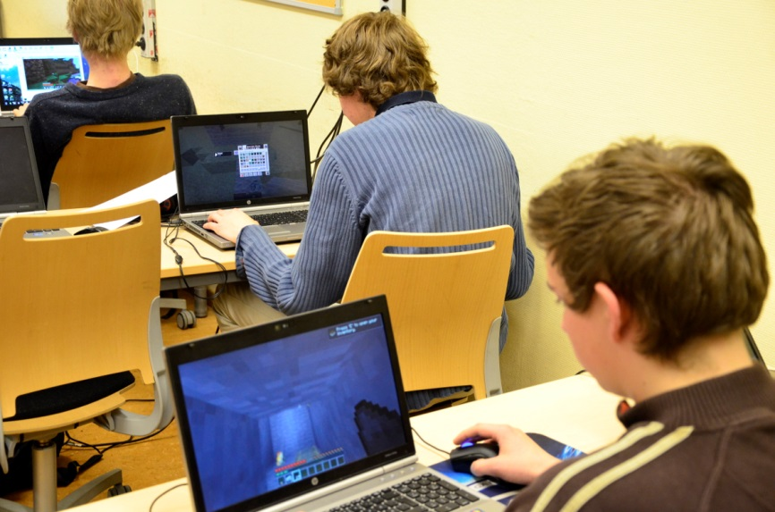

Module 1 - Introduction (Time: 1h)

Media competence area to be developed | Objectives | Activities and products | Equipment
None | Enthusiasm and understanding of the importance of cooperation skills. | Short talks and discussions on cooperation and organization of joint ventures. Present Scrum on a basic level. Show the tool: Minecraft. Divide the participants in teams with 4-6 persons in each group. | Minecraft on a tutor’s computer. Maybe some clips of Minecraft from YouTube. Presentation of Scrum;  e.g. http://prezi.com/2clzli7pied8/scrum-basics/?kw=view-2clzli7pied8&rc=ref-3528163

Module 2 - Learn Minecraft (Time: 2h)

Media competence area to be developed | Objectives | Activities and products | Equipment
Reader | The participants get familiar with Minecraft and the possibilities and needs for building and constructing objects in the game. It’s important that the participants consider the time it takes to do things in Minecraft. | Small task for the participants to carry out individually. Examples that the tutors have prepared to show the possibilities. | One networked computer per participant, one networked computer for the tutor/tutors and one networked computer for the server. One license for Minecraft for each participant and tutor.
Lessons learned | Excitement among the students but also some problems regarding the different levels of understanding and skills in Minecraft among the participants. Some more preparation, like the example under Prior knowledge and skills, from the tutor will make the start better.

Module 3 - Introduction to Scrum (Time: 1h)

Media competence area to be developed | Objectives | Activities and products | Equipment
None | The participants learn the rules of the activity. | The assignment for the group is handed out. The tutor acts as the Product Owner. If there is another tutor available she/he can act as Scrum Master, else this role is a part time assignment for one of the group members. | A meeting room and means to handle documentation of the activities and the assignments.
Lessons learned | The rules in the game where discussed a lot. The different modes of playing Minecraft, survival or creative, raised questions. We decided to go with the creative mode even if the survival mode could provide some extra possibilities for this activity.

Module 4 - Production (Time: 6h)

Media competence area to be developed | Objectives | Activities and product | Equipment
User skills | Build the constructions that the tutor ordered. Assign tasks to every team member. Evaluate the progress each week. | The group starts off with a meeting to plan the first week and divide the first tasks among them. After the meeting they go in to Minecraft and start building.  The next week start off with another meeting when they asses what they have achieved so far and what would be the next step and priorities. This forms the plan for the coming week. | Access to a meeting room. One networked computer per participant, one networked computer for the tutor/tutors and one networked computer for the server. One license for Minecraft for each participant and tutor.
Lessons learned | Supervise the group(s) and remind them to invest time in the evaluation and planning. The building activities are so motivating and fun so that they can consume all the available time. Make sure to do backups on the world/worlds after every iteration. This could be a task for the project groups.

Module 5 - Evaluation (Time: 2h)

Media competence area to be developed | Objectives | Activities and product | Equipment
Critical thinking | Evaluate the team’s performance and learn from that. | The team sits down and evaluates the product together with the tutor. Then they trace the activities backwards and evaluate their planning, decisions and activities. The team writes down their finding in a short report. | Access to a meeting room. At least one networked computer for the tutor/tutors and one networked computer for the server. One license for Minecraft for the tutor.
Lessons learned | If the group(s) concentrates too much on the building process it can be necessary to re-focus them and turn their attention to the cooperation, evaluation and planning.

