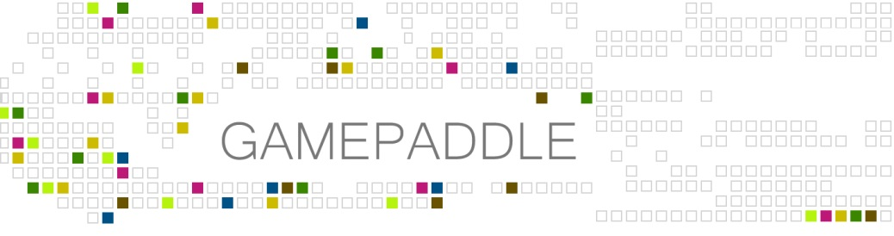

GAMEPADDLE – Video Games. Empowerment. Education.
For further information more information head to www.gamepaddle.eu.

Published under Creative Commons license CC BY-SA 3.0 DE

With the support of the Youth in Action programme of the European Union. Supported by the National Agencies of Austria and Germany.

This project has been funded with support from the European Commission. This publication reflects the views only of the author, and the Commission cannot be held responsible for any use which may be made of the information contained therein.

Chapter 2 - 4
EMPOWER*play (Austria)
by Michaela Anderle

For young people, gaming is a self-evident part of their daily lives in a converging media world. In our projects, we noticed a negative attitude towards games and gaming among our young participants, due to a hesitance or fear of being judged by the fact they play games. How can we encourage young people to advocate their interests and to demonstrate the importance of gaming as a modern cultural practice?
The first mission of EMPOWER*play is to address the gaming experiences of young people, to take this topic seriously and to reflect upon it: which (positive) potentials lie hidden in the act of gaming and which function does gaming serve in the daily lives of young people?
Through collective activities, the existing knowledge can be tied and made visible, so that competences and skills young people use naturally in games can be approached as a topic. Adults often rate or judge games from an observer’s point of view. The foundation for judging games is affected by media coverage about games and gamers with alarming headlines or a simple look over a gamer’s shoulder on the screen, but video games are more than one dimensional screened stories that can be judged by pure observation: playing them and trying them out by oneself are the keys to understanding games and their potential to fascinate.
To bridge this inter-generative gap, the project EMPOWER*play provokes a role switch: young participants become trainers and guides who invite adults to enter their gaming worlds pro-actively. As a highlight at the end of the project, the participants organized a gaming event and invited their significant adult others to join them. They had the chance to show their gaming expertise, as well as motivating the adults to try out chosen games and accompanying them through their first gaming attempts.

Project phases
Until now the project has been carried out twice, with similar content, but with a different time schedule.

Target group and time frame
1) The first run of the project was carried out over seven days within a period of six months with a group of ten young people between the ages of 15 and 22 from WUK m.power (a course for young people to catch up to the lowest Austrian school graduation level). The project took place on seven days with a two to three week gap in between meetings. A project day lasted 3 to 5 hours including breaks.
2) The second run of the project was carried out as a project week of five consecutive days (approximately 30 hours in total) with a group of nine young people between the ages of 15 and 23 from spacelab (a low-threshold labour-market service for youth who have a greater need for support and assistance in planning their educational and vocational future).

Trainers
two media educators (f, m) of wienXtra-medienzentrum

1) EMPOWER*play with WUK m.power
December 2011 to May 2012

Project Meeting 1: Getting to Know One Another
(Time: 2,5h incl. breaks and feedback session at the end)
The first project meeting is dedicated to getting to know one another. The participants and trainers gather information about the gaming habits of the group through partner-interviews (45 min.) and introduce each other to the group: What are currently your favourite games? Why? What is your absolute favourite game? Why? Which platforms (PC, mobile phone, console,…) and with whom do you play? What annoys you in regard to games?
The introduction offers a first opportunity to establish an open atmosphere for discourse on games and to show interest in games that were previously unknown.
Headlines from the media which condemn games and particularly their players or the public discussion on violence-promoting potentials and questions from studies serve as a basis for group discussion (1h) about how young people and adults differ in their approach to games and especially the question of the image of games and gamers that is usually conveyed in the media.
For the trainers as discussion moderators, it is especially interesting to find out how young people react to the representations in the media and what they would like to add to this image or, respectively, what they oppose to the arguments they are confronted with.
Hence, this discussion leads directly into a field of tension - namely of one’s own perception of games and gamers on one side and the public opinion on the other.
This serves also to promote a better understanding of the purpose of the closing event of the project, which is to create a common gaming session with teachers, trainers and other adults in order for them to gain more insight into digital game worlds and thus enable a more nuanced and less binary discourse.

Project Meeting 2: Gaming CV
(Time: 4,5h incl. breaks and feedback session)
The second project day is dedicated to the work on one’s own gaming CV (2h) in order to illustrate one’s own gaming experience and the existing knowledge about digital games.
In a World Café-Setting, the group collects titles of games that they have already played on a large paper tablecloth with the aim of reviving or jogging memories. This collective search for memories of childhood games offers the opportunity to initiate conversations amongst the participants and the group can discover that the experiences of each and every group member are a valuable resource as well as an aid and motivation.
We noticed that this group discussion needs time and guidance in order for the participants to perceive each other as a valuable source of experience and knowledge.
The guideline for the CV includes personal information, details of one’s gaming career and special abilities and skills in games, information on the qualities and traits of game characters,…
On the sheet, there are two empty spaces which function as place holders for photos which emerge over the course of the project, the first one being a portrait photo of oneself and the second one a picture of a game avatar or the representation of a preferred game character.
The portrait photo (2h) is taken in a subsequent photo session (here in the studio of the medienzentrum with white background, flash and digital single lens reflex camera).
After a short technical introduction to portrait photography and studio photography, the participants form teams of two and take each other’s portrait photos. Of course there is enough time to experiment and take snapshots in the studio afterward.

Project Meeting 3: Representation in the Game
(Time: 4,5h incl. breaks and feedback session)
While the preceding day centred on the questions: Who am I? How do I present myself?, this day focuses on the questions: Who am I in the game? What are my skills and abilities? What does my avatar look like?
At the beginning of the project day, all of the photos from the last project meeting are projected onto a screen and subsequently talked about. This discussion on the photos offers a basis to talk about the do’s and dont’s in the handling of photos and rights in connection to photographic images (1h).
As an introduction to the new subject, the group and trainers discuss traits and characteristics which are required in order to succeed in the game. They do so with the aid of differentiation exercises (1h).
Once a participant names a trait/characteristic, they look for like-minded people in the group. Hence, skills that the participants discover in games can be found and collected (e.g. ability to work in a team, communication skills, patience etc.).
These groups are documented photographically, so that this photographic collection of skills can be exhibited at the final gaming session at the end of the project. In this way, the collected skills become visible - in the truest sense of the word - to the visitors.
In the second photo-method (shadow theatre, 2h), the participants look into the subject of their own representation in games. For this purpose, equipped with various props and costumes, they re-enact their favourite game character or favourite avatar behind a secret curtain.

Project Meeting 4: Planning of the Closing Event
(Time: 4,5h incl. breaks and feedback session)
On the fourth day, detailed planning of the closing event (a gaming session) begins. In this first run of the project, this event took place about seven weeks later.
The World Café-tablecloth with the collection of games from the second project day is developed further (1h) by classifying and sorting the games into different colours and then assigning them to different genres. The aim is to create a discussion about the various existing game genres, age restrictions and the popularity of the individual genres within the group.
A PC was available for internet research (e.g., http://www.pegi.info). A photo of this colourful and diverse collection of games serves as an invitation to the final closing event. The rest of the day is dedicated to discussing and planning the closing event and allocating the necessary duties and responsibilities: the production of invitations; Who invites whom?; Who is willing to guide the gaming session?; Which games should be shown and played? (2h)
Since a lot of mental work is required on this day of the project, it concludes with an hour of playing games together (for example movement based games like Kinect Adventures (Xbox 360).

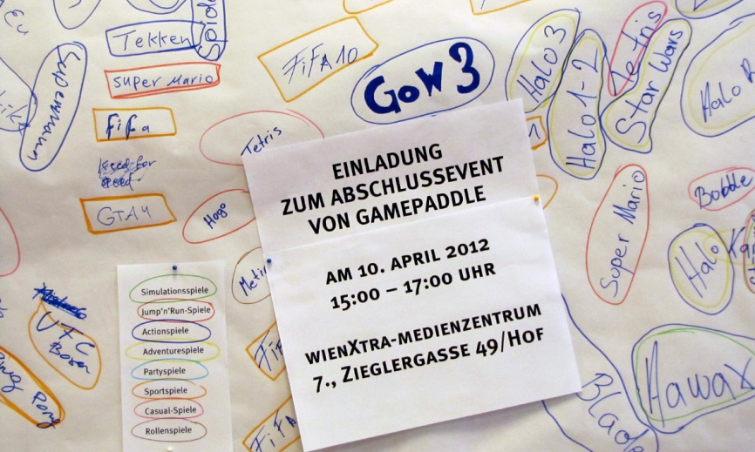

Project Meeting 5: Mobile Phone Video
(Time: 5,5h incl. breaks and feedback session)
The fifth day of the project is dedicated to the joint effort of producing a mobile phone video. There is a loose thematic guideline: games. After a brainstorming session on what would be suitable as a short clip, the group decided to shoot a video riddle that they could show their trainers at the closing event. A short clip to FIFA 12 was produced - and the challenge for the visitors of the closing event was not to guess the term football, but instead the title of the game, FIFA.
Since this is also the last meeting before the gaming session, all organisational duties are discussed again and the current situation of the different areas of responsibility are clarified and laid out.

Project Meeting 6: Closing Event
(Time: 5h incl. breaks and feedback session)
Two hours before the guests arrive, a dress rehearsal takes place with the group.
The moderators ponder and think about the welcoming words and the explanation of the events to follow. The participants who introduce and instruct a game in teams of two prepare the consoles etc. In total, four gaming stations were set up for the visitors: Need for speed most wanted (Playstation2), Mario Kart (Gamecube), Little big planet (Playstation 3) and FIFA 12 (Xbox 360).
After the welcome address or greeting, the introduction to the project, the reference to the exhibition of the gaming CVs and the skill-photographs as well as the explanation of the process of the gaming session by the moderators, the visitors were taken to the individual stations of the exhibition by the young gaming guides, where they spent about twenty minutes at any one time.
Two of the participants kept an eye on the time schedule and asked the visitors to change stations when the time was up.
Some of the visitors showed signs of mild frustration when they had to interrupt the game after twenty minutes.
After two hours, the closing event was over and the participants received great applause from their guests.

Project Meeting 7: Reflection of the Project
(Time: 2 hours incl. a break)
At the end of the project there is enough time to take another look at all the (media-)products that were created and developed over the course of the last months - and also to reflect upon impressions of the project in general and, specifically, the closing event. The participants receive their certificate of participation with individual notes from the trainers on what they contributed to the success of the project.

2) EMPOWER*play with spacelab
MO 10th - FR 14th September 2012

This run of the project run took place on five consecutive project days in the course of one school week and was completed with a short meeting of reflection after several weeks. On the basis of the experiences of the first project run of EMPOWER*play, we took the opportunity to carry out some changes in regard to content. The run of the project will only be outlined in note form if content is identical to the first project. New content or methods will be described briefly.

Project Meeting 1: Getting to Know Each Other and Gaming Biography
(Time: 6h incl. breaks and feedback session)
Partner-interviews (30 min.), Input and group discussion on the public perception of gaming and gamers (1h), discussion and collection of gaming experiences in a World Café-Setting (1h), differentiation exercises on traits, characteristics and skills in games with photo documentation (1h).
During this run of the project, we decided against form and function of a gaming CV.
A CV is strongly aimed at outwardly presenting skills and activities. However, the focus should lie in one’s own biographical reflection. Hence, work on one’s own gaming biography (1h) was taken up.
The medium that served this purpose was the free online-tool „Padlet“, through the use of which participants were able to construct a pinboard on which they could collect notes and various web sources (pictures, videos,...) to their own respective gaming biography.
The work on this gaming-bio-pinboard can be continued throughout the course of the project week.

Project Meeting 2: Gaming Biography
(Time: 6h incl. breaks and feedback session)
In order to lead up to the situation of talking about and introducing games in front of a group, a task related to the gaming-bio-pinboard is set: collecting information on a game which is particularly dear to one’s heart (the first game, the best game, the most recent game,...) and subsequentally presenting it to the group (pictures, fan art, walkthrough-videos, let’s play-videos, Information on makers and producers etc.) (2,5h).
Afterwards, as before, a portrait photo-session takes place in the photo studio to offer the opportunity of posting a photo of oneself onto the gaming-bio-pinboard. (3h)

Project Meeting 3: Planning of the Closing Event
(Time: 6h incl. breaks and feedback session)
Detailed planning of the closing event (4h), which took place two days later in this project (Who presents which game? Who is responsible for which assignment (e.g. moderation/guidance, keeping an eye on the time schedule, caring for the guests,...).
On this project day there is also the opportunity for active gaming in order to determine the computer games that will be presented at the closing event. The focus of the gaming lies on finding out how the game can best be explained. The gaming-bio-pinboard can be used as a backup and aid not only in the preparation, but also in the explaining of the game. The rest of the day (1h) served as a preparation for the next unit of the project: since the recording of an interview in the TV studio of the medienzentrum was planned for the following project day, a short briefing on the interviewee (Karina Fallent, project worker of the BuPP - “the Federal Office for the Positive Assessment of Computer and Console Games”) was carried out. In the course of the presentation of tomorrow’s interview partner, a group discussion developed and brought to light specific topics that the participants wanted to discuss with Karina Fallent the next day.

Project Meeting 4: Production of the TV Interview, Set-up for the Closing Event
(Time: 6h incl. breaks and feedback session)
The fourth day of the project is dedicated to the production of an interview programme, which has many advantages for the project: for one, it is an opportunity to invite experts with which topics concerning gaming can be discussed, and for another, a live production is a good chance for a group of young people to feel that they are all part of a team and in that, effective at putting together a project.
After a 2-hour introductory workshop about live-editing in the TV studio, where everyone has the opportunity to try out all the required positions (interview-situation in front of the camera, camera person, directing), the roles for the actual production are decided on.
In this project, there were two interviewers, two camera people, two directors who were also responsible for the video mixer, one production manager and one person who was responsible for the time schedule (the interview was limited to 15 minutes).
The interviewers raised the topic of media violence and transfer and discussed the Austrian model of positive assessment of computer and console games with Karina Fallent. The finished interview was originally only planned for internal use, but after re-watching their work with pride, the participants made the decision to show it at the next day’s closing event.

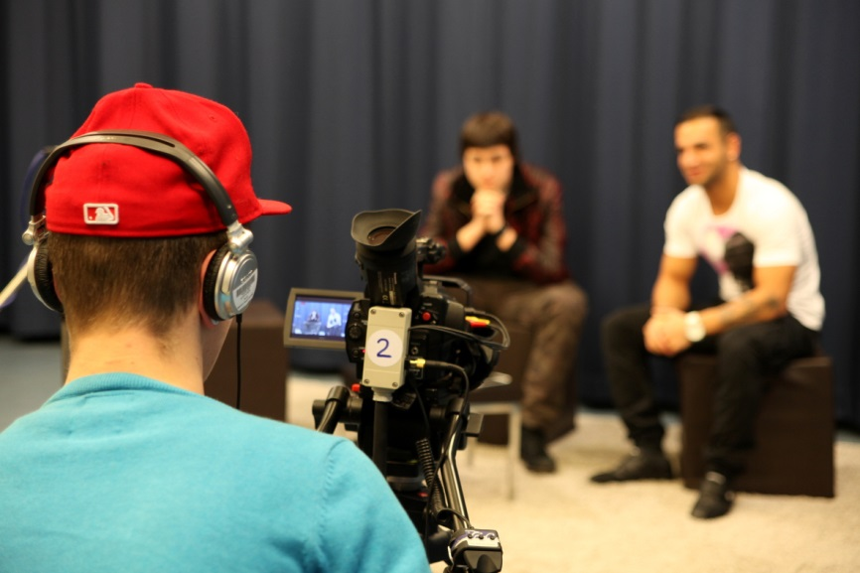

In the final two hours, the consoles are set up for the following day and the rooms are prepared.

Project Meeting 5: Closing Event - “Gaming Matinée”
(Time: 3h incl. breaks and feedback session)
Since this run of the project took place in the course of one week, we were able to send invitation flyers to spacelab in advance, so that they could be distributed to trainers and teachers. This time, we only had half an hour to prepare and rehearse before the guests arrived. The process of the closing event was identical to the one in the first run of the project: reception and welcoming words, gaming session (Minecraft, Spyro the dragon, FIFA 12, Tekken), watching the interview together, receiving feedback from the guests, celebrating - and being celebrated.

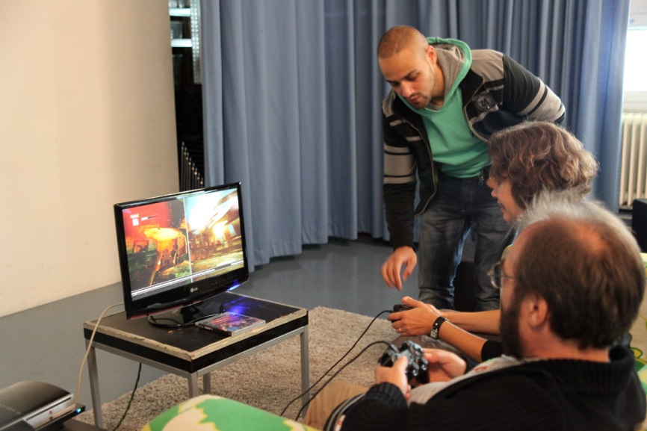

Project Meeting 6: Reflection of the Project
(Time: 1h)
Reflection of the project, certificate of participation, feedback

Reflection, Challenges, Conclusions
At the beginning of the project, the participants had some difficulty in understanding why the reflection on games and the gaming experience could be of importance to them. By the end, they had all come to the realisation that their own gaming experiences and the knowledge thereof are valuable resources for instructing and accompanying their adult guests in a competent manner.
The diversity of methods of the action-orientated media work (video, photo,...) that was used to approach the subject of computer games paid off, because the group methods proved to be important for the dynamics and the enjoyment of working creatively.
Of course, it was equally valuable for the participants to reach goals as a group - and that in the final media productions, the group’s achievement was visible as well as individual inputs. Another advantage was those participants that were not as familiar with computer and console games could also take on an active part in the project.
For many of the participants, it was their first public speaking experience in front of an adult audience. At the beginning of the project, they had little confidence in taking on this role because of speech problems and consequently, fear of speaking in front of a group etc. After the common gaming event, the participants were visibly proud to have mastered a challenge not only with regard to content, but on a personal level. It is very likely that they were able to overcome this obstacle because they spoke about games that were of importance to them and they were able to convey this in a passionate manner.
During the course of the project, the participants could partly use and activate their gaming experiences as sources of self-confidence and self-effectiveness. For them, it was especially valuable to receive attention and respect from the adults.
The participants visibly enjoyed demonstrating their expertise and were successful in giving the visitors a relaxed introduction to the gaming world. Both sides were able to profit from the role-reversal (teachers/pupils); for one, the young people had the experience of being and feeling effective, as is illustrated by the statement of one of the participants (17 years old) after the project: “I really had something to say and they listened. Everyone went home with a smile, that was the most beautiful thing!” Furthermore, an understanding and appreciation of the teacher-situation developed in the participants. They reached the limitations of what is explainable and learned that one and the same explanation is not necessarily understood in the same way by all and that an individual response to the Vis-à-vis is required: “I never knew that ‘teaching’ was so difficult.”

Media competence areas to be developed according to chapter 1.6 | Reading | - Knowing the genres of games  - Reflecting on games in connections to other media  - Being able to read up on games and to evaluate information
 | Writing | - Creating a media product with mobile phone (recording, editing, presenting)  - Creating a media product in a TV studio (Interview)
 | User/Consumer | - Reflecting on personal use of video games  - Reflecting on rights concerning photos and images (copyright, personal rights)
 | Critical/Social | - Knowing the rating systems like PEGI  - Taking part in discussions about video games  - Reflecting on the image of gamers and how it is constructed through media

Games
FIFA 12 (Electronic Arts, 2011)
Kinect Adventures (Microsoft Game Studios, 2010)
Little Big Planet (Sony Computer Entertainment, 2008)
Mario Kart (Nintendo, 2003)
Minecraft (Mojang, 2009)
Need for Speed most wanted (Electronic Arts, 2005)
Spyro, the dragon (Sony Computer Entertainment, 1998)
Tekken (Namco Bandai Games, 1994)

http://mpower.wuk.at
http://www.spacelab.cc
http://padlet.com
www.bupp.at (german) http://bupp.at/en (english)
http://bupp.at/de

