GAMEPADDLE – Video Games. Empowerment. Education.
For further information more information head to www.gamepaddle.eu.

Published under Creative Commons license CC BY-SA 3.0 DE

With the support of the Youth in Action programme of the European Union. Supported by the National Agencies of Austria and Germany.

This project has been funded with support from the European Commission. This publication reflects the views only of the author, and the Commission cannot be held responsible for any use which may be made of the information contained therein.
Chapter 2 - 3
SIMaging the City. The Educational Use of Video Games in a Youth Club of Palermo (Italy)
by Massimiliano Andreoletti, Gianna Cappello, Annalisa Castronovo, Marcello Marinisi and Anna Ragosta

This module starts from the basic assumption that Media Education (Media Literacy, Media Literacy Education) has a great potential in informal education contexts. As with schools, in these contexts too media can be adopted both as a tool of expression/communication/information retrieval and as an object of study in and of itself, with multifaceted - and often contradictory - implications (social, cultural, political, economic, etc.). This double level of media use in educational contexts (either formal or informal) is crucial for the development of the citizenship in the digital era, for fostering social inclusion and promotion as well as cultural and intercultural growth and exchange. Media educators operating in these contexts play the fundamental role of facilitating processes of self-reflection, dialogue, collaborative work, problem-solving and so on.
As an application of this assumption, we have carried out a series of Media Education activities in a youth club – Centro Tau – located in La Zisa, one of the most disadvantaged neighbourhoods of Palermo (Italy). In particular, we have focused on a video game – SimCity – building on the idea that “a video game is an abstract world where the subject plays a central role in all phases of the game […]. The video game can be then considered as an environment where technology is both the tool that mobilizes the playing activity and, more importantly, a world with an added value where the subject has the chance to explore, experiment, manage, interact and communicate with high levels of autonomy, interaction, presence, immersion and imagination” (Andreoletti, 2012: 153-154). Following Andreoletti’s and Ragosta’s scheme, we thought that SimCity - as all city builder games - may develop five functions that make it particularly useful in a context like Centro Tau where the relationship with the surrounding city is quite problematic given its high level of micro-criminal activity, poverty and social marginalization:
- Conception and development of the project (long-term vision of the city, identification of shared choices of development)
- Territorial planning (allocation of residential, commercial and industrial)
- Resources and services management (from choosing energy sources, to distributing social services and infrastructures to citizens, to organizing urban transportation, etc.)
- Economic and financial planning
- Assessment and evaluation of the state of the project according to the objectives set at the beginning.

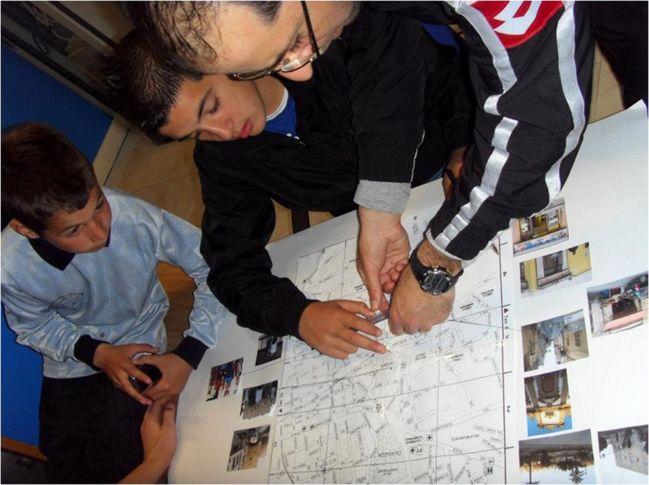

The ultimate educational aim of using a city simulation game like SimCity is not simply that of playing the part of the mayor, but more importantly of co-building an environment where participants can reflect - both individually and collectively - on the simulated city and also on the real one as they experience it daily. Therefore, we recommend that educators plan and develop all activities keeping in mind that their work must be always carried out in a constant confrontation with and analysis of the daily context where the subjects live. Furthermore, educators should keep in mind that their work ultimately aims at helping the subjects in:
- Reflecting on the fundamental choices that need to be done for the wellbeing of citizens
- Reconstructing their surrounding territory in a critical way
- Developing a sense of civic responsibility
- Understanding the different components of territorial planning and development, in particular the difference between the public and the private intervention
- Studying and understanding far-away scenarios and contexts (both culturally and geographically)
- Expressing one’s own desires and experiment one’s own choices
- Adopting solutions according to a sustainable development perspective.
We also recommend that educators:
- Develop short-time and focused activities in order to prevent attention drifts and falls
- Facilitate interaction with the most difficult parts of the game
- Facilitate the acquisition of a democratic communication mode among the participants
- Prompt the progress of the activities
- Re-organize activities according to the different situations and point of view that may emerge along the way
- Facilitate the bridging between the virtual and the real world
- Document as much in detail as possible all the activities, keeping track of all changes and solutions adopted.
After a short training of the educators working at Centro Tau, conducted by Massimiliano Andreoletti and Anna Ragosta, activities started in early March 2012 according to the three-module scheme ending in mid-June 2012. The training was focused on direct experimentation of the SimCity and has made reference to the structure of the project and the methods of intervention with the video games.
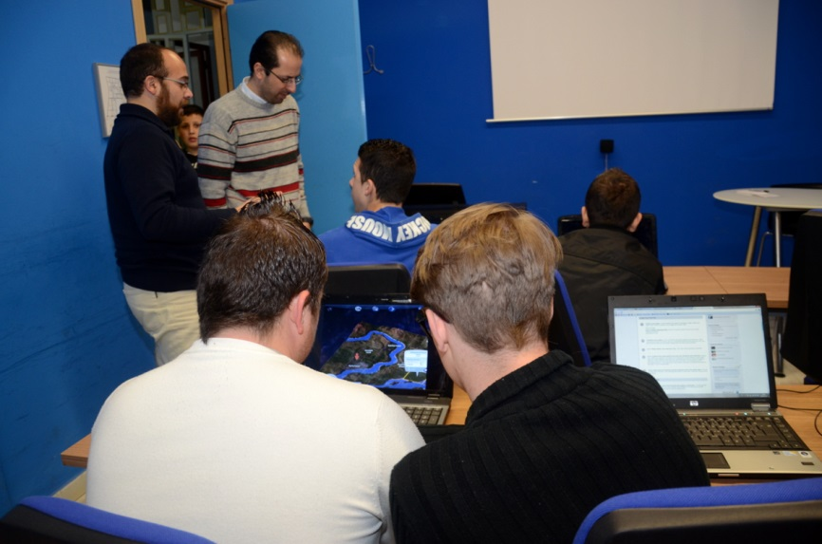

At the conclusion of the project, we can say that the young people of La Zisa, attending the youth club Centro Tau, have developed a higher civic sense towards their living context, expressing much more self-confidence in their ability to find and judge critical situations in it. In other words, they have developed a higher consciousness towards themselves and the world around them. Ultimately, our project has proven how video games can be a tool for youth empowerment inasmuch as they help increasing various specific skills at the level of either personal development or social and interpersonal relationships. Video games can also be a valid means to develop participation and a sense of active citizenship as they helped the youth in Centro Tau to think of themselves as protagonists intervening concretely in the process of change of their neighbourhood and living context.

Module 1 - Analyse and Reconstruct your Lived City (Time: 10h)
This first module aims at creating a bridge between the simulated city and the real city as well as developing the capacity to reconstruct the latter within the former. All passages need to be gradual and proceed through discussion and confrontation from the personal lived experience to the mediation of others’ experiences.
Media competence areas to be developed | MEDIA READER - Capacity to read the linguistic structure (codes and conventions) of written and audio-visual texts  Resources - Know the codes and conventions of written and audio-visual texts  Interpretative strategies - Understand the construction of written/audio-visual texts and that they are representations of reality - Know how to recognize the constituent parts of written and audio-visual texts - Know how to recognize the communicative purpose of written and audio-visual texts (inform, persuade, advise, entertain, etc.)  Action structures - Know how to analyse the functioning structure of written and audio-visual texts recognizing the linguistic elements composing them  Self-regulation structures - Be able to reflect critically on personal uses/readings of written and audio-visual texts  MEDIA WRITER - Capacity to produce a media message/product using properly the linguistic structure (codes and conventions) of written and audio-visual texts in order to reach a certain purpose; capacity to produce written and audio-visual texts using the proper rules written and audio-visual language in order to reach certain purposes  Resources - Know the concept of authorship - Know the concept of communicative intention - Know the elements of a communicative project  Interpretative strategies - Know how to recognize the constituent parts of written and audio-visual texts  Action structures - Know how to produce a message using the proper rules of audio-visual language in order to achieve a communicative goal  Self-regulation structures - Be able to reflect critically on one’s own construction of written and audio-visual texts
Objectives | Be aware, both individually and collectively, of the most significant aspects of the surrounding reality starting from the lived experience of one’s own neighbourhood (meeting places, locations related to important memories or experiences, home, school, etc.).
Activities and products | Through individual and group work, youths produced a map of the neighbourhood where they live (a poster) by using audio-visual documents produced/retrieved during the activity. In particular, the activity was carried out in three steps and involved on average 10 young people (2 girls/8 boys):  - 1) Brainstorming → Identification of places that have positive and/or negative connotations for the young people. This activity was carried out by an educator of the Centro Tau. After explaining the goal of the activity, she started inviting young people to think about their surrounding context (the Zisa neighbourhood of Palermo), particularly those locations they think are the most important in their lived experience. The third step concerned the implementation of the flash card by the group so as to obtain an overall view of the neighbourhood, or to be more exact, a choral portrait of a particular life context of which the young people themselves are an integral part (4h).  - Production and retrieval of audio-visual documents to be inserted in the final product → Description of their surrounding reality using written and audio-visual texts either taken from the Web, magazines, etc. and also produced by themselves. They took pictures and shot some videos that represented them within the neighbourhood (the Zisa) where they live. They also collected images related to places that are particularly representative of their own lived experience in the neighbourhood (the church, restaurants, the betting centre etc.) (3h).  - Production of a map of the neighbourhood using the written/audio-visual documents collected where the most important locations in their daily life experiences were indicated (3h).
Assessment and evaluation | This activity has the objective to explore and become aware of own urban context (district/city) and then re-create it using different media (photos and/or videos of the territory made by the people and materials derived from online resources). On a practical level it is possible to identify different axes that allow an assessment of participants’ skills:  - Recognize within a physical map the different elements of own reality (urban, suburban, rural area; ancient, modern and contemporary part; housing, commercial, industrial, infrastructure, etc.)  - Locate within its reality areas/spaces/resources/services intended to the interests/needs of the various sectors of civil society (children, adolescents and young adults, adults, elderly, men, women, etc.)  - Operate in an appropriate manner with different media (machine photography, camcorder, online resources of geo-localization etc.)  - Organize own work in a group dividing roles and operational tasks in order to map the area as large as possible of own local reality  - Describe the operational methodology used for the conduct of operations, identifying strengths and weaknesses
Equipment | One Internet-connected computer every 2/3 people; digital camera; printer; scissors and paper

Module 2 - Tell me About You and Your City through Your Favourite Video Game (Time: 10h)
Media competence areas to be developed | MEDIA READER – (see Module 1)  MEDIA USER – Capacity to discriminate and reflect on one’s own media uses  Resources - Know the possible needs and motivations that lead to exposure to a videogame  Interpretative strategies - Know how to recognize a selection strategy - Know how to recognize the personal and familiar habits appealed to by videogames - Know how to recognize the reasons and the needs satisfaction mechanisms of a videogame fan-group  Action structures - Be able to choose among different media uses - Be able to manage leisure time in relation to video gaming  Self-regulation structures - Be able to reflect about the personal choices of video games and identify possible misbehaviours
Objectives | Reflect on their desired city as a way to reflect upon themselves and their future. This objective was to be attained through a projective action by which young people materialize their own desires, making them visible and sharable, within the virtual worlds of their favourite video games.

Activities and products | Young people were to perform a projective action by making a selection of video games that, in their view, better represent the activities and environments they aspire to. The activities gave to young people the opportunity to live (although virtually) experiences that it is not possible to live in the physically tangible reality. As with the previous module, activities were carried out through three distinct steps:  - Through a peer discussion, selection of favourite video games that best represent their desires and aspirations. This phase was carried out by another educator from Centro Tau, who explained to youths the aim of the activity so as to prepare them for the selection of video games and the following contest (2h).  - Video game contest → Young people participated in a video game contest where five teams, each consisting of two players, were going to defy each other. The scheduled meetings were ten and each was to include the challenge plus a discussion at the end of the playing time. Each player was scheduled to play five times, each time with a different video game. To ensure that teammates would not remain inactive during the playing time of the other teammate, we decided run parallel sessions of SimCity 4 (2h).  - Discussion → Critical analysis of the playing activity with regards to the adopted strategies, the relationships between teammates and the confrontation between the experiences lived/wished in real life and those simulated in the virtual world of the video game played (1h).

Assessment and evaluation | This activity has the objective of increasing knowledge of the video game and to reflect on one's own person and local reality:  - Identify adequate video games (or video game genres) to their own aspirations/desires, justifying the choice  - Indicate the reasons for the choice of video games  - Organise in a small group (couple of people) the best titles subdivision they want to play with, knowing combine their skills to video games proposed  - Participate in an active way with all video games, including those that they have not chosen, both in moments of video gaming and in moments of observation;  - Share with the fellow the used strategies (or to use) to play in a better way the playful activity;  - Recognize within video game the elements related to the own person/personality;  - Describe in a structured way connections real and/or possible between own reality (society, culture, family etc.) and the world represented by the video game;  - Recognize the specific characteristics of different genres of used video games, confirming one or more favourite genres or identifying new ones;  - Provide a ranking of the favourite games among those used.
Equipment | Computers and game consoles for playing video games in pairs.

Module 3 – Create Your Ideal City (Time: 10h)
Media competence areas to be developed | MEDIA USER – (see Module 2)  CRITICAL THINKING – Capacity to understand media as an environment where certain social relations take place, behaviours models are presented and spaces of participation are offered (to both individuals and social groups)  Resources - Know about concepts related to the socio-cultural dimension (cultural backgrounds, historical conceptions, world views, etc.)  Interpretative strategies - Know how to recognize implicit and explicit points of view, values, ethical issues and cultural background of a video game  Action structures - Know how to evaluate views and values - Know how to highlight the moral and cultural perspective inscribed in a video game  Self-regulation structures - Be able to reflect about personal views and values in relation to video games and identify possible misbehaviours
Objectives | Reflect, individually and collectively, on the needs and desires about the construction of the ideal city starting from the awareness of the peculiarities, limits and possibilities of the real city (the Zisa neighbourhood in particular); develop a proactive attitude and a renewed critical sense towards one’s own context of living.

Activities and products | This is the core module of the ME project carried out at Centro Tau. It was developed according to the following scheme:  - Creation of the ideal city from individual gamers. For this purpose in each computer we installed SimCityTM 4 Deluxe Edition. Afterwards, we introduced the aims of the project and gave instructions on how to play to new players.  - Gaming sessions. They extended from March to May 2012. Each session lasted two hours, including also the time for discussion about the gaming experience just carried out (5 game sessions: 10h; 8 boys/2 girls).  - Discussion and confrontation between the real city and the SimCity 4 one. After each gaming session, gamers were invited to discuss and report, through questionnaires, focus groups and short interviews (some of which done by gamers themselves), the difficulties encountered during the gaming sessions as well as the strategies and solutions adopted. They also discussed about the strengths and weaknesses of the real city in relation to the ideal one as well as their hopes for the future of their real city (the Zisa neighbourhood in particular). Through these discussions and reports the young people were led to create a wish-list of all the elements that in their opinion should be present in their ideal city.  - Presentation of the ideal city as a final product conceived by the whole group, a city where more space was given to public green areas, to recreational structures and meeting places for young people, to big and modern sports facilities, as well as to shopping centres, a city more fit to meet the needs of the community and also better connected to large roads, ports and major international airports that can open to its inhabitants the doors to other realities and environments.

Assessment and evaluation | This activity has the objective to rethink its own urban context based on their own desires, expectations, projects etc.:  - Identify an individual and/or group planning that acts as a guide for the realization of its own ideal city  - Conjecture the feasibility of its own strategy and project  - Specify a planning that goes to affect all dimensions (social, economic, cultural, political etc.)  - Rethink its own reality on the basis of an individual and/or shared with the group planning  - Select items to maintain or to eliminate from your territorial reality and give reasons for this decision  - Find a hierarchy of priorities which allows the implementation of land resources in time  - Design resources that meet the needs of the enrichment of the territory  - Motivate their choices in a medium/long term and not just in the short term  - Identify the strengths and weaknesses of own project  - Check the adherence of their own project with the initial hypotheses  - Identify the critical factors that have made difficult to realize its own project  - Indicate the potential and the limits of the used video game for the realization of its own project
Equipment | Computers for playing SimCity 4

References
Andreoletti, M. (2012). Videogioco. In: Aglieri M. & P. Ardizzone (eds.). Realtà educative. Milano: Unicopli.

Game
SimCityTM 4 Deluxe Edition (Maxis, 2003)

Our activities have been inspired by the model developed by Andreoletti and Ragosta for their chapter S’IMpara in Parola, A. (Ed.). (2012). (forthcoming). MediaLand. Secondi Passi in Media Education. Trento: Erickson.
For more details, see Andreoletti and Ragosta (ibidem).
Educational objectives, methods, activities development and findings related to SimCity are exposed in Module 3, see below.

