Gamepaddle
Video Games. Education. Empowerment.

Michaela Anderle & Sebastian Ring (Ed.)

Ledizioni Srl
The Innovative LediPublishing company
Via Alamanni 11 – 20131 Milano Italy
Tel. 00390245071824
Fax 00390242108107
info@ledizioni.it
www.ledizioni.it

Published under Creative Commons license CC BY-SA 3.0 DE
ISBN Print Version: 978-88-6705-409-1
ISBN ePub Version: 978-88-6705-410-7

With the support of the Youth in Action programme of the European Union. Supported by the National Agencies of Austria and Germany.

This project has been funded with support from the European Commission. This publication reflects the views only of the author, and the Commission cannot be held responsible for any use which may be made of the information contained therein.
Table of Contents
Introduction | 4
Chapter 1
Game and Video Game.  Reflections between Education and Entertainment.  Massimiliano Andreoletti | 7
Video Games in Real Life  Annalisa Castronovo & Marcello Marinisi | 23
Social Media and Digital Gaming Worlds – far more than Playing Games  Sebastian Ring | 35
Potentials of Video Games  Anu Pöyskö | 45
What Makes a Game Attractive?  Anna Ragosta | 59
Rating Video Games  Anna Ragosta | 64
Media/Digital Competence. The European and Italian Definition  Gianna Cappello | 66
Chapter 2
The Gamepaddle Project – Games. Education. Empowerment.  Tobias Härnvi, Ida Pöttinger | 76
Cooperation in Minecraft  Tobias Härnvi | 82
SIMaging the City. The Educational Use of Video Games in a Youth Club of Palermo  Massimiliano Andreoletti, Gianna Cappello, Annalisa Castronovo, Marcello Marinisi & Anna Ragosta | 92
EMPOWER*play  Michaela Anderle | 105
Card Game Design. Designing a Card Game about Video Games  Sebastian Ring | 117
Tools | 124
Chapter 3
About the Authors | 126
Introduction

In April 2011 video game scholars, researchers, teachers and media educators from Austria, Germany, Italy and Sweden found their way to a springlike Munich to share their knowledge on video games, young disadvantaged gamers, excessive gaming and educational potentials of video games. The Munich meeting marked the beginning of a two year long partnership that involved knowledge transfer, development of educational concepts, their realisation in schools and youth clubs in the partner countries, as well as the evaluation, discussion and presentation of the projects’ outcomes in a final meeting in autumnally Vienna. The diverse backgrounds of the participants, the insights in their countries’ culture of discourse on video games, as well as research and practical educational activities has been a great enrichment for the conceptual works.
In the educational discourse of the participants’ countries, video games, one of the favourite leisure activities of many young people, are often regarded as a vital risk for young people. Especially excessive gaming or playing violent video games among children and adolescents troubles teachers, educators and parents. The lack of knowledge about digital gaming worlds, as well as the lack of own gaming experience can lead to misjudgement and overseeing the resources acquired by young gamers. The Gamepaddle project is starting at that point: identifying young people’s game-related resources and help them to benefit from them in other primarily non-game-related contexts as school, intergenerational dialogue, creative activity or civic commitment. In Gamepaddle’s practical educational activities video games were used to train project-management skills, encourage reflection on the urban neighbourhood, create a card game about video games that facilitates discourse on video games or teach adults how to play.

What will you find in this Publication?
This publication has the aim to document and share the experiences that were made in Gamepaddle’s educational activities, so that teachers, youth workers and media educators find inspiration and practical advice for own projects dealing with empowerment of young people by using video games.
The first part of the publication with articles by Massimiliano Andreoletti, Annalisa Castronovo, Marcello Marinisi and Sebastian Ring gives insight into digital gaming worlds, their development and peripheral media landscapes. Educational background knowledge like description of potentials of video games and definition of (digital) media competences are described in the articles by Gianna Cappello, Anu Pöyskö and Anna Ragosta.
The second part contains the conceptual basis for the Gamepaddle projects in schools, youth clubs and labour market actions as well as detailed information on their process and outcome. The project descriptions also involve educational goals, methods, as well as lessons learned, practical advice.
The third part introduces the participating scholars, researchers, teachers and media educators. They also give advice on where to turn to for useful literature in their native language as well as cooperation partners in their countries.
The Gamepaddle website www.gamepaddle.eu contains further material, tools and products of the projects. We are curious about your feedback, your ideas and inspirations, so feel free to contact us.

Michaela Anderle, Sebastian Ring
Vienna and Munich, October 2015

CC by Bob Troia @ flickr
Chapter 1 - 1
Game and Video Game.
Reflections between Education and Entertainment.
by Massimiliano Andreoletti

Anyone who tries to make a distinction
between education and entertainment
doesn't know the first thing about either.
Marshal McLuhan

The educational and training potentials of video games – which have been debated in the teaching context over the last years – have seen a slow but progressive shift of the attitude of the institutions and people in training agencies of every order and degree towards the acknowledgement of the many training and educational potentials of the medium, although it has not yet been possible to define the dimensions through which video game should be observed from a teaching point of view.
It is possible to divide the attempts that have been made so far into two categories of contributions:
1. Those that focus on video game activities considering the risk-benefit dualism in the use of such media, they highlight the former quoting researches often lacking scientific value and will not go any further than showing the latter;
2. Those that exalt video games as a powerful learning media, especially on a disciplinary level, though not justifying this process with theoretical references and not identifying the modality in which the video game can be introduced into daily didactic activities.
The teaching research on video games should start from a reflection upon the issues concerning man in relation to video game and technology. Then it should identify the characteristics that video games could and should present in order to be considered as educational media.
Starting from this consideration, the central issues related to video games will be analysed first beginning with a general talk that stresses both the meaning of electronic media in the relationship to man and the role that digital technology is gradually playing in contemporary society and culture; after that there will be the description of three meaning pairs that are supposed to characterize a preliminary reflection upon the medium from an educational-training point of view - interaction and participation, simulation and immersion, exploration and mastery.

Questions

Man vs. Machine?
In order to reflect upon the meaning that video games have within the teaching research it is necessary to first of all understand the role that such media play in modern society and which can be the sense horizons that it has in its relationship with man. For centuries each culture has expressed games that were different from the ones of previous and following cultures, therefore creating new ones and eliminating the superfluous (Staccioli, 2004) ones. It is thus natural to ask why video games have appeared now. You could at first reply very superficially that technology has only now allowed developing such an entertainment mode. To understand the meaning that technology, or rather digital technology, has in our culture, it is essential to consider that over the centuries technology has increasingly affected man’s operational dimensions. From the industrial productive fields, technology has gradually entered those environments connected to knowledge objects, passing from economy and science to art and culture until it has filled spaces and times which make man different from any other living being: leisure time. In games an evolutional process began centuries ago with the introduction of small mechanic devices that were hand operated or used electric power (analogue technology) has led to video games (digital technology).

Analogue vs. Digital?
Thus, the starting point focuses on the relationship between man and machine in the moment the latter becomes the intermediary of the gaming activity. If any human activity can be considered in the form of a game, we must not make the mistake of thinking that technology, especially the digital one, can convey any kind of game.
Currently the completely analogue game culture – which has developed over 3.000 years – is at risk of not finding a way to be “digitized” (Jenkins, 2010). The term digitization as it is used here does is not mean the process of converting phenomena and behaviour into discrete representations through mathematical algorithms. It is instead considered as the meaning that such process is having for mankind – the impossibility to simulate the deepest and intimate dimensions of the human being (emotions, feelings, affections) and the reduction of some experiential aspects which present a mediate and simplified use in digital technology (relationships, society, world).
Still the digital game must not be considered as opposing or eliminating the analogue game, it must be seen as a new way of conceiving the game since its presence enriches the general game scene. Video games present new game situations that led the classic game model to a crisis as its space-time-dimensions and goals must be clear and set in advance. Endless simulation games – such as SimCity and The Sims – present the typical situation in which a player might theoretically play an endless game without ever reaching a clear goal but prolonging the game itself endlessly (Juul, 2005).
Digital games with such characteristics lead to another fundamental question: Should they still be considered as video games or should they be called video toys?

Video Game vs. Video Toy?
Distinguishing between game and toy may look simple, but defining the toy characteristics is complex since there is no univocal game definition. In our perspective, the game is peculiar to the person who is acting as player, therefore it is an inward-pointing action. On the other hand, the toy is connected to the object – whether material or immaterial – that undergoes the action of playing. In this sense, the relationship between game and toy is the relationship that is established between a person and the surrounding environment, and playing can be seen as a person’s ability to interact with the environment and the elements it contains. Thus, the wide range of playing does not depend on the quantity and the economic value of the materials within the environment but on their variety and quality, they must always be considered as a support to the game activity. The game is not an action that is directed inwards from outwards, from the environment to man, on the contrary it is directed outwards and on the outside because the person is the drive of the game activity – without a player there is no game and the toy is an inert matter.
Over the last years, the reflection (Goldschmied & Jackson, 1996; Bondioli, 1986; Bondioli, 1996; Guerra, 2008) on the characteristics of the game setting has highlighted the quantity and the variety of the game materials – regarded as objects within a given space and with the function of supporting people’s game activity. In the simplification process carried out by adults such materials are named with the term toy, but this definition tends to be reductive and misleading. Since it usually refers to those commercial products whose game characteristics are: high specialization (they can only do one thing), little flexibility (they are not adaptable to other game situations) and little freedom of action (they reduce the game possibilities to a limited sphere of situations).
The material supporting the game activity is generally divided into two categories: structured material and non-structured material. The objects that belong to the first category are those products, mostly industrially manufactured, specifically designed for playing and usually made of plastic. The second category includes all the materials that present the following characteristics:
- low specialization level: they can adapt to game contexts which are very diversified;
- high flexibility level: their roles and functions in the game activities are always new and different;
- high freedom of action: they allow to act with a small space-time limitation;
- infinite use: their function is not limited to a restricted sphere of space-time situations;
- no pre-established goals: they do not have any special meaning within the game, thus becoming part of the process.
This category includes natural materials (wood, stones, sand, fabric, water, vegetables, fruit and so on), those who were originally produced for the many different purposes of human activities (recyclable materials, industrial materials, home items, food items) and those designed for a creative game activity (small bricks, crayons, modelling clays, glue and so on).
The wide range of video game types on the market can be divided into two categories of games:
1. Those that have a specific objective to reach (constrain the victory to reach the highest score; defeat of the opponent; conclusion of options and/or gaming opportunities; obtaining the predetermined goal etc.) or allow a maximum time for the playful activity can be approached with the term games as they enable the player to act within an environment well defined in time and space. In these cases the rules define the boundaries within which the subject is free to act.
2. Those that do not have a specific goal to reach or a time limit within which the game concludes (they are formally infinite) can be compared to unstructured toys, since they allow the player to manipulate the game to his liking, bend it also for purposes which are external and extraneous to the objectives of the game. Machinima is the most typical example of this concept. The game is meant here as a non-structured to support the free and personal playful activity: the player uses the potential and the resources of the world simulated to set the scene ludic forms different and alternative.

Learning vs. Fun?
In recent years, the institutions and training agencies ascertained the strong interest of parts of younger generations towards gaming entertainment and have tried to find the philosopher’s stone that transformed their commitment to video games into training and disciplinary activities. The tools identified do not always have achieved an acceptable result, because if the objectives have been achieved on the content/school matter level, on the interest/fun level they rarely managed to get to say “I’m playing” to the end-user.
These failures certainly are to the delay of the research in social sciences and humanities and to the deficiency inherent in many educational environments, accompanied by a reflection on the human activity that sees positive and educational dimensions only in work, understood as “effort” and “duty”, in opposition to playing games, understood as “loss of time” and “pleasure”. The expression “duty comes first!” belongs to a popular pedagogy still dominant, which finds its roots in the protestant ethic (Himanen, 2003) and doesn’t see a valuable opportunity for learning, discovery, comparison and experimentation in playing games. In addition to this, the difficulty of integrating playful methods into school-educational activities – that occurs already at the beginning of the second cycle of the primary school – does certainly not make the task easier for those who believe that the game stimulates the learning person to approach problems and issues the world and culture.
The fundamental mistake is to think that learning is always played off against fun, that there is opposition between gaining knowledge and play, as if the pleasure of discovering new things and the satisfaction to find appropriate solutions to a problem can belong only to the educational-disciplinary area and the nature of playing games is only amusement, carelessness and fun. In reality, the great effort during the playful activity takes the player to concentrate, to find the best strategies to achieve the result, not to underestimate any variable for understanding the problem as a whole, to commit oneself to playmates that collaboratively help him to achieve the goal. In this sense, the game becomes a serious activity and loses all those negative meanings that relegate the game to a practice with no formative and educational purpose, to take place only after productive occupations and understood as a filler for a “vacuum” time.

Video Games vs. Serious Games?
It appears that video games – described as reality mediated by digital technologies in which spontaneous, free, voluntary acts take place, purely for fun and detached from the urgencies and the boundaries of the ordinary life – must be folded and labelled as serious games, so that they might be considered as appropriate tools for the needs and culture of the educational institution in general – although something like a non-serious game might not exist (Andreoletti, 2010).
The debate about serious games, however, is not free from ambiguity and confusion: at a macro level it is likely to lose sight of the meaning that a video game should have into the wider world of the game, while at a micro level it tends to have an unclear idea about what the boundaries are that differentiate serious games from commercial bookshelf games (Rockwell & Kee, 2011). In some cases the latter acquire connotations of the first as they reveal educational purposes. In other cases commercial games seem to more or less concentrate on fun.
Serious games differ from commercial games in terms of an “educational purpose explicit and carefully weighted” (Abt, 1987), although other authors point out that the term “’serious’ in ‘serious games’ is intended to reflect the purpose of the game, why it was created, and has no bearing on the content of the game itself” (Michael & Chen, 2006). According to this concept the difference is only given by the intentions of the game designer, not by the product actually made.

Characteristics
The difficulty of defining what a game is also implicates the complexity of achieving a clear definition of video games. Omitting a cursory definition that refers to the video game as “a game whose rules are automatically managed by an electronic device that uses a man-machine interface based on the display as an output system” (Andreoletti, 2010), it is necessary to analyse the elements and dimensions of similarity and dissimilarity of video games and games. This examination is vital for the use of video games within training and educational courses.

Interaction and Participation
It’s a common opinion that the main feature of the video game is its ability to respond in an appropriate manner (output) to the stimuli offered by the player (input). In reality, this process must be seen as a reciprocal one, as even the player responds to situations presented by the game: the interactivity can then be defined as the ability “to test the environment, explore it and, finally, interact with it and change it” (Aukstakalnis & Blatner, 1995). The process of two-way interaction creates a strong bond between man and the machine and the reciprocal influence generated between the two systems creates dependency up to the point that the first completely immerses into the second and isolates himself from the real world, while the second cannot exist without the first, in the sense that man is the true engine of the playful activity.
The lived experience within a virtual world is defined by the David Zeltzer’s model (Zeltzer, 1992) and is represented by three dimensions:
• autonomy: “quantifies the ability of a computer model to react to an event or to a stimulus”;
• interaction: “defines the access to computer parameters, the ability to alter them and get an immediate reply”;
• presence: “quantifies the number and type of stimuli exchanged between the operator and the virtual world”.
Interaction described in this way only shows the existence of a reciprocal influence between the two systems without defining time, mode, purpose and quality of this relationship. “The interaction competes to technology, the participation competes to culture” as Henry Jenkins says (Jenkins, 2010). In Seymour Papert’s words, it “is not the computer that dominates the man but it is the man to dominate the computer” (Papert, 1994) and in consequence it can be argued that the interaction must be understood as the action that a person conducts within a given system.
The active dimension involves primarily that the subject has the awareness that he is the starting point and the end of the relation to technology and that the relation to it should be understood as a process of enrichment for him and the other players that can participate in the relation to and through technology itself. The participation must be understood as the way in which people interact within a given system.
The participation involves the knowledge of the nature of the relation to technology (video game) in the final dimension (because there is this relation?), in the modal dimension (in which way is this relation situated?), in the temporal dimension (when does it start, when does it stop and how many time does this relation take?), in the spatial dimension (where does this relation take place?) and in the relational dimension (who are the agents within this relation?).

Simulation and Immersion
The simulative function of the videogame results from a reconstructive process which reduces a world, a reality or a fantasy. This process is done by the game designer, which carries out an analysis of a phenomenon, of a process or of a system achieved through the construction of a mathematical model, which can be explained on two levels:
- Macro: the inability to fully reproduce any existing system, by considering:
  - the complexity of the real world in its dimensions;
  - the ignorance of the real in its entirety;
- Micro: the choices made by game designer that within a range of technological and playful constraints creates:
  - a closed system without any link to other systems;
  - a system adapted to the gameplay (Andreoletti, 2010).
The simulation element is already present in traditional games and appears to be meant as the detachment from the reality in which you live and to immerse into a new playful reality: on the one hand playing games means a close relation to reality and on the other hand to be separated radically. The player is aware of this situation because when he plays while remaining in the real world (we cannot be separated from it), he or she is found in another world, the fantastic one (re-) created in the game, which is closely tied to the real world (you cannot imagine anything outside of the existing).
The way of immersion in the reality of the game of each subject, can be explained following two axis:
- Type of immersion: When a player plays, he or she immerses physically into a new reality, separated only formally from the world, and in it he or she interacts with the elements of the playful world. Interaction and immersion differ between the classic game and the video game. In the latter the immersive process moves from the sensory-motor axis (in the game the immersion is predominantly physical) to a logical-formal axis (in the game world the immersion is predominantly mental). The intellectual component of video games has a greater weight and role respect to the traditional game, as the playful activity takes place in a world reproduced within a machine, through algorithms, designed by a game designer. The courses of participation are mediated by a machine;
- Level of immersion: While playing the subject participates freely and voluntarily in the playful activity with diversified degrees of involvement on the basis of personal (physical and psychic condition, humor, interest, etc.) and environmental factors (degree of definition of the setting, quality of the present materials, freedom of action etc.) factors. Being inside of the magic circle (Huizinga, 2002) created by the game does not imply the existence of an optimal level of involvement in the playful activity (immersion), but depending on the intention with which players decide to play may vary from time to time, going from a minimum level, where he plays a marginal role – in respect to the center of the action – to a maximum level, on which he is the engine (or one of them) of the playful activity.

Exploration and Mastery
The game is governed by rules that define nature and borders without predetermining the strategies and behaviours that players could put into action. In fact, “the rules of a game should not be confused with the strategies of the players. Each player chooses his strategies freely (i.e., the general principles that govern his choices). While every single strategy can be right or wrong (a condition that these concepts can be interpreted as exact), is at the discretion of the player use it or discard it. The rules of the game, however, are absolute commands” (Von Neumann & Morgenstern, 1953).
All types of game are brought together by two characteristics: the simplicity and the reduced number of rules. Due to commercial conditions, a game cannot be too complex and have too many rules. It then might fail in business and not disseminate enough at the popular level. The approach to the game that every subject comprises two consecutive phases:
- Exploration can be defined as the process of knowledge and understanding of the rules that govern a playful action.
- Mastery can be defined as the path on which the same subject can steer these rules in order to acquire a level of expertise and develop strategies that enable him or her to play in an effective manner.
These two steps have their own characteristics which determine time, space, and completion procedures:
- Exploration:
  - precedes the mastery;
  - doesn’t cost the subject much time and much effort;
  - involves objects, tangible or intangible, which become media for action;
  - is conveyed by a person or a text;
  - necessarily is completed before the beginning of the playful activity;
- Mastery:
  - following the exploration;
  - depending on the circumstances it may be short or long, simple or tiring;
  - the maintenance of an appropriate level of mastery in some cases may require a frequent activity;
  - the identification of appropriate strategies for some games may require a lot of commitment and concentration.
From these characteristics we understood that games respond to a classic formula: It’s easy to know them, it’s difficult to master them. However, the emergence of digital games has led to a crisis of this model, as the exploration and mastery processes can also vary considerably according to the types of games:
- Exploration:
  - does not come to an end before the activity of mastery, but can go hand in hand with it;
  - the rules are acquired through a process of direct experimentation, in a small part can be shared with or disseminated by other people and are not known by reading a text (absence of in-depth manuals on the operation of the game);
  - the process of knowledge of the rules is long, complex and varied especially for those video games born from the process of hybridization of genres and consisting of different types of games and in the so called “emergent video games”, i.e. those titles that “contain a high number of interactions between different parts of the system” (Juul, 2005);
- Mastery:
  - in the video game the mastery process is not subsequent but contemporary to the exploration phase;
  - in some video games (simulations, strategic, role playing games) the complexity of the game does not allow the player to approach the playful activity in its entirety from its initial moments, but he or she needs a playful training phase where the player is gradually introduced to all of the features (configurations, menus, facilities etc.) and he or she is encouraged to immediately try out the knowledge just acquired;
  - unlike the non-digital game, in which the difficulty and complexity produced by the combination of the rules are present at the beginning (the player adapts to the game) and vary depending on the skill of the opponent, some video games gradually increase the level of difficulty and complexity as the game goes on, adapting these two dimensions to the skills of the player (the game adapts to the player).

Definition
The search for a video game definition suffers from the same difficulty that we encounter when we talk about games in general. We can’t say that there is a lack of literature on games, but the complexity of the medium in constant evolution makes it almost impossible to give a definition (Mäyrä, 2008).
Over the years, many researchers working in the fields of game studies have tried to define what video games are, what their meaning and their context is, which functions they have in today's society, which may be the effects arising from their use etc.
In most of the texts, the existence of the video game derive from technology that becomes the central element. In this sense, it is meant as “a game whose rules are automatically managed by an electronic device that uses a man-machine interface based on the display as an output system. […] It has become an out-and-out mass cultural phenomenon, a medium or even a visual art in itself, the video game can live in reason of computer technology and electronics (for both software and hardware)”. The anthropological dimension is not considered, as if man had no relationship with the existence of the game itself. “The key to better express the potentials of the videogame as a tool lies in its technological matrix, or better in being the product of the digital manipulation caused by computers (Alinovi, 2004). “The video game derives from the manner in which it performs this playful activity: in front of a screen, a monitor a player interacts with the actions within the fictional world of the video game with the joystick or other instruments of man-machine dialog" (Nardone, 2007).
The first attempt to overcome this technological bond takes place in the reflections on technology as expression of contemporary culture and on certain aspects of video games as connected to the being of a person: “The video game has a dual nature: on the one hand is a game, hence is activity, praxis. On the other hand, it’s video, therefore it refers to a see, an aesthetics. Within the meaning of practice, the video game maintains its structural continuity, recurring characteristics, brands can be traced back to those identified by Roger Caillois in his seminal ‘Man, Play and Games’. Vice versa, on the aesthetics side, the video game is subjected to continuous and often radical transformations which in turn reflect the rapid succession of technical improvements” (Bittanti, 1999).
The authors that extend the technological components of video games by anthropological components and their playful dimension recognize video games as games. Video games are considered like any other materials that support playful activities and get to be seen as “an abstract world where some goals may be obtained by following certain rules and where the subject assumes a central role in all phases of the game” (Fernández-Manjón, 2009). The ludic dimension presented in video games is marked by a series of elements – “conflict and challenge; imagination and curiosity; perception of progress/advancement; progressive difficulty; feedback” (Fernández-Manjón, 2009) – showing how video games can be the contact point between the anthropological dimension and the technological dimension.
Some of the definitions also took too far, going to seek exclusively functional elements within video games, totally disregarding the aspects connected to digital technology. For Jesper Juul a video game is a “rules-based system with a variable and quantifiable results, where different values are assigned different results, the player exerts effort in order to influence the outcome, the player feels emotionally bound to the result and the activity’s consequences are non-negotiable” (Juul, 2005). The man takes the central role within the (video)playful activities: “The video game is a system, not an activity, an event, or a physical object. However, it is inseparable from the players, which are necessary to engage in artificial conflict” (Montola, Stenros, & Waern, 2009).
But what are the effects associated to the use of video games? Going beyond the controversy on the presence of violence in video games, the discussion should be extended to all the cultural-mediated events of contemporary society. Some authors identify the point of grip in the emotional component. For Matteo Bittanti “the video game is a happiness machine: is specially developed to satisfy the player by an instant gratification. […] The video games produce endorphins and reduce the levels of stress, anxiety and irritability”. Ivan Fulco even says that “the video game is a democratic psycho-medicine. As if to say: it acts on the nervous system, but only if the subject is willing. To realize this, it’s enough to observe any video player, expert or beginner, in front of a good video game. After a preliminary study phase, in which the player’s attention is limited, something revolutionary takes place. The player finishes to blend in with the game. He becomes one with the electronic image. In a precise instant, the video game, virtual sponge, absorbs all the cognitive capacities of the spectator. Just a moment, and his hands are clasped around the controller, the eyes are glued to the screen, the responses to external stimuli are progressively attenuate until they reach zero” (Fulco, 2004).

References
Abt, C. (1987). Serious Games. Lanham (Maryland): University Press of America.
Alinovi, F. (2004). Serio videoludere. Spunti per una riflessione sul videogioco. In: Bittanti, M. (ed). Per una cultura dei videogames. Teoria e prassi del videogiocatore. Milano: Edizioni Unicopli.
Andreoletti, M. (2010). Videogiochi. Questioni, tassonomie, similitudini. In: REM. Ricerche su Educazione e Media, volume 2 (n.1), June 2010. Trento: Erickson.
Aukstakalnis, S., & D. Blatner. (1995). Miraggi elettronici. Milano: Feltrinelli.
Bittanti, M. (1999). L’innovazione tecnoludica. L’era dei videogiochi simbolici (1958-1984). Milano: Jackson Libri.
Bondioli, A. (1986). Lo spazio ludico: il gioco e i giochi. In: Frabboni, F., Maragliano, R., & Vertecchi, B. Il gioco. Firenze: La Nuova Italia.
Bondioli, A. (1996). Gioco e educazione. Milano: Franco Angeli.
Fernández-Manjón, B. (2009). Games as a didactic tools. Integrating educational videogames in the learning flow, presentation at the meeting Edu-Tech 2009. La tecnologia al servizio dell’educazione. Milano.
Fulco, I. (2004). Lo zero ludico. Decostruzione del videogioco e fondamenti della pulsione ludica. In: Bittanti, M. (ed). Per una cultura dei videogames. Teoria e prassi del videogiocatore. Milano: Edizioni Unicopli.
Goldschmied, E. & S. Jackson. (1996). Persone da zero a tre anni. Crescere e lavorare nell'ambiente del nido. Bergamo: Edizioni Junior.
Guerra, M. (2008). Progettare esperienze e relazioni. Azioni, contesti, sperimentazioni e formazione nei servizi educativi per l’infanzia e le famiglie. Bergamo: Edizioni Junior.
Himanen, P. (2003). Etica hacker. Milano: Feltrinelli.
Huizinga, J. (2002). Homo ludens. Torino: Einaudi.
Jenkins, H. (2010). Culture partecipative e competenze digitali. Media education per il XXI secolo. Milano: Guerini Studio.
Juul, J. (2005). Half-Real. Video games between real rules and fictional world. Cambridge, MA: MIT Press.
Mäyrä, F. (2008). An introduction to Game Studies. Londra: Sage Publication.
Michael, D. & S. Chen. (2006). Serious Games: Games that educate, train, and inform. Boston, MA: Thomson Course Technology PTR.
Montola, M., Stenros, J. & A. Waern. (2009). Pervasive games. Theory and design. Burlington: Morgan Kaufmann.
Nardone, R. (2007). I nuovi scenari educ@tivi del Videogioco. Bergamo: Edizioni Junior.
Papert, S. (1994). Il computer e i bambini. Milano: Rizzoli.
Rockwell, G. & K. Kee. (2011). The leisure of Serious Games: A dialogue. In: Game Studies. The International Journal of Computer Game Research, volume 11, n. 2, May 2011.
Staccioli, G. (2004). Culture in gioco. Attività ludiche per l’apprendimento. Roma: Carocci.
Von Neumann, J. & O. Morgenstern. (1953). Theory of games and economic behaviour. Princeton: Princeton University Press. Cited after Juul, J. (2005). Half-Real. Video games between real rules and fictional world. Cambridge, MA: MIT Press.
Zeltzer, D. (1992). Autonomy, interaction and presence. In Presence, volume 1, n. 1. Cambridge, MA: MIT Press.

Games
Quake (GT Interactive, 1996)
SimCity (Maxis / Electronic Arts, 1989)
The Movies (Activision, 2005)
The Sims (EA Games, 2000)
CC by Bob Troia @ flickr
Chapter 1 - 2
Video Games in Real Life
by Annalisa Castronovo & Marcello Marinisi

Introduction
The history of video games is relatively short, but nevertheless fraught of very interesting effects and consequences. One thing that immediately catches the eye is the extraordinary speed with which video games have evolved since they were created.
In a society that underwent large, deep and, in many ways, sudden changes – even to suggest the idea of ​​a liquid modernity (fortunate metaphor with which Zygmunt Bauman (2000) has attempted to describe both the uncertainty and the frenzy of the so-called post-modernity as transience and relativisation of boundaries typical of globalisation) –, the area of digital technology has perhaps seen a powerful acceleration more than any other, becoming a driving force for the growth of other fields. But the effects of such transformations have not remained limited to individual specialized areas in which they had their first uses, in fact, they have also brought about profound changes in other fields. Digital media is changing more ordinary practices of life, becoming part of everyday life not only of the so-called White Anglo-Saxon Protestants (WASP), but of the whole world. Indeed, although there are limits (which are those implied in the famous issue of the digital divide), nowadays digital media is used from one end to the other on Earth regardless of ethnicity, gender and age.
If the progress of the Information and Communication Technologies (ICTs) has been quick, certainly, the evolution of games created to be played on digital platforms should not be underestimated. In this regard, it seems appropriate to give a brief overview of the changes that led video games into domestic environments, in schools and even in the streets.

Video Games: An Historical Overview
Before becoming fledged games and therefore goods intended to entertain, to amuse and as a pastime, video games find use for other purposes. In fact, after the patent obtained by Thomas T. Goldsmith Jr. and Estle Ray Mann in 1948 for having invented – during the previous year – the Cathode-ray tube amusement device (inspired by radar display tech used during the Second World War combined with transparent film labels), in 1952 A.S. Douglas created OXO, which he used at first to complete his dissertations, whilst in 1958 the physicist Willy Higinbotham invented Tennis for Two to make the laws of physics clear to his students through the game (Wolf, 2012: 476).
In short, those mentioned above could not yet be called video games as we know them today, they were more like science experiments. The first video game worthy of being considered as such was Spacewar!, invented between 1961 and 1962 by Steve “Slug” Russell (who taught at MIT). In fact, unlike the others, it showed – completely in real time – a world with physical rules and situations able to evolve.
From the Seventies onwards, video games reached the general public; in fact, at first the hardware had an enormous size and was prohibitively expensive (tens of thousands of dollars per computer). It was Galaxy-Game – a reprogrammed version of the classic Spacewar! – the first game to be conceived as an arcade machine with tokens (coin-op), but Nolan Bushnell’s Atari (who wished to supersede the pinball) was the first company able to spread video games quite quickly: in 1973 it sold about 2,000 units of the coin-op named Pong.
Whilst the company responsible for the distribution of home consoles for video games is Sanders and Associates. It invested in an idea of Ralph Baer (1966), a television engineer, and it also knew how to market it, together with Magnavox, – during Christmas of 1972 – by placing it on the market of the Magnavox Odyssey: sold 165,000 units of the game of ping-pong during the first year! In 1976, it was Atari, however, to also make its way in the market for home consoles superseding the brainwave of Sanders and remaining in the collective memory as the true deliverer (in electronics) of boxed fun in the world (Matarazzo, 2007: 166).
Video games had their own golden age from 1978 with Space Invaders by Taito; amusement arcades multiplied and coloured arcade games were introduced (for example Pac-Man); they hit a peak in the Eighties, when they began to be defined by genre: action-adventure game, action role-playing games, adventure games, beat ‘em up, cinematic platformer, computer role-playing video games, console role-playing video games, fighting games, hack and slash, interactive movies, platform games, scrolling platformers, scrolling shooters, isometric platformer, isometric shooter, light gun shooter, maze games, platform-adventure games, racing games, rail shooter, real-time strategy, run & gun shooters, rhythm game, stealth games, survival horror, vehicle simulation games, visual novels.
The Nineties brought about relevant innovations, among them the gradual transition from 8 to 64 bits, which resulted in a substantial improvement in the sound and graphic quality. In addition to the consoles Sega Mega Drive and Super Nintendo Entertainment System (SNES), came Game Boy and Game Gear that’s the first mass handheld consoles (thanks to LCD screens). With more powerful and less costly processors, video games in need of higher performance found adequate support. In fact, not only 3D graphics replaced the raster graphics, but with the arrival of the Sony PlayStation it was passed to use the CD-ROM drive, which can store much more information than the previous technology. The market success of the new console was so massive that PlayStation Generation spoke about a mass phenomenon. Over 104.25 million units were shipped. Massively Multiplayer Online Game (also called MMO and MMOG, some of which are role-playing games: MMORPG) then revolutionised the way we are thinking about games. They provided a platform for concurrent gaming via the Internet for a potentially unlimited number of players that can interact with each other (for example: Air Warrior, Neverwinter Nights, Ultima Online, and so on) (Thomas, Orland, & Steinberg, 2007: 79-82).
With the 21st century came the best-selling console of all time, the PlayStation 2 with its 153.68 millions of machines sold (datum that goes back to May 2012). A new device that really changed gaming habits – and therefore the practices linked to them – was an invention by Nintendo, the Wii. Thanks to the primary wireless controller, the Wii Remote, accelerometers and an infrared LED transmission system, this machine can transpose the player’s movements directly into virtual reality shown in real time on a TV screen. In 2010, the same company put the Nintendo 3DS on the market which is the first handheld video game console that produces game 3D images without the need for special glasses.
In our opinion, what makes such a great technological evolution interesting, are in particular the ways in which it spreads. Extension and mix led Henry Jenkins (2006a) to discuss even convergence culture: the media contents pass from one medium to another and new as well as unexpected combinations sometimes lead to further changes. Video games evolve in this way, they even find new uses in the most modern ICTs. Moreover, just think of the applications designed for the most popular social network sites (SNSs) of the moment.
However, if on the one hand technological innovation gives the input so that a change can take shape, on the other hand what never ceases to amaze is the fact that the inventors, humans, evolve and make evolve not only their way of life but also the inventions themselves through constant transformative acts: man invents and reinvents himself.

Reflecting on Using Video Games in Everyday Life
The transformation that from the Fifties to the present day concerned electronics – and in particular the hardware and the practices of use relating to video games – highlight that during this period of time, which led to such growth and such changes, producers and consumers never ceased to talk (Jenkins, 2006a; Stazio, 2012), though sometimes in an unconscious way for the latter. Indeed, if on the one hand the genius of a few gave the opportunity to face something new, it is true that on the other hand there was an audience listening, since the post-war period, was ready and willing to face and to determine any changes: A communion of intent that has made video games a hen that lays golden eggs for some and a great opportunity to escape and leisure time use for many others.
However, as it often occurs in technology-related areas and with contents that it can spread, video games were quick to adapt to changing times. Are we sure that the first substantial change in gaming practices – from a few to the many customers of amusement arcades – was determined by the will of one man? And that this multiplied the sales of video games in general (sold in one year: 2,000 coin-op vs. 165,000 game consoles) (Matarazzo, 2007: 166)? Perhaps the real genius lies in those who are able to understand and satisfy the needs and desires of potential consumers. Often they are precisely the latter, especially in recent years, to exceed the expectations of producers. Of course the support of the people made a difference.
According to data from Ipsos related to the November 2012, the average incidence of gaming amongst the online population aged 16 to 64 years old in Europe is at 48% (at the top of the list is Sweden with 62%, followed by Great Britain, Spain and Portugal with 40%, Italy not far with 41%) (IpsosMediaCT, 2012b: 5).
The transition of video games from a medium used in public space to one used in a private space already meant a big change in the practices of gaming, not so much with reference to the skills of the players, but rather to the perception of the video game itself such as it is and in relation to the life practices of the users. The introduction of a new element, which is, for example, that of video games in domestic environments marked an important change: no longer under the eyes of strangers at standard times, but at a place chosen by the player, who is only in company with selected people and who is moreover free to play without inserting a coin for each match. Entire families (therefore at last also women and children and no longer only men) were able to approach to a new practice: playing a video game.
In Italy, 48% of the internet users that have played a video game in the last 12 months are females (vs. 52% males) and generally in Europe there are 43% females vs. 54% males. Moreover, on average 39.5% of European parents play games with children, 58% in Denmark, but 25% in Poland (39% in Italy). When asked: “What are your main reasons for playing video games with your child/children?”, 40% of European parents said “They ask me to”, 36% “To spend time with them”, and 34% “It’s a fun activity for all the family” (IpsosMediaCT, 2012a: 4; 2012b: 8, 20). In these terms, the game is now on the imaginary rightly linked also to the domestic dimension. In the European scenario, Italy is the country in which parents believe less than in other countries that video games encourage children to be creative (33% vs. European average of 47%) and Italy appears to be the most worried about the aggressiveness of video games (48% vs. European average of 27%). In general, on average, in Europe parents of children who play games believe that video games in particular encourage the development of skills (58%), while the impact on aspects of information (29%) and social (25%) is considered to be less (IpsosMediaCT, 2012b: 21-25).

Back to Public Spaces: Mobile Gaming
The handheld console released people from the use of video games in a closed environment and in a specific place. In this way, video games crossed a significant boundary not only in the physical sense, but also in a conceptual sense, because it has become an accessory (e.g. also an ornament) for all kinds of purposes. Therefore, it is conceivable that consoles have reached a high degree of customization over the years, for example, Nintendo DS portable consoles were available in nine official colours. Electronic games have been brought to your fingertips: on the bus or in the classroom, at home or at work, in the car or in a waiting room. In short, not just any place, but also any moment can be a good one to have some fun. Gaming is back in public spaces, but with a major difference: it always stays with the player. Moreover, it is shared only by choice of the owner, who can always decide to show off her/his skills – even to a complete stranger sitting next to her/him. Now the console is to all effects a personal item.
Personal does not necessarily mean solitary. Indeed, as soon as the costs have allowed this, video games are shared in a very wide manner. Online gaming marked a new frontier of play. It is no longer in the shared environment, but a common practice lived even with people scattered in the most distant parts of the globe. If the game has always been an excellent resource to build friendships and create or strengthen relationships (from polo matches to those of futsal, from poker to the game of bocci, and so on), cut down the physical limits, it turns out be a powerful tool for socialisation. On the other hand – as claimed by Stefania Bassi and Massimiliano Andreoletti (2009: 136) – gaming promotes active participation, relationality and dialogue, and consequently the process of socialization.
So, if the handheld console dissolved ganglia, cloud gaming has certainly destroyed the last ties which, from a physical standpoint, anchored and limited players still: they can not only play where they want, but without the need to worry about the hardware limits in terms of performance. The cloud gaming indeed allows the user to access the game without sophisticated equipment, because the so-called client is located entirely on an external server: simply connected to the Internet through a browser and you’re done.
If, for a long time, video games appeared as interest of a few people or of people with a special passion for electronics and such, in recent years with cloud gaming and with the emergence of SNSs and of the so-called Web 2.0, the Network is shown as a new home of the video game. In this way, users even traditionally little or not inclined to video games have become gamers. We refer precisely to users using SNSs, which in many cases approached others with the sole aim to maintain or build relationships at a distance and in a short time it has been able to access, at no additional cost (compared to that incurred for using the Internet), to a whole range of applications, among some of them are games. This is why many new gamers do not consider themselves as such and at the same time the number of those who use these applications rocketed in a very short time. The SNSs figures vary from day to day, but what leaves no doubt is the extent of this phenomenon. These applications are also accessible via some operating systems (such as Apple’s iOS and Google’s Android) present on smartphones. This combines the advantages of modern handheld consoles with the large extension of users reached by the SNSs and with the opportunity to be online through the use of a medium that is now diffused in a widespread manner. With a smartphone, for example, the user brings with her/him not just a phone, but also a game console that can make her/him constantly interconnected with friends (and with classmates). This may already be enough to explain the success of certain applications (among the most famous: FrontierVille, CityVille, Gardens of Time and The Sims Social). Boys and girls, managers and housewives can play on- and offline every time they want having a mobile phone between their fingers. Now video games are extremely affordable for all, free from bulky boxes, pocket-sized and highly accessible also in economic terms.

Crossing the Borders between Virtual and Real Worlds
The Internet is not solely responsible for phenomena “of custom” related to the use of video games. The Nintendo Wii indeed (thanks to Wii Sports in particular), making it possible to simulate the movement from real space to virtual space, profoundly transformed the conception of video games and influenced the practices of use and of life. So the game comes out of the console and it is experienced in real space, which becomes the arena. The living room is transformed into a tennis court or a ski slope, for example, and as a result the game is much more involving because the player takes part with her/his whole body. This invention has concretely changed the way of playing with electronic devices. Today it isn’t rare and it isn’t a coincidence that boxing or golf matches played with Wii are being widely cited (for example on the TV series Gossip Girl and True Blood). Technology influences people’s lives and sometimes it does not only make possible what seemed impossible before, like playing with people far away in space, but creating situations previously unthinkable, perhaps giving the opportunity (at very low costs when compared to those to be supported in real ones) to live and to share places and experiences otherwise almost unthinkable for an ordinary citizen, whether to do an extreme sport or to take kids fishing without physically going to the lake (perhaps hundreds of miles away) and without relying on holidays or on weekends to do such activities together with them.
Gaming – and also video gaming – becomes, in the manner described above and possible today, a very meaningful practice. So video games can be considered as a symbolic resource important to build or to strengthen relationships, as a creator of contents which go to carve out a significant place in the collective imagination and as a tool to achieve even the impossible, not only and not so much in terms of virtual experiences but rather of experiences that have important and practical results in real life (Paccagnella, 1997).

References
Bassi, S. & M. Andreoletti. (2009). Il videogioco nell’attività formativa. In: Cortoni, I. (Ed.). Una scuola che comunica, Volume 1.: I processi nel contesto interno). Trento: Edizioni Erikson.
Bauman, Z. (2000). Liquid Modernity. Cambridge: Polity; Italian translation: (2002). Modernità liquida. Roma-Bari: Editori Laterza.
Boccia Artieri, G. (2008). Share This! Le culture partecipative nei media. Una introduzione a Henry Jenkins. In Jenkins, H. (2006b). Fans, Bloggers and Gamers. Explorating Participatory Culture. New York: New York University Press; Italian translation: (Boccia Artieri, G., trans., 2008) Fan, blogger e videogamers. L’emergere delle culture participative nell’era digitale. Milano: FrancoAngeli.
Castells, M. (2000). The Rise of the Network Society, The Information Age: Economy, Society and Culture, Volume 1). Cambridge, MA-Oxford, UK: Blackwell; Italian translation: (2002). La nascita della società in rete. Milano: Università Bocconi.
Cortoni, I. (Ed.). (2009). Una scuola che comunica, Volume 1.: I processi nel contesto interno. Trento: Edizioni Erikson.
D’Amato, M. (2009). Nuovi paradigmi dell’immaginario. Treccani.it L’enciclopedia italiana. Available at: http://www.treccani.it/enciclopedia/nuovi-paradigmi-dell-immaginario_%28XXI-Secolo%29/ (accessed 05.11.2012).
Ha, A. (2012, July 25). Zynga Falls Short Of Analyst Estimates For Q2: $332M In: Revenue, Bookings Decline From Last Quarter, Lowered Outlook. TechCrunch. Available at: http://techcrunch.com/2012/07/25/zynga-earnings-q2/ (accessed 20.11.2012).
IpsosMediaCT. (2012a). Videogames in Europe: Consumer Study. Italy. Available at: http://www.isfe.eu/sites/isfe.eu/files/attachments/italy_-_isfe_consumer_study.pdf (accessed 04.11.2012).
IpsosMediaCT. (2012b). Videogames in Europe: Consumer Study. European Summary Report. Available at:
http://www.isfe.eu/sites/isfe.eu/files/attachments/euro_summary_-_isfe_consumer_study.pdf (accessed 04.11.2012).
Jenkins, H. (2006a). Convergence Culture: Where Old and New Media Collide. New York: New York University Press; Italian translation: (2008). Cultura Convergente. Dove collidono i vecchi e i nuovi media. Milano: Apogeo.
Jenkins, H. (2006b). Fans, Bloggers and Gamers. Exploring Participatory Culture. New York: New York University Press; Italian translation: (2008). Fan, blogger e videogamers. L’emergere delle culture partecipative nell’era digitale. Milano: FrancoAngeli.
Matarazzo, E. (2007). La Rai che non vedrai. Idee e progetti sul servizio pubblico. Milano: FrancoAngeli.
Paccagnella, L. (1997). Getting the Seats of Your Pants Dirty: Strategies for Ethnographic Research on Virtual Communities. JCMC, 3 (1). Available at:
http://jcmc.indiana.edu/vol3/issue1/paccagnella.html (accessed 05.11.2012).
Stazio, M. (2012). L’essenziale è invisibile agli occhi. I pubblici e il loro lavoro nell’economia della cultura. Milano: FrancoAngeli.
Thomas, D., Orland, K., & S. Steinberg. (2007). The Videogame Style Guide and Reference Manual. Power Play Publishing. Available at: http://www.gamestyleguide.com/VideoGameStyleGuideeBook.pdf (accessed 05.11.2012).
Wikipedia. The Free Encyclopedia. (2001). History of video games. Available at: http://en.wikipedia.org/wiki/History_of_video_games (accessed 13.11.2012).
Wolf, M. J. P. (Ed.). (2012). Encyclopedia of Video Games: The Culture, Technology, and Art of Gaming. Santa Barbara, CA: Greenwood.

Games
Air Warrior (Kesmai, 1987)
CityVille (Zynga, 2010)
FrontierVille (Zynga, 2010)
Galaxy-Game (Computer Recreations, Inc., 1971)
Game Boy (Nintendo, 1989)
Game Gear (SEGA, 1990)
Gardens of Time (Playdom, 2011)
Magnavox Odyssey (Magnavox, 1972)
Neverwinter Nights (Infogrames/Atari, 2002)
OXO (noncommercial, 1952)
Pac-Man (Midway Games, 1980)
Pong (Atari, 1972)
Sega Mega Drive (SEGA, 1988)
Space Invaders (Taito, 1978)
Spacewar! (noncommercial, 1962)
The Sims Social (EA Games, 2011)
Tennis for Two (noncommercial, 1958)
Ultima Online (Electronic Arts, 1997)
Wii Sports (Nintendo, 2006)
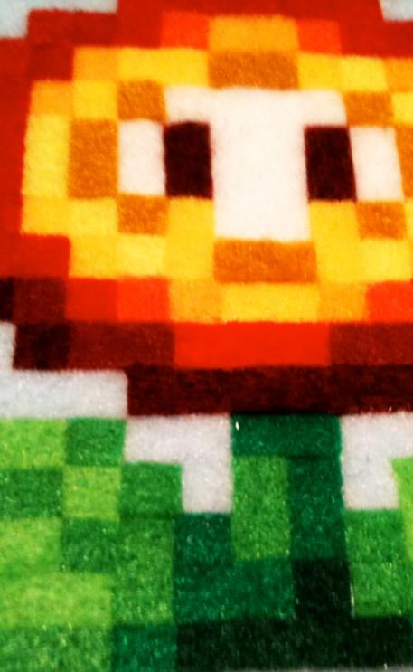
CC by Bob Troia @ flickr
Chapter 1 - 3
Social media and digital gaming worlds – far more than playing games
by Sebastian Ring

Not too long ago we were surrounded by a media environment widely different from today’s standards. Telephones with cords were commonplace, text messages did not yet exist, and quite a long time would pass between taking a photograph and looking at it. Who would have imagined video platforms like YouTube, social communities like Facebook or mobile applications like foursquare or swarm? Things have changed, not only in a technical but also in an economic way, and even more if you look at what people nowadays are able to do with these new devices and applications. Since the 1980s – even before internet and mobile phones emerged – electronic playing devices conquered the entertainment market. The generation X might remember them very well: the Atari, Commodore C64, Nintendo Game Boy or Amiga 500. One or the other will even nostalgically reimagine good times with 8-bit sound and pixel graphics. This article will try to give insight into developments in the field of social media and describe potential advantages they might provide for young people interested in video games: gaining information on digital game worlds, communicating with their peers and many more.
The media world has not only changed in terms of technical and platform innovations. Another development, described by communication scientists with the concept of media convergence (Wagner, 2009), is starting to show. As the digitalization process is going forward and the internet and multifunctional devices such as computers, smartphones or tablet PCs are spreading, the different media products are coming closer together. This can be easily explained by looking at one of the most successful pieces of literature in the last decades: Harry Potter. Most people might know the young wizard from Joanne K. Rowling’s book series. But his stories have also been transferred to other media forms: Several movies based on the books have launched in cinemas and on TV, you can buy the DVDs or BlueRays and even stream the movies on demand via internet to your tablet PC or laptop. There are also clips, trailers and mash-ups on user generated platforms like YouTube. Some of Harry’s fans might be audiophile and turn to audio dramas or soundtracks published within the context of cross-media marketing strategies, the same way all kinds of merchandising gadgets are advertised. Harry is also part of numerous social network sites: His Facebook fans add up to over 70 million, and there are a lot of private profiles on several platforms created by fans across the world. Dedicated forums are used to publish fan fiction and to discuss the adventures of Harry and his friends as well as other questions like release dates. Even people interested in various forms of play can find their share among the video games, Harry Potter Lego pieces and many more. The central motive for people to watch and play Harry Potter related movies and games is the story of his and his friends’ adventures combined with an affection for certain activities (e.g. playing, creating, talking to others about Harry, watching a movie etc.). Phenomena of media convergence can also be found the other way round, when video game text is being transformed into a movie (like Tomb Raider and Lara Croft) or into a book (like the World of Warcraft book series). Besides, most video game journals and magazines use online platforms to provide their audience with content through other channels or in other ways (multimedia, trailers, discussion boards etc.).

New Ways of Communication
The internet has changed the way we communicate in many ways. There are two particular phenomena closely linked to each other which especially depict the change in the last years: web 2.0 and social media. The term web 2.0 does not describe a new version of the internet that has replaced the web 1.0. It is rather a different form of practice when it comes to using the media. Publishing for a potentially broader audience online (user generated content), multimedia communication, networking and self-presentation have become central media activities, and the web 2.0 provides the infrastructure for them. Its platforms, wikis and blogs are easy to use and programming skills or own web servers are not necessary. Looking at young people navigating through convergent media worlds, the web 2.0 seems to be a control room and distributing centre. Users get the chance to talk about their interests and post photos, videos or links they find amusing, interesting or worth sharing among their peers.
Social network services enhance networking among friends, families and likeminded. Young people also make use of the platform for self-presentation, identity work and social integration – activities closely linked to development tasks in adolescence. Gamers can also share game-related information like automatic status-updates on achievements, gained levels, links to game-movies, artwork and information on gaming-events like LAN-parties or -fairs that can be commented or liked by their community friends. The worldwide most frequently used social community is currently Facebook, but there are also a lot of other sites connected to each other that are popular among young people: video-platforms like YouTube, gamers’ forums or communities, digital game distribution platforms like Steam, hardware-related communities like X-Box Social and many online magazines and sites with comment and discussion threads provide room for discussions among users and distribution of information.

What Motivates Young People
During the phase of adolescence, young people make use of web 2.0 platforms and social network services because of certain motives: they use them for amusement, information, distraction, development tasks like identity-work and social integration (JFF et al., 2011: 13). Young people are seeking orientation in a complex world and society, are discovering different role models, reflecting on their suitability for their own life and working on their value systems. Furthermore they want to play an active part in society, want to experience self-efficacy and participate in shaping this world. These motives unite today’s generation of young people across milieu borders. But when we look at the way young people use the media, their specific preferences and actions, we find big differences. One differentiating factor is gender. Boys are more likely to turn to technical and game-related activities. Especially young male gamers prefer to play in a same-sex peer-group and deal with topics like assertiveness or breaking taboos. Girls rather turn to other forms of play, like singing or dancing games as well as casual games, played offline or online in social network services or on the smartphone (MPFS, 2011: 45).

Playing Games and the Social Web
Video games are a prime example for convergent media worlds (Gebel, 2009: 151). Game related content can be found on a variety of sites on the internet and within social network services. The communication on games influences what we think of video games, gamers and the way games are played in many ways (Mia Consalvo (2007) describes this with respect to mainly professional content as paratext). First of all, young people are able to find information resources. They can easily stay informed about their favourite games, hardware and gaming trends, events, e-sports and other things. Commercial and professional content providers (developers, magazines, blogs etc.) use web 2.0 and social media platforms for their purposes as well as educational institutions do. Depending on the aims of the protagonists, the social web can be an important resource for marketing and advertisement as well as for educational purposes like raising awareness for certain topics. Information can be easily received and also spread among the users of social network services. Over viral communication, information is quickly spread among the peer group. Many websites offer buttons for sharing content via social network services like Facebook, Twitter, Google plus or others. More and more games also allow sharing achievements within a game. Whatever is posted, liked, commented or shared online is more or less strongly related to the identity of the young people communicating and its relevance for the peer group. Digital gaming worlds – understood as video games and the sphere of communication about games within the convergent media worlds – are becoming more and more connected. Most online games feature tools for communicating with your teammates. Also external tools like Skype or Teamspeak encourage provide communication tools and many game-related platforms community-functions, too: Broadly used game distribution platforms like Valve’s Steam, Sony’s PlayStation Network, Microsoft’s Xbox live, game- or developer-related platforms like Blizzard Entertainment’s (the creators of World of Warcraft, Starcraft or Diablo) battle.net, Rockstar’s Social Club or platforms for browser gaming like bigpoint.com feature networking and self-presentation functionalities. For the process of developing an own identity and finding one’s place in a social environment, the participative functions of web 2.0 and social media platforms bear potential.

Finding Orientation, Critique and Participation
Social media and web 2.0 platforms are not only used to exchange information. They also serve as a platform for presenting oneself and getting feedback from others. Working on one's identity is an important development task while growing up, and social media can be useful for these efforts (Wagner & Brüggen, 2013). Young gamers can present their personal interests, games they play, achievements, avatars and information on games they consider relevant for themselves or their peers. Platforms can be distinguished in regard of their thematic focus or function, interests of platform providers and of course the community members themselves. Adolescents create their own media environment by connecting with others and subscribing to feeds and podcasts etc., depending on the way platforms and content meet and fit their specific interests. Young people’s shares in online-communities and the values embedded in social media communication can function as a source of orientation for others. During adolescence the peer-group becomes more and more relevant as a guiding instance for developing own values. Being aware of what others play and how they discuss certain game-related topics as well as commenting on others’ actions and getting feedback can be described as a resource for identity development. Not only individual issues are discussed online, but also ones of broader social interest, like discussions on violence and video games, the image of gamers in society, the role of video games in school education etc. But what young people find online might not necessarily be right in a moral sense or useful for a successful development. An important task for educators is to help young people develop media competence, to encourage critical reflection on content found online and also to motivate young people to participate in online discourses on topics that are relevant to them.

Social Games – Playing Games with Friends
When looking at online communities like Facebook that don’t solely focus on gaming, video games play an increasing role both as content of communication and also as a form of ludic action. The so called social games like Farmville, Texas HoldEm Poker, The Sims Social etc. are embedded in the social network environment. For those interested in information on current social and casual games, there are online magazines like gamezebo.com or online statistic tools like appdata.com which provide an overview over the most commonly used social games, Facebook- and smartphone-apps.
Although these games are called social, they are in fact not. The reason they have this name is that they are played within the social community. The youths are supposed to play these games with their community friends, although they don’t really get the chance to communicate with each other. The game evolves asynchronously. The players don’t really interact – even though they might be acting at the same time. Fellow players are presented visually and it’s usually possible to leave messages. Most social games are so called casual games that neither demand expert knowledge or skills for playing nor a lot of time. You can turn to them again and again in a daily routine, although you might not spend a lot of time on each playing session. Most of these games are free to play, which means that the primary access is expenseless. You can register with your social media account or your email address. The providers draw profit by exploiting the users’ data or by in-game sale of items or other benefits for the players. Through actions demanded by the game – which are generally limited for a certain time interval – you will gain resources (e.g. play money) needed to proceed in the game or acquire assets and items. By spending real money (e.g. via credit card, paysafe card, phone call or other) you can acquire these resources in a quicker way and avoid compulsory gameplay breaks. This model of achieving profit is still called free-to-play, because spending real money is not obligatory, although the games are designed in a way to make it more enjoyable by buying certain items. Reselling these items is generally not possible. When the game is shut down by the developer, players will lose their assets. While the fun in playing many of these games will not necessarily result from playing with friends, it might come from communicating about the games and the game actions.

Challenged by the New Media Worlds
Whenever people communicate, there are certain risks involved for young people. Especially young boys playing video games not appropriate for their age are endangered, because they might be confronted with disturbing content or contacts. This is not the place to discuss youth protection laws and mechanisms. But an important aspect related to social media communication is that the platforms’ users themselves might publish problematic content, e.g. by posting images, links or violent movies over their community profiles. Just like with any other piece of information, it’s easy for young people to spread non-suitable content virally among their peers. Another dimension of risks can arise through contact to others in social media services or online games (e.g. racist propaganda, sexual harassment etc.). Cautiousness is especially demanded when meeting people for the first time in real life, when they were formerly only known via social media.
Another area that might be challenging for young people as well as for adults like parents, teachers or youth workers, is the field of data privacy, personal rights and copyright. The vast majority of social media platforms as well as free to play games are gaining profit from their users’ data. Protecting one’s own private data is not easy, since most platforms are very untransparent about their privacy settings. Whether information is posted online does not only depend on the action of an individual, but also on the action of others (Wagner et al., 2010). The fact that adolescents are posting information about themselves is legitimate because of their interests and motives described above: working on their identity and social networking. Additional dynamics are generated by others posting texts, photos, videos etc. not only of themselves, but also of their peers. Unspoken rules and norms about appropriate content are often quite heterogeneous and untransparent for most members of a peer-group. Conflicting priorities like protecting one’s own and the other’s privacies on the one hand and presenting oneself and interacting with others on the other hand make it difficult to develop clear and universal rules of action. Furthermore, the way platform providers generate profit from exploiting their data is not always transparent to the users.
Educators can and should provide the knowledge young people might lack. Knowledge about how platforms work and legal issues are one condition for actions that are self-determined in the interest of other people. Another educational target is to sensitize young social media users for possible consequences of their partially public online communication as well as to initiate discourses about values and norms among the peer-groups.

Focusing on Media Competence
The central aim of media educators is to strengthen young media users in order to empower them to use the media in a self-determined and active way (Theunert, 2009). The media are an integrated and constituting part of modern society and the everyday life of children and adolescents. As described above, media worlds become increasingly convergent, and video games are an integral part of online communication. Young people interested in video games will use this environment to stay informed, play and communicate with their peers and participate in public discourses on video games. A competent way of using the media includes the self-determined selection of media, critical reflection but also creative action. Practical media education efforts in times of social media and web 2.0 are about much more than focusing on youth protection and the risks that young people encounter while communicating in convergent media worlds. Media educators should raise awareness for the web’s participative potentials and enrich the preferences and competences of young people. In this publication you can find more background information on media competence in Gianna Cappello’s article “Media/Digital Competence. The European and Italian Definition” and the Gamepaddle modules for educational practice. German readers will also find useful information as well as tools and methods for educational efforts regarding social media and web 2.0 in the publications webhelm (JFF & AJ, 2011) and surfguide (AJ, 2012).

References
Aktion Jugendschutz Landesarbeitsstelle Bayern e.V. (Ed.). (2012). Surfguide. Hintergründe und Methoden zum Umgang mit exzessiver Mediennutzung. Leitfaden für pädagogische Fachkräfte. München: AJ.
Consalvo, M. (2007). Cheating. Gaining Advantage in Videogames. Cambridge: MIT Press.
Gebel, C. (2009). Computerspiele: Arbeit an der Identität zwischen Realität und Virtualität. In: Theunert, H. (Ed.): Jugend - Medien - Identität. Identitätsarbeit Jugendlicher mit und in Medien. München: kopaed (Reihe Medienpädagogik, 16). p. 145-158.
JFF – Institut für Medienpädagogik & Aktion Jugendschutz, Landesarbeitsstelle Bayern e.V. (2011). webhelm. Die Werkstattcommunity für Daten, Rechte, Persönlichkeit. Materialien für pädagogische Fachkräfte. 2. Auflage. München.
MPFS – Medienpädagogischer Forschungsverbund Südwest (Ed.). (2011). JIM 2011. Jugend, Information, (Multi-)Media. Basisstudie zum Medienumgang 12- bis 19-Jähriger in Deutschland. Stuttgart.
Theunert, H. (Ed.). (2009). Jugend - Medien - Identität. Identitätsarbeit Jugendlicher mit und in Medien. München: kopaed (Reihe Medienpädagogik, 16).
Theunert, H. (2009). Medienkompetenz. In: Schorb, B., G. Anfang & K. Demmler. (Eds.). Grundbegriffe Medienpädagogik Praxis. München: kopaed, p. 199‐204.
Wagner, U. (2009). Konvergenz. In: Schorb, B., G. Anfang & K. Demmler. (Eds.). Grundbegriffe Medienpädagogik Praxis. München: kopaed. p. 156-158.
Wagner, U., N. Brüggen & C. Gebel. (2010). Jugendliche und ihre Perspektive auf Datenschutz und Persönlichkeitsrechte in Sozialen Netzwerkdiensten.http://www.jff.de/dateien/JFF-Bericht_Datenschutz_Persoenlichkeitsrechte.pdf (accessed 06.07.2013).
Wagner, U. & N. Brüggen. (Eds.). (2013). Teilen, vernetzen, liken. Jugend zwischen Eigensinn und Anpassung im Social Web. Baden-Baden: Nomos (BLM-Schriftenreihe Band 101).

Games
Diablo (Blizzard Entertainment, 1996)
Farmville (Zynga, 2009)
Harry Potter Video game Series (Electronic Arts)
Starcraft (Blizzard Entertainment, 1998)
The Sims Social (EA Games, 2011)
Texas HoldEm Poker (Zynga, 2007)
Tomb Raider (Eidos Interactive, Square Enix, 1996)
World of Warcraft (Blizzard Entertainment, 2004)

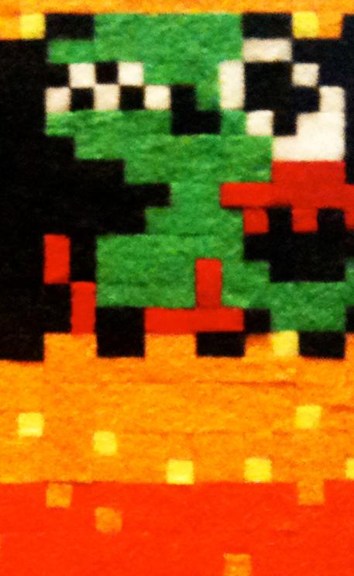
CC by Bob Troia @ flickr
Chapter 1 - 4
Potentials of Video Games
by Anu Pöyskö

1. Video Games and (Educational) Play Theory
When we talk about video games in an educational context, we face a paradox situation. On the one hand, there is broad consensus about the positive impact of (classic) games and playing for learning, healthy development and mental well-being. On the other hand, video games are discussed almost exclusively negatively.
So, the question is what makes games and playing special - and whether these characteristics also apply to video games.
As Rainer Buland (2010) points out, in German language we use the word Spiel for very different activities, whereas in English there is a distinction between “game” (for a game with its specific set of rules, like a game of chess), “play” (for children’s play as an experimental and creative activity), gambling and sports. According to him, especially “play” has great educational potential. Within such a definition, the borders between different types easily become blurred, though. While most modern digital games nicely fit the “game”-definition, some of them, with their endless possibilities to explore and create worlds of one’s own (just think of roleplaying games), seem more “play-“ than “gamelike”.
Several general definitions of what a game is exist, but most of them agree on certain key characteristics. Playing a game is a voluntary act - we decide freely to play or join in a game. A game is a sphere with specific rules and agreements that only apply within the framework of the game. It has a beginning and an ending, and its ending is open, uncertain - which is a source of excitement. While we play a game, we act on an as-if basis: our actions are deeply meaningful within the framework of the game, but have no consequences outside of it. (Rosenstingl & Mitgutsch, 2009: 20-23, Klimmt, 2008: 9). All these criteria roughly apply to video games, too.
Jürgen Fritz defines a game through its three dimensions. First, a game has a behavioural dimension: while playing, we act in a “different” way, self-determined and experimental. We experience excitement and can live out our fantasy and creativity. The second dimension, framing, describes the way a game/play creates a world of its own, a “magic circle”, which only exists as long as the persons involved agree to “keep it up”. The third dimension defines a game/play as a construct of rules, agreements and materials (Fritz, 2004: 17-35). These dimensions can also be found in video games.
The ability to create flow-experiences is often seen as something very typical for play and game, even if not exclusively: we can experience flow during other leisure-time activities and even at work. During flow, our actions and our consciousness merge into one another; we concentrate deeply on what we are doing and have the feeling of having everything under control. The condition precedent to flow is having clear goals and a clear feedback structure. The requirements of the tasks on the one hand, and a person’s skills and expertise and their scope of action on the other, should be well balanced - the demands should neither be too excessive nor too low. (Fritz, 2004: 99-101). The structure of many video games - clear goals and a clear step-by-step reward system, the possibility to define the level of difficulty oneself or the way difficulty levels gradually rise during progress in the game - creates good conditions for experiencing flow.
According to Wolfgang Einsiedler, self-efficacy is a major factor of the learning potential of games and play:
“While playing, a child discovers its self, its self-awareness as an independent, free acting human being. It can experience the connection between action-result and action-consequence“ (Einsiedler, 1993: 61). As for video games, their attraction is greatly based on the transparent connection between action and feedback (Klimmt, 2008: 8).
Children’s leisure time today is by trend increasingly organized by adults, so those who observe children’s cultures often lament the loss of non-pedagogical, adult-free free space for self-organized play (e.g. Einsiedler, 1993: 68-70). Here, virtual gaming spaces can be regarded as something that might, to some extent, help to counterbalance this development.

2. Learning from Games: A Threat rather than a Potential?
If video games are games and carry all the positive potentials of games, why are we so reluctant to regard them in this light?
First, for a long time most adults knew video games only from a spectator’s perspective and took their own experiences with television as a basis for understanding this new medium – thus mixing up very different kinds of media experience. This point of view prevented them from viewing video games for what they are – games. For a spectator, a video game might appear television-like – but from a gamer’s point of view, watching television and playing a video game have little in common. As early work on video games suggests, just a little gaming experience of one’s own was often enough to change the perspective (e.g. Löschenkohl, 1995: 73-76).
Secondly, as the evaluation of video games focused on content rather than form (Fromme & Biermann, 2009: 119), the negative aspects of game content - particularly violence - quickly started to dominate the discussion, profoundly blackening the public image of video games. So instead of asking whether a person could learn something in and through video games, we found ourselves rather wishing they would not. Video games might teach me how to solve problems, but they might teach me aggressive behaviour as well.
So, the question is whether the negative (and positive) aspects of a game remain within the framework of the game, or if - and under which conditions - something can be transferred into other fields of life. Jürgen Fritz’s (2004) concept of “framing” seems useful when dealing with the question of transfer.
According to Fritz, a person’s existence consists of many different worlds: there is the real world which forms the basis for everything, but also the as-if-world of play, the world of dreams, the mental world (a person’s thoughts, ideas and fantasies), the virtual world and the world(s) of media. All these worlds are meaningful for an individual and intertwine in a complex manner. To be able to cope with these different worlds, we need to develop an ability to frame them in a way that makes sense. The ability to frame also has an influence on whether, and in which manner, we transfer experience from one world to another.
The competence to frame the different worlds of our experience/existence correctly has, according to Fritz, three aspects. The first and most basic one describes the ability to distinguish between the different worlds, to be able to tell whether something is real or a dream or belongs to the as-if-worlds of play, fiction or virtuality. Children start to develop this competence at an early age: when they begin to use different “framing signals” to signify their action as play. Later, and step by step, they learn to frame their experiences with the media world correctly, starting with simple insights (like that there are no little people living inside the television set), followed by learning to recognise fiction as “just a story” (Fritz, 2010: 105-107). When talking about video games, young people often seem to question the adults’ abilities to frame these correctly, by pointedly repeating “it is not real, it is just a game”.
The second aspect of framing asks in which way structures, actions and items in the other worlds refer to the real word. It describes the ability to link the different worlds in an analytical manner - using the real world as a reference point for everything else, while still seeing them as different entities. (Fritz, 2010: 108). In some cases, a lot of information is needed to evaluate the real world references – to determine, for example, whether a war game gives a realistic impression of historical events, you need to know a lot about history. The evaluation of the real world references found within the media or virtual worlds must not always follow a simple true-or-not-scheme. A completely fictional product can refer to actual questions and problems in an abstract manner. A game or story for children can take place in a fantasy setting, but may still have many meaningful references to a child’s everyday reality. A young person might well know a daily soap does not give a realistic impression of relationships, but still use it to reflect their dreams and wishes.
The third aspect is the ability to reflect one’s own manner of “living in and with” those different worlds. A self-reflexive approach to the virtual world and the world of media means that we are aware of how we use games and other media, notice when the way we use media changes, know about the motives of our media use and are able to question them as well as being conscious about the significance of media in our daily life (Fritz, 2010: 108).
Gamers - even quite young ones - can usually easily distinguish the game world from the real world (first aspect). Their ability to regard structure and content of a game in relation to the real world depends on many different factors, for example age, experience, education and so on (second aspect) (Fritz, 2010: 111). But even if, on an intellectual level, one recognises a game as “just a game”, a lengthy stay in virtual gaming worlds still can leave its traces; influence (unintentionally, unconsciously) our perception and patterns of thought and action (Fritz 2010: 112). In regard to the question of transfer, the third, self-reflexive aspect seems especially relevant.
Tanja Witting (2007) conducted a series of in-depth interviews with gamers for her study and reflected the possibility of transfer with them. According to gamers’ self-observation, what they sometimes do is transfer patterns of action from games into their mental world – let their imagination run wild and develop violent fantasies. However, this does not influence their behaviour in the real world. The closer a game action resembles the everyday reality of the gamer, the more problematic they experience possible transfer: playing a racing game can have negative short term effects on one’s driving behaviour. (Witting, 2007: 226-227)
The simplistic explanation for not transferring patterns of action from games into the real world is the lack of means. A person who throws spells in an online role game can’t use magic in the real world because they simply aren’t able to. A person who plays a first-person shooter game doesn’t normally walk around with a gun. However, being aware of and self-reflexive about a possible transfer seems to be the more fundamental and reliable answer. According to Jürgen Fritz, gamers who develop this ability are able to recognise action schemata that they have learned in games and subsequently assess their suitability for real world situations (Fritz, 2010: 113-114). This ability - but to this I shall get back later - seems to be equally relevant for the intended, positive transfer: profiting of and learning from the games.

3. Learning in and through Video Games
Video games have already obtained some attention in educational settings. They have a great potential of grabbing and holding a person’s attention, which suggests it would make sense to try and use this potential for educational purposes also. So-called „serious games“ are specially designed for learning purposes, to encourage concerning oneself with complex questions, raising awareness or making a statement. Game-based learning uses video games as a starting point to dealing with curricular issues (e.g. analysing history simulations to determine their accuracy).
In the following, the focus doesn’t lie on such intentional, didactic use of video games, but on the informal learning that happens „on the fly“. When a young person turns her/his attention to a video game, it is seldom about intentionally learning something, and the producers of popular (commercial) video games follow no educational goals. (Fromme, 2006: 183)
Watching a gamer’s performance, one first notices the easy-to-observe physical abilities like good coordination of hand and eye, fast reactions, spatial skills in a 3D-environment and the ability to divide visual attention. (Rosenstingl & Mitgutsch, 2009: 141; Fromme, 2006: 184; Ohlson, 2010: 13) But there might be more... Apparently, since there is a huge variety of video games, learning experiences that take place in games may be different, one game genre stressing one aspect more than another.

3.1 Making Sense of the World
According to Konstantin Mitgutsch and Herbert Rosenstingl (2006: 138,142), learning by playing video games is about collecting information, developing a strategy based upon this information, making decisions and rethinking and transforming strategies in a new situation. In many video games, the player gathers (and needs) quite a lot of information during a game. In most cases, this newly obtained information is immediately utilized. That is why young players find it much easier to remember game-related things than subject material they try to study for school.
If we focus on the content, learning in video games might appear meaningless for everyday life. But if we focus on the process, that is exactly what learning essentially is about. According to Johannes Fromme, Benjamin Jörissen and Alexander Unger (2008: 2), learning can be understood as a self-reflexive process of collecting and co-ordinating references to oneself and to the world. Learning is basically a process of orientation. In a complex modern society, this means being able to reflect things from different points of view and to act in a flexible manner in changing situations, while at the same time creating new meaningful connections.
Wolfgang Zacharias sees video games as spheres of possibilities that enable us to experiment with the connection and interdependence between a person and their environment, subjects and symbols, emotions and thoughts, realities and abstractions. These experiments can provide us with interesting insights (Zacharias, 2011: 32). A good game has a certain “real world-like” complexity; it offers several options of action; neither is there only one “right” solution nor are all possible options equally good (Rosenstingl & Mitgutsch, 2009: 138).
David Shaffer and his co-writers argue that video games which confront players with simulated worlds can have epistemic quality: “Video games are important because they let people participate in new worlds. They let players think, talk, and act—they let players inhabit—roles otherwise inaccessible to them” (Schaffer, Squire, Halverson, & Gee, 2004: 5).
According to Ralf Biedermann and Johannes Fromme, certain video games can raise understanding for political systems and for what it means to act in such a system: “It becomes clear that … a single action can have a wide range of effects, also such that were not intended.” (Biedermann & Fromme, 2009: 134).
In video games, we can take over different roles and identities, thus get a chance the view the world from different perspectives. Cheryl Ohlson points out that “some games encourage players to ponder moral dilemmas, as when playing a war game from both sides of the conflict, or when your character or the storyline changes as a result of your behavior in the game.” (Olson, 2010: 21).

3.2 Learning through Experience
According to Johannes Fromme, intensive encounters with new worlds and situations are always connected to learning. Things function differently in a game. Our normal strategies of thinking and learning don’t necessarily work. This encourages us to rethink our existing way of doing things, which gives way to self-reflexive processes (Fromme, 2006: 191).
Konstantin Mitgutsch connects the ancient concept of “the power of failure and irritations for learning and experiencing” (Mitgutsch, 2010: 47) with video games. According to him, “learning based on a play does not only engage the learner through entertainment and challenge, but also through confrontation and passion” (same: 49). Using the adventure game Shadow of Colossus as an example, Mitgutsch demonstrates what he calls the negative dimension of the process of learning - the one that challenges our pre-experience and thus forces to us to rethink (same: 56). The sophisticated game breaks with several conventions: sequences between the single game tasks completely lack in action: the player just rides seemingly endlessly through an empty, beautiful landscape. The enemy shows no aggression, so the player tends to feel guilty when killing it. At the end, there is no victory but the feeling of being used and mislead (same: 56-58). According to Mitgutsch, games like this have a great potential “to provoke unlearning, relearning and learning anew” (same: 59). However, video games that challenge players’ expectations in such a radical manner seem to be a rather marginal phenomenon.
Matthias Bopp looks at video games from the perspective of art education and also sees them offering possibilities for learning through - in his example - aesthetic experiences. According to Bopp, a meaningful experience has three components: we know what is happening and recognise what is important (facts), we can act in a way that makes sense (know-how) and are aware of what we feel in the situation (emotion). A rich supply of different experiences helps us to quickly orientate in new situations - a central ability in complex and rapidly changing modern societies (Bopp, 2011: 46-47).
Experiences we make in the virtual worlds of games are “real” experiences in the sense that they really happen to us. However, one might question their meaningfulness, especially when the game situation has little in common with any real life situation a person might encounter. But as Herbert Rosenstingl and Konstantin Mitgutsch point out: “It is not the content of the game that becomes reality, but the learning: experiencing, reacting, remembering, experimentation. Neither does a dog game turn us into dogs, nor does a first-person shooter turn us into murderers, but we learn to react to situations, experiment with expectations and to try out different options of action.” Rosenstingl & Mitgutsch, 2009: 135).
For Matthias Bopp, the value of experiences we make through art - which also includes aesthetically interesting video games - is not determined by how much art resembles real life. Some ways to see and experience the world are only made possible through works of art. A game may represent the real world in an incorrect way or have a questionable moral message, but still offer interesting aesthetical experiences (Bopp, 2011: 52).

3.3 Problem-Solving
In most video games, some kind of planning and problem-solving is required.
“Games don’t have to be labeled as ‘educational’ to help children learn to make decisions, create strategies to solve problems, and anticipate consequences”, Cheryl Olson points out (2010: 21).
In their long-term study with an ethnographic approach, Pilar Lacasa and Rut Martinez-Borda describe a 5-year-old girl’s experience and progress while playing Super Mario games: “If analyzing the girl’s activities when interacting with the game teaches us something, it is certainly that she wasn’t wasting her time. All the time she was forced to reason and solve specific problems […] she was developing abilities related to solving complex problems that will be very useful in her future life as a citizen of the twenty first century.“ (Lacasa & Martinez-Borda, 2010: 162).
Gabi Uhlenbrock, who works with video games in a youth work setting, describes a situation where she was helping a young boy to solve a certain quest in the MMORPG World of Warcraft: “He found out that there were several possibilities to solving the problem and obtaining the required information: he could read the quest description more closely, ask others, do research on the internet or make use of specific game mechanics (that offer support). Last but not least, he got tips from friendly and competent co-players, who thus served as positive role models within the peer group.” (Uhlenbrock, 2011: 160).

3.4 Social Learning
Not so long ago, gaming was regarded as a lonesome activity. Today, video game structures and mechanics increasingly encourage playing together (on- and offline multiplayer mode). But even before that (when video games had already formed a relevant part of the everyday life of many young people), observing others playing games, discussing games and sharing gaming experience made gaming a social activity.
According to Ralf Biedermann and Johannes Fromme, video games increase the diversity of possible social spheres we can enter and gain experiences in (Biedermann & Fromme, 2009: 122). David Schaffer and his co-authors describe gaming communities as “valued communities of practice” and stress the importance of being involved in such communities, actively participating in the further development of the shared practice (Schaffer, Squire, Halverson, & Gee, 2004: 18). For a gamer, gaming communities are profoundly relevant peer groups.
Once more, the way external spectators view a game and the way the gamers themselves view it varies widely. Johannes Fromme, Benjamin Jörissen and Alexander Unger demonstrate this by using the first-person shooter Counter-Strike as an example. The common perception focuses on the violent content of the game. From the gamers’ perspective, social interaction and being part of gamers’ communities are what Counter-Strike essentially is about (Fromme, Jörissen, & Unger, 2008:16).
According to Gabi Uhlenbrock, social learning always takes place when a group of people share a common goal which can only be reached through shared efforts. Video games potentially provide a good environment for learning to co-operate, because the motivation is usually high and therefore also the willingness to work well together. “The social sphere of a video game includes all elements of social learning: perception, establishing contact, communication, tolerance, dealing with conflicts, mutual regard and respect, patience and loyalty. Success in a game requires reliability, planning, endurance and division of labor.” (Uhlenbrock, 2011: 148). In her practical work as a youth worker she observes that conflicts in the world of game often originate from the same sources as conflicts in the real world do. Having a closer look at a game conflict, talking about how and why it happened, can thus produce useful insights for both game- and real world situations (Uhlenbrock, 2011: 159-160).
A lot of research has been carried out on the complex social interaction structures in games that require collaboration. Diane Carr and Oliver Martin describe learning in an online role-playing game as an “ongoing process that involves sharing, specialization and negotiation, as well as a constant blurring of the boundaries between play and other areas of life” (Carr & Oliver, 2010: 45). Long-lasting gaming communities like clans or guilds are true “test environments” for how a community works: groups can be democratic or hierarchical, a person needs to find their own place in the group structures, questions of participation and leadership are negotiated, as well as rules and regulations for accepted and unaccepted behaviour (Geisler, 2010: 175).

3.5 Video Games as “Identity Workshop”
The aspect of experience in a game doesn’t only refer to the outside world but also to one’s own self. While playing, we experience ourselves in different roles and situations and subsequently learn more about ourselves. But is it really necessary to have a shot at being a wild action hero or a killer? As Konstantin Mitgutsch and Herbert Rosenstingl point out, for role experiments a wide variety of possible roles is necessary. This can’t be provided by video games only, but games can serve to widen the spectrum (Rosenstingl & Mitgutsch, 2009: 40).
In a similar way, the social learning aspect in a video game also quasi automatically includes learning more about one’s own self. According to Martin Geisler, especially long-lasting gaming groups (clans, guilds) with strong social bonds can offer ideal stages for experimental self-expression. A player can develop and try out different roles and different positions within a collective, receiving immediate and direct feedback from their peers (Geisler, 2010: 174). This aspect is particularly strong in online role-playing games, which explicitly invite to role experiments and require a lot of collaboration as well as a clear division of labour.
Gaming experience can influence one’s personality in the way that knowledge about games and gaming is directly relevant for life in the real world. Some assessment centres already regard intense gaming experience as a positive factor, since gamers are considered to be achievement-oriented, team-minded, loyal and engaged, with a good ability to deal with failures and frustrations (Rosenstingl & Mitgutsch, 2009: 137).

4. Skip School – Let’s Play?
Since there seems to be so much meaningful learning taking place in the world of games, maybe we should consider cancelling school childrens’ lessons and instead, let them spend the time playing video games? But even for a superficial observant, it is obvious that those competences and experience we gain in video games do not automatically transfer into real world situations. Someone who leads a group in a game does not necessarily perform the same role in the real world. Someone who deals with time-consuming, somewhat boring game-tasks with the patience of a saint does not necessarily transfer this attitude towards their homework.
In the same way we identified reflection and self-awareness to be a key to prevent undesirable and inappropriate transfer from video games into the real world, these could also be the main means to enable positive transfer. Here, we can identify a task for education. As Konstantin Mitgutsch and Herbert Rosenstingl put it, it “takes a lot of effort to draw the experience from the ‘magic circle’ of a game into other fields of life” (Rosenstingl & Mitgutsch, 2009: 146).
Only, the question of “how” has not yet been answered satisfactorily. The positive potentials of video games are widely known about, but since there is but little educational practice, they remain a theoretical concept. This is why several authors stress the importance of developing new methods and strategies for a “pedagogy of video games” (e.g. Klimmt, 2008: 16, Bopp, 2011: 59).
The basic approaches might be quite simple, though. In her concept of play-based learning, Sabrina Schrammel (2008: 124) suggests not to focus on the game itself but on the practical experience of playing. Players’ as-if-actions in a game are something concrete and comprehensible we can immediately start to talk about in educational contexts. Christoph Klimmt unites both aspects (the content of the game and the act of playing) and identifies a “communicative approach” as a relatively simple pedagogical strategy to deal with and make use of video games. The contents of games can form a gateway to approaching different themes and subjects. Talking about the act of playing strengthens a person’s ability for self-reflection (Klimmt, 2008: 13-14).
An important step is to try to verbalize the learning that takes place in a game. Pilar Lacasa and Ruth Martinez-Borda (2010: 162) advise adults (parents and educators) to accompanying children in their playing progress and, after gaming sessions, to talk about what has just happened: “... this will help to raise awareness of the problems to be solved, and above all, to re-formulate, to discover the way to solve them and, in the end, to encourage thought and reflection.“ (Lacasa & Martinez-Borda, 2010: 162).
In times when children and young people face growing demands and competition, paying attention to their gaming expertise can also be an additional source of positive self-perception. Cheryl Olson says that parents and educators should “encourage the use of games to build relationships. One thing many children said they liked was teaching others how to play. Being able to teach can give a child a real sense of pride and self-esteem.” (Ohlson, 2010: 24). The gap between game worlds and school should be closed. The knowledge and competences young gamers have acquired can be useful for training other skills. Teaching others to play is one example, giving a lecture on games or public discourse on games in front of the class, doing research and presenting the results might be another simple way for educators to train key competences of young gamers and grant appreciation for their knowledge and skills.
All these findings point to a recommendation to take video games and the experience children and young people make with video games seriously, to give them room in educational processes and to encourage reflection. The individual pilot projects of Gamepaddle demonstrate possible ways to accomplish this.

References
Biedermann, R. & J. Fromme. (2009). Identitätsbildung und politische Sozialisation. In: Bevc, T. & H. Zapf. (Eds.). Wie wir spielen, was wir werden. Computerspiele in unserer Gesellschaft. Konstanz: UVK.
Bopp, M. (2011). Erfahrungswissen in Computerspielen. In: Winter, A. (Ed.). Spielen und erleben mit digitalen Medien. München: Ernst Reinhardt Verlag.
Buland, R. (2010). Spiel im Sinne von „play“ als effizienter Bildungsprozess. Ergebnisse aus der Gehirn- und Spielforschung.
http://www.spielebox.at/fileadmin/daten/spielebox/PDF/pdfs_2010/Spielbox-Artikel.pdf (accessed 06.07.2013)
Carr, D. & M. Oliver. (2010). Tanks, Chauffeurs and Backseat Drivers: Competence in MMORPGs. In: Mitgutsch, K., Ch. Klimmt & H. Rosenstingl. Exploring the Edges of Gaming. Wien: Braumüller.
Einsiedler, W. (1993). Das Spiel der Kinder und Jugendlichen: vergnügt - gestreßt - gefährdet? In: Bauer, G. HOMO LUDENS - Der Spielende Mensch (Bd. 3). München - Salzburg: Verlag Emil Katzbichler.
Fritz, J. (2004). Das Spiel verstehen. Eine Einführung in die Theorie und Bedeutung. Weinheim und München: Juventa.
Fritz, J. (2010). Virtuelle Spielwelten mit Kompetenz rahmen. In: Ganguin, S. & B. Hoffmann. (Eds.). Digitale Spielkultur. München: kopaed.
Fromme, J. (2006). Zwischen Immersion und Distanz: Lern- und Bildungspotentiale von Computerspielen. In: Kaminski, W. & M. Lorber. Clash of Realities. Computerspiele und soziale Wirklichkeit. München: kopaed.
Fromme, J., B. Jörissen & A. Unger. (2008). Bildungspotentiale digitaler Spiele und Spielkulturen. In: Medienpädagogik. Zeitschrift für Theorie und Praxis der Medienbildung (Themenheft Nr. 15-16: Computerspiele und Videogames in formellen und informellen Bildungskontexten)
http://www.medienpaed.com/Documents/medienpaed/15-16/fromme0812.pdf (accessed 06.07.2013)
Gebel, Ch. (2009). Lernen und Kompetenzerwerb in Computerspielen. In: Bevc, T. & H. Zapf. (Eds.). Wie wir spielen, was wir werden. Computerspiele in unserer Gesellschaft. Konstanz: UVK.
Geisler, M. (2010). Soziale Prozesse beim Computerspielen und in Computerspielgemeinschaften. In: Ganguin, S. & B. Hoffmann. (Eds.). Digitale Spielkultur. München: kopaed.
Klimmt, Ch. (2008). Unterhaltungserleben beim Computerspielen. Theorie, Experimente, (pädagogische) Anwendungsperspektive. In: Mitgutsch, K. & H. Rosenstingl. Faszination Computerspiele. Theorie - Kultur - Erleben. Wien: Braumüller.
Lacasa, P. & R. Martinez-Borda. (2010). Mario Bros, an old friend of learning. In: Swertz, Ch. & M. Wagner. Game\\Play\\Society. Contributions to contemporary Computer Game Studies. München: kopaed.
Löschenkohl, E. (1995). Computerspiele - Gefahr oder Herausforderung. In: Bauer, G. HOMO LUDENS - Der Spielende Mensch (Bd. 5). München - Salzburg: Verlag Emil Katzbichler.
Mitgutsch, K. (2010). Passionate Digital Play-Based Learning. (Re)learning in computer games like shadow of colossus. In: Mitgutsch, K., Ch. Klimmt & H. Rosenstingl. Exploring the Edges of Gaming. Wien: Braumüller.
Olson, Ch. K. (2010). What Young People Learn from Electronic Games. In: Mitgutsch, K., Ch. Klimmt & H. Rosenstingl. Exploring the Edges of Gaming. Wien: Braumüller.
Rosenstingl, H. & K. Mitgutsch. (2009). Schauplatz Computerspiele. Wien: Braumüller.
Schrammel, S. (2008). Play based learning. Die Aktivität des Computerspielens als Lernanlass. In: Mitgutsch, K. & H. Rosenstingl. Faszination Computerspiele. Theorie - Kultur - Erleben. Wien: Braumüller.
Shaffer, D.W., K.R. Squire, R. Halverson & J.P. Gee. (2004). Video games and the future of learning. http://gise.rice.edu/documents/FutureOfLearning.pdf (accessed 06.07.2013)
Uhlenbrock, G. (2011). Soziales Lernen in Online-Rollenspielen am Beispiel World of Warcraft. In: Winter, A. (Ed.). Spielen und erleben mit digitalen Medien. München: Ernst Reinhardt Verlag.
Wittning, T. (2007). Wie Computerspiele uns beeinflussen. München: kopaed.
Zacharias, W. (2011). Spiel(en) neu denken: Homo ludens medialis 2.0? In: Winter, A. (Ed.). Spielen und erleben mit digitalen Medien. München: Ernst Reinhardt Verlag.

Games
Counter-Strike (EA Games, 2000)
Shadow of the Colossus (Sony, 2006)
Super Mario (Nintendo, 1987)
World of Warcraft (Blizzard Entertainment, 2004)
Chapter 1 - 5
What Makes a Game Attractive?
by Anna Ragosta

The opposite of play isn’t work: it’s depression.
Brian Sutton-Smith

The videogames have always been associated to many stereotypes and are accused of being responsible for producing adverse mental and physical effects on gamers. Like any other activity done to excess it may have negative effects, but the latest studies have shown that with good gaming habits (e.g., appropriate time, environment, moderation of online games, etc.), the digital games can be considered a safe and satisfactory activity.
Recently, we are witnessing the increasing interest in use of new technologies of play for education and training. Ever more research aimed to analyse the impact of educational, therapeutic and social games designed with or without educational goals.
Playing games is always educating. Learning is always present in the game, even when it is not the aim. It seems that as an educator you are forced to add a qualification to the gaming activity to justify its presence in education. The discrimination aims at playing games in general and consequently extends to video games (see also Massimiliano Andreoletti’s article “What is a video game?” in this publication).

Game as the Basis of Culture
According to Huizinga, play is one the fundamental dimensions of human condition. He believes that the game is at the origin of social organization and culture. Culture that in its manifestations such as theatre, music, dance, literature, art, sports and more has the game’s nature: through the representation of fictional action these actions represent, simulate real action and are able to draw future scenarios and futurity.
For our species, the game is a vital activity, universal and continuous that crosses our whole existence, is a necessity for survival.
Paraphrasing Huizinga, we can say that more than Sapiens, Homo is Ludens: the childhood game allows us to take possession of a wide range of tools and mental models. Play is one of the main forms of brain's development since birth. Piaget – early as 1945 – claimed that the child, through the game takes hold of a set of skills that will enable from adult to interact effectively with the physical and social environment. This new paradigm of simulative mind (simulative theory) allows us to understand how the complex processes of knowledge works and to explain the fundamentals of mental activity.
The simulative mind acts in a situated way, that is tied to experience; it is able to provide mental representations of events and phenomena by integrating the information coming from different sensory modalities, emotions, affections, behaviours and actions etc. to create new worlds. Playing and creating fictional worlds in which the actions playfully simulate the real ones enables the subjects to learn. Playful mind and simulative mind go hand in hand and their interaction allows humans the huge development of their knowledge and its applications, of the events comprising the emotional and relational life as well as their artistic and creative expressions at different levels (Anolli & Mantovani, 2011).

The Meaning of Play for Learning
We learn by playing and learning we play. The attitude to learn is a human characteristic and also a socio-cultural one that is applied in relationship with others and with the culture in which one is embedded. By interacting with others we learn in a direct way (imitating behaviour, following the instructions, etc.) or indirectly through the works of human ingenuity (novels, movies, books, music, painting etc.). The game allows perfecting certain skills such as the exchange of roles, imitation, imagination, comparison, discernment between reality and imagination, communication. Who plays learn to follow the rules, to build a strategy, to think for themselves, to make choices, test oneself and others, learn to dare staying in the rules.
The technology of video games has been much used for years for training in a stimulating, motivating and realistic environment, where you can explore, collaborate, memorize, get more information in order to progress in the different levels of play, making mistakes and then learning doing. The users are, for example surgeons, soldiers or firefighters.
Play becomes a synonym for learning. Playing is learning. Video games can have an emotional impact on players. Studies have shown that emotions can help the memorization process. Furthermore, the games can increase players’ self-confidence.

What Makes a Video Game Attractive?
But what makes a game attractive? Psychology can help find answers. In a study published in the January 2007 issue of Motivation and Emotion researchers from the University of Rochester and Immersyve Inc. (lead investigator Professor Richard Ryan, a motivational psychologist) looked at the underlying motives and satisfactions that can spark players' interests and sustain them during play. They found that the games could provide opportunities for achievement, freedom and even a connection to other players. The results suggest that people enjoy video games because they find them intrinsically satisfying. Increasingly, neuroscience is demonstrating the importance of making learning a fun and positive experience. Pleasurable experiences cause the body to release dopamine, which in turn helps the brain remember facts. One great example of how this is making it into the classroom is Khan Academy, an online learning portal that challenges students to complete games and problem sets in order to win badges. Many students report feeling an affinity for subjects like math and science that they did not have before the game-based learning program was implemented in their schools. Even when students did not have a marked increase in test scores after using Khan, they reported a more positive attitude about learning, which can often be a major hurdle for educators. Recent research has also shown just how much of an emotional experience learning can be, with negative emotional states like fear, anxiety, shame or worry making it difficult or impossible for students to reason, learn or store new memories. This data further stresses the need for developing learning environments that are not just fun but are also positive, safe places for students.

Games as Imitation and Simulation
In the 1990s, researchers from the Department of Neuroscience, University of Parma, led by Prof. Giacomo Rizzolatti, have made a revolutionary discovery for neurological and psychological disciplines. The discovery, the mirror-neuron mechanism, has identified a specific neural competence, which is the basis of all the processes of imitation and early construction of empathy in interpersonal relationships.
If we want to survive, we must understand others’ actions. Furthermore, without action understanding, social organization is impossible. In the case of humans, there is a faculty that depends on the observation of others' actions: imitation learning. Unlike most species, we are able to learn by imitation, and this faculty is at the basis of human culture. The neurophysiological mechanism appears to play a fundamental role in both action understanding and imitation. The mirror neurons or empathy neurons are activated in our brain when we look at the behaviours and emotions of the others.
Rizzolati also discovered a property of the brain: neuroplasticity. His intuition has inspired the research on the relationship between media, education and the brain: from his studies, it became clear that this plasticity lasts throughout our lives, even if in childhood and adolescence is more accentuated. This is confirmed by a nascent branch of neuroscience, neuro-education, through the work of Karl Fischer at Harvard University (one of the editors of The Educated Brain) and Japanese Koizumi. These studies show that learning by doing (deweyiana memory) – maybe by playing video games – prepares the brain for solving increasingly complex problems, and is therefore a valuable resource for education.
Like video games and computer technologies, learning theories have evolved significantly. The design of educational systems has been greatly influenced by development in educational psychology and instructional design.
Among the current educational theories, the constructivist approach says that the subject learns through interaction with the environment and peers. This involves a process of trial and errors, in addition to the ability of players to interpret the present and past experiences in order to update their knowledge.
While the first educational software was inspired by theories of cognitivism and behaviourism, latest video games, due to their complexity, their open-ended and collaborative nature, encourage a constructivist approach to learning. In video games, players can develop new hypotheses and theories, test them and adapt them because of their knowledge and skills.

Learning for Life
To learn, one must act and experience oneself, in acting one becomes competent, grows and matures. Being a part of the knowledge society requires a skill set very heterogeneous and complex that the World Health Organization has called life skills, including decision-making skills, skills in dealing with problems, creative thinking, critical thinking, effective communication, relational competence, self-awareness, empathy, emotion management and stress management.
Life skills to which may add skills such as the ability to search for information and knowledge, the ability to work in a team and be able to participate effectively in the life of the community of which one belongs. Each citizen should feel free to express their ideas and participating in the change. New technologies, and therefore also video games, are an important social opportunity to promote participation and the assumption of responsibility. They can be a key feature of education of an active citizen who wants to be participating in the knowledge-based society.

References
Battro, A.M., Fischer, K. W., & P. Léna. (Eds.) (2008). The educated brain. Cambridge, U.K.: Cambridge University Press.
Ryan, R. M., Rigby, C. S., & A.K. Przybylski. (2006). The Motivational Pull of Video Games: A Self-Determination Theory Approach. In: Motivation and Emotion, Volume 30. Springer Science+Business Media, LLC. p. 344-360.

by Anna Ragosta

Rating Video Games
Which video games you might chose to use in an educational contexts depends on different factors, e.g., a specific content, a certain functionality like multiplayer modes of play, available hardware and financial resources etc. Depending of the age of your project’s participants, you will also have to take youth protection in account.
To determine if the content of the digital game is suitable for the students in terms of age and content, existing rating systems can help. The Pan European Game Information (PEGI) is a rating system that helps to ensure that the content of a game is suitable for the target audience. It is a voluntary system used in 32 European countries, but is only enforced in two (Finland and Norway; in Germany a different system of regulated self-regulation by the video game industry, the USK, has been implemented). The information to guide the consumers involves a logo that represents the minimum recommended age (3, 7, 12, 16 and 18) and icons that indicate the nature of the content.
Symbols of PEGI – Pan European Game Information

PEGI and USK will only tell you that playing a labeled game does not put young people at a certain age at risk. What PEGI doesn’t indicate is a video game’s cultural or educational value. Unfortunately, there are only few platforms that provide information on video games from an holistic educational perspective. In Austria, the federal institution BUPP provides recommendations on video games according to the principle “advising instead of forbidding”.

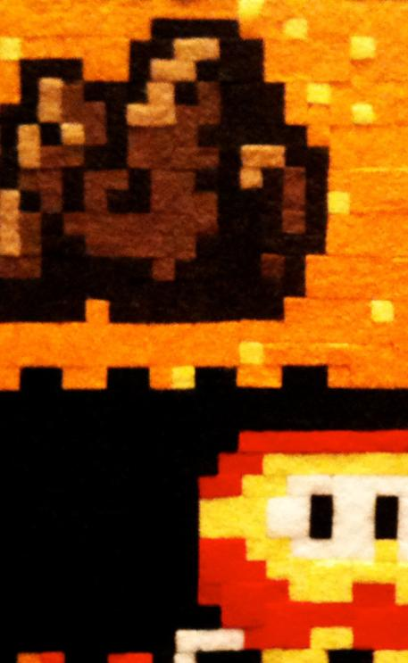
CC by Bob Troia @ flickr
Chapter 1 - 6
Media/Digital Competence. The European and Italian Definition
by Gianna Cappello

Media Literacy and Media/Digital Competence. The European Union View
In 2007, the European Union Commission issued a Communication titled A European approach to media literacy in the digital environment where media literacy is clearly defined as “the ability to access the media, to understand and to critically evaluate different aspects of the media and media contents and to create communications in a variety of contexts” (European Commission, 2007: 3). Furthermore, the Communication states the “levels” of media literacy:
- feeling comfortable with all existing media from newspapers to virtual communities;
- actively using all kinds of media, like use Internet search engines for information retrieval, or participate in virtual communities, or better exploit the potential of media for entertainment, for accessing culture, intercultural dialogue, learning and daily-life applications;
- having a critical approach to media as regards both quality and accuracy of content;
- using media creatively, that is take advantage of Internet distribution channels to create and disseminate images, information and content;
- understanding the economy of media and the difference between pluralism and media ownership;
- being aware of copyright issues and legal issues, given the role younger generations play in their double capacity of consumers and producers of content.
Much more recently – May 2012 – in setting out the framework for the Digital Agenda for the coming years, the European Union Commission issued a Communication about the European Strategy for a Better Internet for Children. The Communication states quite clearly four actions in order to improve the members states’ policies about the empowerment and protection of children with regards to ICTs (information and communication technologies):
- to stimulate the production of creative and educational online content for children and develop platforms which give access to age-appropriate content;
- to scale up awareness raising and teaching of online safety in all EU schools to develop children’s digital and media literacy and self-responsibility online;
- creating a safe environment for children where parents and children are given the tools necessary for ensuring their protection online, such as easy-to-use mechanisms to report harmful content and conduct online, transparent default age-appropriate privacy settings or user-friendly parental controls;
- combating child sexual abuse material online by promoting research into, and use of, innovative technical solutions by police investigations.
I want to focus on the first two as they refer directly to the field of media literacy and the question of digital competence. The first action is to be developed not only by creating creative and educational content for children but by children by encouraging children’s creativity and participation, “to grow and shape their world in a safe, creative way, to build communities, and to be active in a participatory society” (European Commission, 2012: 7). As for the second action, the Commission clearly states that “children need to develop their critical thinking and digital and media literacy skills to be able to actively contribute in a participatory society. They need access to and advice on how to use tools suited to their age that would help them act safely and responsibly online. The focus of awareness and empowerment actions should be to develop self-protection and self-responsibility in the online environment among children” (European Commission, 2012: 8). It also suggested that member states should implement strategies to include teaching online safety in formal and informal education, on the one hand, and provide adequate teacher training, on the other. Partnerships between public and private agencies should also be promoted.
From its part, the Commission will support the identification and exchange of best practice among member states in the areas of formal and informal education on online safety, the creation of relevant educational content, and public-private partnerships aimed at reaching out to children, parents, teachers and carers.
Although, in my opinion, this Communication, as a whole, seems to adopt a protectionist approach, yet it does keep a relevance of its own as it clearly shows how the Commission is increasingly open and supportive towards media and digital literacy, as a series of other documents have also proven throughout these years. It also shows how the Commission values the need “to develop a specific module within Europass for digital competence and improve the indicators for use and impact of ICTs in education” (European Commission, 2012: 8).
As we all know, digital competence is one of the Key competences for lifelong learning recommended by the European Parliament and the Council in 2006. These competences are considered as “necessary for personal fulfillment, active citizenship, social cohesion and employability in a knowledge society” (European Parliament and Council, 2006: 4). More precisely, the Recommendation defines digital competence as “the confident and critical use of Information Society Technology (IST) for work, leisure and communication” (same: 6). As such it implies basic skills such as the capacity to use computers “to retrieve, assess, store, produce, present and exchange information, and to communicate and participate in collaborative networks via the Internet” (same: 6). It also implies the capacity to understand “the opportunities and potential risks of the Internet and communication via electronic media for work, leisure, information sharing and collaborative networking, learning and research” (same: 7); to take full advantage of creative and innovative uses of IST and “be aware of issues around the validity and reliability of information available and of the legal and ethical principles involved in the interactive use of IST” (same: 7). Ultimately, the use of “IST requires a critical and reflective attitude towards available information and a responsible use of the interactive media” (same: 7).
The Recommendation clearly shows a shift in EU thinking from a merely technical approach to ICTs to a more cognitive, ethical and citizenship-oriented one. ICTs are not mere machines, they are also and more importantly philosophical devices which change (albeit not in a deterministic manner) the way people think, act and interact.

Defining Competence and…
Given the European context briefly described here, let’s turn now to see how digital competence has been defined according to a cross-disciplinary perspective. Scholars have defined competence in many ways stressing out different components. One very popular definition is the one made by Philippe Perrenoud (2003) who describes competence as “the faculty of mobilizing a set of cognitive resources (things known, capacities, facts, etc.) in order to resolve with pertinence and efficacy a series of situations” (Perrenoud, 2003: 17). Competence is a human intrinsic characteristics made of certain capacities, knowledge and experiences which are always expressed and embodied – situated – in a given context. As such, competence is not a status, but a process, i.e., the process of mobilizing certain resources (subjective knowledge, procedural knowledge, skills, practical and cognitive capacities, attitudes and dispositions), rather than simply holding them. A person can be defined competent in a domain not just because of his/her knowledge or skill, but for his/her ability “to act efficiently in a situation” (Parola, 2010: 32). In other words, the competent person, when facing a certain situation or problem, is able to understand it in the best way and to make the best decisions to face and solve it, or to change his/her strategy if that is not working.
As Trinchero (2008: 329) suggests, four components define the level of competence of a person:
- the amount and the quality of the resources held, consisting of the knowledge and skills about a certain field, and their appropriateness to solve the problem;
- the explicit and implicit models that allow the person to understand the problem, and then select the appropriate strategies for addressing it (interpretation structures);
- the operational strategies enacted by the person to reach a predefined objective within a specific situation and/or problem (action structures);
- the capacity to assess whether the adopted strategies are the most effective for the specific purposes or whether they should be modified. Self-reflection and self-regulation involve the capacity of a person to learn from previous experiences in daily life (self-regulation structures) (Trinchero, 2008).
Being competent implies the ability to manage knowledge and techniques, knowing how to integrate them, making use of metacognitive adjustments in order to ultimately turn them into action, an action which is not mere behaviour nor practical activity: it is doing something being goal-oriented, that is tending towards the solution of a given problem. In Vognsen’s words, it is an “action competence” composed by three dimensions: factual knowledge (scientific, systematic, specialized), interpretative knowledge (intuitive, spontaneous, holistic) and a commitment to change (values, meanings, opinions), all of which make possible the production of criteria to develop responsibly selected and alternative action (Vognsen, 1993: 14-17). Competence therefore involves not merely knowing that of knowing how but also wanting to, a will to commitment, so to speak. Framed within the long debate about human agency vs. structural constraints, this notion of competence makes it clear that the more competent one is, the more s/he acquires freedom of action. As Cohen puts it, “the latitude of freedom of agency crucially depends upon the range of practices that an agent is competent to perform” (Cohen, 1987: 279).
In sum, the notion of competence has a multidimensional nature. It is:
- complex as it implies a combination of knowledge, skills, attitudes, behaviors, etc.;
- transversal as it crosses across disciplinary boundaries;
- social as it relates to specific social and cultural contexts;
- situated as it is always embodied in concrete situation of learning;
- “visionary” and goal-oriented as it implies some kind of vision for social and individual change.

… Digital/Media Competence
If we now turn to digital competence, we can start by identifying four basic areas of action which bring us back to the definition of media literacy:
- technical – the conditions of access to media (in terms of both technical infrastructures and basic usage skills);
- critical – the capacity to search for, select, analyze and critically evaluate information according to one’s own needs (critical understanding skills);
- creative – the capacity to create and share media content (creative production/communication);
- strategic – the capacity to use digital information for reaching certain goals (professional, social, cultural, educational, ethical, etc.) and produce social change.
More specifically, if we think of specific media and media uses, we can have:
- relational/communication competence – the capacity to interact with others, to share content, to participate to online communities (for example, E-mail, web forums, instant messaging, social networks, SMS/MMS, etc.);
- cognitive/critical competence – the capacity to use critically Internet services and information sources (for example, online games, information retrieval, e-commerce, upload/download of multimedia files, etc.);
- creative/ethical competence – the capacity to create and manipulate digital content within specific platforms and communities according to certain creative, participatory, social, ethical goal-oriented motivations (for example, virtual environments, file sharing, blogging, etc.).
Figura 1. Digital Competence Framework
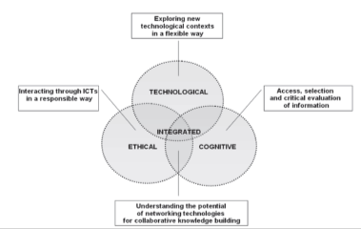
Source: Ranieri M., 2008.

This multifaceted definition of digital competence can be schematized within a framework where the technological, ethical and cognitive dimension integrate and develop a common area where knowledge and action can be collaboratively built and shared (see Fig. 1).
If we frame this definition of digital competence within a more media-inclusive approach, we can say that a media competent person must:
- know how to read media. The linguistic structure of media messages (their ‘opacity’) requires the capacity of understanding media codes and convention and the gradual activation of a literacy process to fully understand the contents of media texts (reading skills);
- know how to write media, that is produce media texts with creative purposes reflecting on communicative intentions and effects (writing skills);
- know how to critically evaluate media, that is take a distance from the observed object (critical thinking skills);
- know how to use at best the media, that is make aware decisions and choices in media uses (user skills).
If we go back to Trinchero’s components which define competence and intersect them with these specific areas of a media-related competence (the media reader, the media writer, the media user, the critical thinker), we can build a more precise profile of the media competent person to be taken into consideration whenever we need to assess and evaluate media education activities in both formal and informal contexts (see Fig. 2).

Figura 2. The Media Competence Profile
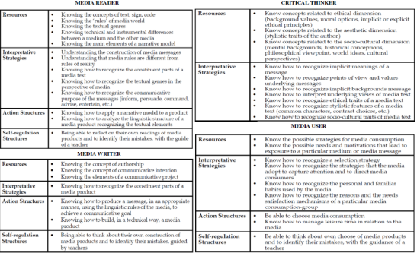
Adapted from Trinchero R., op. cit.

References
Cappello, G. (2009). Nascosti nella luce. Media, minori e media education. Milano: Francoangeli.
Cohen, I. J. (1987). Structuration theory and social praxis. In: Giddens, A. & J. H. Turner. (Eds.). Social Theory Today. Cambridge: Polity Press, pp. 273-308.
European Commission. (2012, May 2). European Strategy for a Better Internet for Children, Communication from the Commission to the European Parliament, the Council, the European Economic and Social Committee and the Committee of the Regions. COM (2012) 196 final. Brussels. http://eur-lex.europa.eu/LexUriServ/LexUriServ.do?uri=COM:2012:0196:FIN:EN:PDF (visited November 2012).
European Commission. (2009, August 20). Commission Recommendation on Media literacy in the digital environment for a more competitive audiovisual and content industry and an inclusive knowledge society. C(2009) 6464 final. Brussels. http://eur-lex.europa.eu/LexUriServ/LexUriServ.do?uri=OJ:L:2009:227:0009:0012:EN:PDF (accessed November 2012).
European Commission. (2007, December 12). A European approach to media literacy in the digital environment. Communication from the Commission to the European Parliament, the Council, the European Economic and Social Committee and the Committee of the Regions. COM (2007) 833 final. Brussels. http://eur-lex.europa.eu/LexUriServ/LexUriServ.do?uri=COM:2007:0833:FIN:EN:PDF (accessed November 2012).
European Parliament and Council. (2006, December 18). Recommendation of the European Parliament and of the Council on Key competences for lifelong learning. 2006/962/EC. Brussels. http://eur-lex.europa.eu/LexUriServ/LexUriServ.do?uri=OJ:L:2006:394:0010:0018:en:PDF (accessed November 2012).
Giddens, A. & J. H. Turner. (Eds.). (1987). Social Theory Today. Cambridge: Polity Press.
Le Boterf, G. (1994). De la competence: essay sur un attracteur étrange. Paris: Les Editions d’Organisation.
Parola, A. (2010). In Search of a Definition of Media Competence. In Parola, A. & M. Ranieri. Media Education in Action. A Research Study in Six European Countries. Firenze: Firenze University Press, pp. 26-33.
Parola, A. (Ed.). (2008). Territori mediaeducativi. Trento: Erickson.
Parola, A. & M. Ranieri. (2010). Media Education in Action. A Research Study in Six European Countries. Firenze: Firenze University Press.
Perrenoud, P. (2003). Costruire competenze a partire dalla scuola. Roma: Anicia, p.17.
Perrenoud, P. (2002). Dieci Nuove Competenze per Insegnare. Invito al viaggio, Roma: Anicia.
Ranieri, M. (2008, March 27-28). Slides of the intervention at the International Conference on Youth Learning and The Media. Zhejiang University Seeco Educational Research Centre. Hangzhou, China. http://www.digitalcompetence.org/index.php/conferenze-e-articoli/ (accessed November 2012).
Trinchero, R. (2008). Valutare la competenza mediale. In Parola, A. (Ed.). Territori mediaeducativi. Trento: Erickson, pp. 327-337.
Vognsen, C. (1993, October 23-26). Action Competence. Paper presented at the Third International Workshop on the Project Children as Catalysts of Global Enviromental Change, Royal Danish School of Educational Studies, Skive.

Chapter 2 - 1
The Gamepaddle Project – Games.Education. Empowerment.
by Ida Pöttinger & Tobias Härnvi

Background
“Gamepaddle: Empowerment of young people with unequal opportunities through media education and vocational training for media educators, social workers and teachers“
This is a quote from the first project description in English written by Dr. Ida Pöttinger of JFF. She recruited the first participants to the project at the World Summit on Media for Children and Youth in Karlstad, Sweden during June 2010. A successful application for funding to the EU program Youth in Action by JFF made it possible to start the project. In the spring of 2011 the project was under way with participants from Austria, Germany, Italy and Sweden.
In October 2012 the final meeting in the project was held in Vienna, Austria.

Why Gamepaddle?
Extensive use of video games and the perception of gaming from the surrounding society can be a problem for young people. Video gaming among adolescents is a subject that is criticized and discussed frequently in media and elsewhere. Video games are often blamed for much of what the adult generation perceive as negative habits and conduct by the young; violence, laziness, bad language, poor sleeping and eating habits. This is nothing new. Video games have, like all other forms of media, suffered the same lack of appreciation and acceptation from the older generations. Books, comics, radio, gramophones and television have all suffered the same criticism. All those other forms of media are now an accepted and important part of our culture. Today they are viewed as important vehicles of human development. We are convinced that video games will follow the same path.
It is however unfortunate that there has to be a gap between the young video gamer and the adult generations views of it. This gap leads to missed opportunities and unnecessary tensions between the generations. Youngsters can become socially stigmatized when their video gaming is viewed as a negative component of their life and this make them even more reluctant to take part in other activities. The adults and the society in general miss the opportunity to draw on the positive effects of video gaming. They also lose their influence over and insight into the value sets and qualities that the young video gamer acquires through their gaming activities. Socially and educationally disadvantaged young people are more vulnerable to these effects.

Objectives
The objectives for Gamepaddle are to empower young video gamers so that they can take part in activities such as education or work.
There are a lot of misconceptions on video gaming activities from non-gamers or even casual video gamers. Misconceptions can for example be that video gamers becomes violent, that video gaming leads to a lonely and asocial lifestyle or that video gaming as addictive in the same way as drugs or gambling.
In Gamepaddle we think the opposite. Video gaming and experiences acquired through video gaming activities can be powerful assets to use in the real world.
In the project Gamepaddle we have tried to develop methods that can bridge the gap between the adult non-gamer and the video gaming youth. The methods are based on the practical use of video games and our goal is formulated as follows:

What we want to achieve through Gamepaddle?
- Develop methods for validation of knowledge and skills gained through video games
- Give youngsters analysis tools so that they can make informed decisions about their video gaming habits, video gaming and video games content
- A good documentation with well-planned methods

What to achieve through Gamepaddle?
- Validation of skills and competences obtained through video gaming
- Empower young people so that they can make informed decisions on video gaming habits, video games and their content
- A good report with well documented methods

Implementation

What to do in Gamepaddle?
Initially we identified three activities that we needed to focus on in order to achieve our goals:
- Develop methods and tools to identify skills, competences and values obtained while video gaming
- Develop methods to get gamers to reflect on their video gaming activities, video games and their content
- Develop methods to evaluate the above activities
During the project we also recognised the need for information to non-gamers that work with, or in other ways come in contact with, young gamers. As a result of that we have produced texts about video games, the potentials of video games, video games and social media, video gaming and society, methods for evaluation and also provided references and suggested further reading.

How did we do this?
The project are planned and carried out in four steps:
- The first step was to collect relevant information about video games from the participating partners and countries. This phase was named Gamepaddle info.
- The second step was the design of a pedagogical model for the development and evaluation of modules, i.e. a set of actions to achieve the desired goals, and the development of a set of modules. This phase was named Gamepaddle Education (Training).
- The third step was the implementation of these modules by the participating partner for testing and evaluation.
- The fourth step where the presentation of our results. This phase was named Gamepaddle Spot.

Participants
Participants in the project include researchers, teachers, social workers and educators from Germany, Austria, Italy, and Sweden. The participants represent the following institutions:
- JFF – Institut für Medienpädagogik in Forschung und Praxis in Munich, Germany
- Karlstads Internationella TIME-utbildning in Karlstad, Sweden
- MED – Associazione italiana per l’educazione ai media e alla comunicazione, Italy
- Università Cattolica del Sacro Cuore in Milan, Italy
- University of Palermo, Italy
- wienXtra-medienzentrum in Vienna, Austria

The actual project activities have been implemented in stages. Each phase began with work in each participating country and ended in a meeting where the results where shared and the objectives for the next stage set.

The first stage
The first stage consisted of surveys on the current situation in the participating countries. This stage ended with a meeting at JFF in Munich where participants reported current situation and devised a plan for the next stage.
The conclusion from the first meeting was that the situation differed quite a lot in the different countries. Here are some examples of these differences:
One positive aspect of video gaming that the Swedes had encountered was the enhanced English vocabulary that the gamers acquired. This effect was not that pronounced in Austria, Germany and Italy due to the fact that the games generally where translated in to their native language.
In Germany, and to some degree even in Austria, the strict regulation of content in video games posed a challenge for the project. The institutions that work with young gamers have to follow the strict rules even if the gamers themselves do not. This can lead to undesirable effects and makes it harder to choose appropriate games to use in activities. There is also a definite risk of alienation between the adults in the institutions and the young gamers.
In Italy the video games had made it into media education and research and our Italian participants had many examples and tools to present already at our first meeting.
We could also see that the public opinions on video games and the view from research reports and researchers differ in all the participating countries. The public opinion, as expressed in media, like newspapers, radio or TV, or in discussions with teachers and parents are more or less totally negative towards video games. The positive aspects that are frequent in researchers’ findings are normally not mentioned in the public debate.

The second stage
During Stage two, the target was to produce a number of practical applications in the form of standardised modules. These modules should be useful for teachers and others working with young people. The modules should be used to help young persons to verify and develop skills with the help of video games and also to reflect on video games, gaming and game content. During the final meeting for this stage, in Gauting outside Munich, we produced the final template for the modules and the tools for evaluation.

The third stage
During stage three the modules were tested and evaluated in the participating countries. Difficulties and uncertainties were revealed and the modules were adjusted or rewritten accordingly. During this phase the remaining written records on the project as a whole, about video games, the potentials of video games, video games and social media, gaming and society, evaluation methods and references and suggested reading were also produced.

The fourth stage
The last gathering of the project group was held in Vienna during October 2012. At the meeting the different participating groups presented the results of the test run of their modules. All the text for the final product was revised and discussed. Apart from all the work with the texts the participants also took part in Game City 2012 and 6. ViennaGamesConference "Future and Reality of Gaming 2012” (FROG 2012) Michaela Anderle from wienXtra-medienzentrum and Sebastian Ring from JFF gave a presentation of our work and participated in the panel discussion on games and learning.
After the meeting in Vienna the work on texts continued together with the search for a suitable publisher for the printed and electronic version of our publication.

Result
Gamepaddle has already manifested itself in results in the participating countries. In addition to the activities in the tested and evaluated modules, the project has inspired and contributed to a number of minor and major events and a continuous flow of information between the participating institutions. Information and articles about video game related events and research has been communicated to all participants quickly and efficiently via facebook-group.
Among the activities undertaken are for example information events for teachers and parents, lecture sessions and activities around video games and learning with students and other youth groups. Through contacts developed in the projects three young students from Sweden got the possibility to travel to Palermo, Italy, and participate in parts of the implementation and evaluation of the Italian module.

Development Opportunities
Video gaming among youth and its positive and negative effects is reaching increased awareness around the world, as not least this project demonstrates. With information and modules that Gamepaddle has developed educators and others who work with young people can develop their own activities that give young people more opportunities to benefit from their experiences and skills from video gaming in the real world, and acquire a better ability to moderate their video gaming activities and reflect on the contents of video games.

Chapter 2 - 2
Cooperation in Minecraft
by Tobias Härnvi

Using the Game Minecraft to Learn Basic Project Management with a Scrum-like Approach
Cooperation and project oriented work is constantly getting more common in schools, companies, organization and even in family life. The ability to organize and take part in smaller or larger project is a skill that could be honed in cooperative multiplayer games. Many, if not to say most, young people of today have experienced cooperative multiplayer games and many play frequently. After taking part in this activity they can apply what they learned hands on in the games on a modern project management technique.
There is a version of Minecraft developed especially for schools, MinecraftEDU (http://minecraftedu.com). You can get educational discounts on the game at their site. There is also a server manager with extra functionality for teacher available that dramatically flattens the learning curve for new users.

Prior Knowledge and Skills

Learners:
Some knowledge of movement and orientation in virtual worlds with WASD and mouse. To familiar the participants with Minecraft there could be an extra activity that we tested. In the MinecraftEDU package there is a tutorial world. The world consists of a track with instructions for movement and some challenges to solve. The track challenged the players with obstacles and gates and gave instructions on boards in game how to solve the challenges. We tested this with participants that had no prior knowledge of Minecraft and the outcome was positive.

Tutors:
Install Minecraft, client and server. The game content and mechanics of Minecraft. Start a new world. Maintenance of the server with backups. Basic knowledge of project management with the iterative model Scrum. With the MinecraftEDU package the server management is greatly facilitated.

Location
Any location with network access works. The activities in the game could even be carried out of-site. A good place for meetings is essential.

Time
Two sessions per week, one hour each, for six weeks.

Age
Depending on the level of the theoretical content regarding Scrum but the activity should easily fit any one from the age of ten. We have tried it with adults (teachers) and 16-year old students.

Resources
One networked computer per participant, one networked computer for the tutor/tutors and one networked computer for the server. The server program could be hosted on one of the client computers. One license for Minecraft for each participant and tutor.

Key Competences Developed
• Digital competence
• Sense of initiative and entrepreneurship

Objectives and Areas of Media Competence

General Objective
To be a better team player and organizer.

Specific Objectives
To learn the basics of the iterative project management method Scrum.
To learn that gaming can develop real life skills.
To reflect on gaming activities and achievements

Structure of the Activities

Sub-Modules
Week one: Introduction to the activity and the functions in Minecraft
Week two: Examples of buildings and constructions in Minecraft and time to practice building. The week ends with the rules and the task for the coming weeks. A suitable task is to order a small village with a house, a shop and a connecting road.
Week three to five: One scrum, evaluation and planning meeting, per week and between them they build their constructions in Minecraft according to the assignment and the planning from the last scrum.
Week six: Evaluation and report from the project.

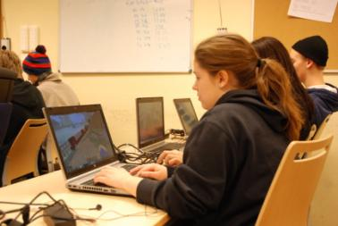

Assessment and Evaluation of the Activities, i.e., the Product

Reaction
This evaluation becomes complete at the hand-in of the report from the team but should be an on-going activity during the whole module. At every report/planning meeting there should always be room for questions about the spirit in the team and

Learning
The learning that takes place during the module is constantly evaluated. Every week of the production time starts with a meeting. The tutor is responsible for the to do list, the backlog. The backlog is the documentation and the priority of the things that have to be done to accomplish the overall assignment. The iterative nature of the model gives the tutor an excellent opportunity to follow the learning curve of the team members at every meeting.

Change/Transfer
All the participants have likely done some group oriented work in school and maybe outside of school to. A simple questionnaire that asks about their experiences of that kind of activities and what they could do in these circumstances with the competences they developed in this module.

Suitable questions are:

Then
What is the typical outcome from cooperative work in school as you see it?
How are the workload usually distributed in them?
How do they make you feel?

Now
Is there a better way to cooperate with assignments than the “normal” school solution?
Would you be able to work in a better way if you got assigned to a task together with others?

Would you?
Would you feel different, from the way you described before, if you worked like that?

Media productions
The media production in this module is not the main focus but it’s important that the outcome is evaluated as it is the final representation of success or failure for the team. The quality of the creation in Minecraft should be compared to the assignment that the customer ordered at the start of the module.

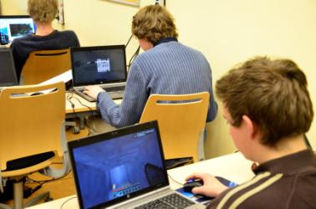

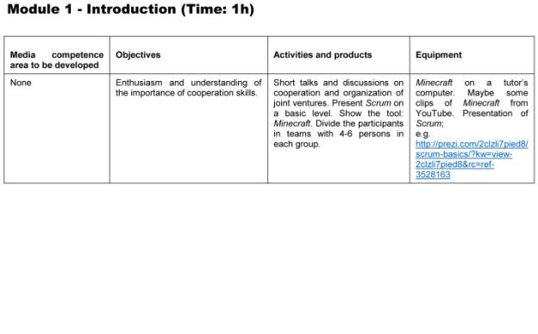

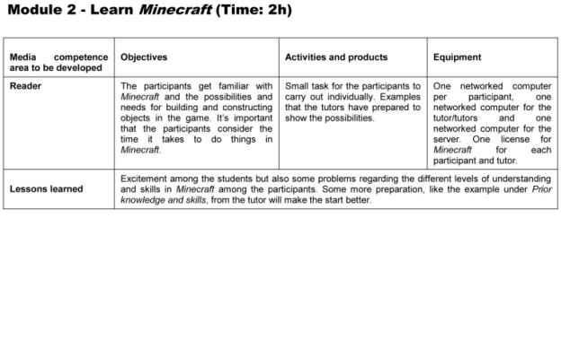

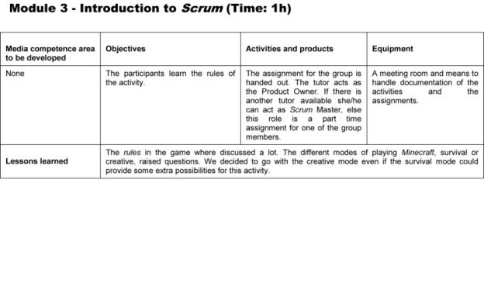

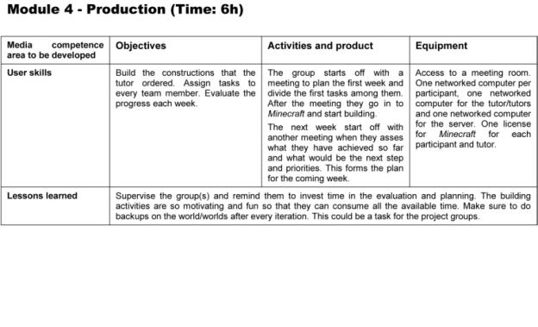
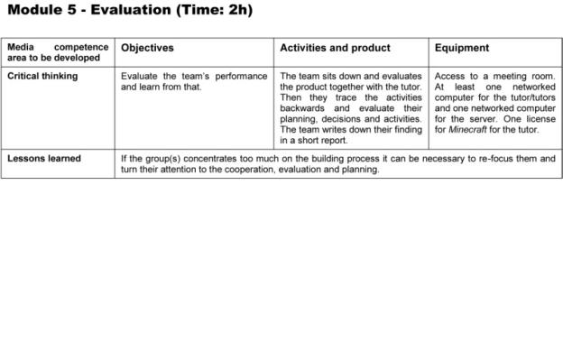
Chapter 2 - 3
SIMaging the City. The Educational Use of Video Games in a Youth Club of Palermo (Italy)
by Massimiliano Andreoletti, Gianna Cappello, Annalisa Castronovo, Marcello Marinisi and Anna Ragosta

This module starts from the basic assumption that Media Education (Media Literacy, Media Literacy Education) has a great potential in informal education contexts. As with schools, in these contexts too media can be adopted both as a tool of expression/communication/information retrieval and as an object of study in and of itself, with multifaceted - and often contradictory - implications (social, cultural, political, economic, etc.). This double level of media use in educational contexts (either formal or informal) is crucial for the development of the citizenship in the digital era, for fostering social inclusion and promotion as well as cultural and intercultural growth and exchange. Media educators operating in these contexts play the fundamental role of facilitating processes of self-reflection, dialogue, collaborative work, problem-solving and so on.
As an application of this assumption, we have carried out a series of Media Education activities in a youth club – Centro Tau – located in La Zisa, one of the most disadvantaged neighbourhoods of Palermo (Italy). In particular, we have focused on a video game – SimCity – building on the idea that “a video game is an abstract world where the subject plays a central role in all phases of the game […]. The video game can be then considered as an environment where technology is both the tool that mobilizes the playing activity and, more importantly, a world with an added value where the subject has the chance to explore, experiment, manage, interact and communicate with high levels of autonomy, interaction, presence, immersion and imagination” (Andreoletti, 2012: 153-154). Following Andreoletti’s and Ragosta’s scheme, we thought that SimCity - as all city builder games - may develop five functions that make it particularly useful in a context like Centro Tau where the relationship with the surrounding city is quite problematic given its high level of micro-criminal activity, poverty and social marginalization:
- Conception and development of the project (long-term vision of the city, identification of shared choices of development)
- Territorial planning (allocation of residential, commercial and industrial)
- Resources and services management (from choosing energy sources, to distributing social services and infrastructures to citizens, to organizing urban transportation, etc.)
- Economic and financial planning
- Assessment and evaluation of the state of the project according to the objectives set at the beginning.

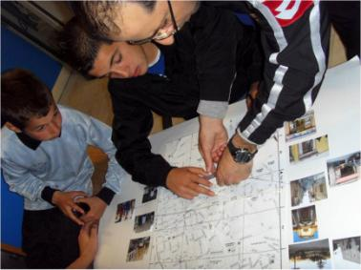

The ultimate educational aim of using a city simulation game like SimCity is not simply that of playing the part of the mayor, but more importantly of co-building an environment where participants can reflect - both individually and collectively - on the simulated city and also on the real one as they experience it daily. Therefore, we recommend that educators plan and develop all activities keeping in mind that their work must be always carried out in a constant confrontation with and analysis of the daily context where the subjects live. Furthermore, educators should keep in mind that their work ultimately aims at helping the subjects in:
- Reflecting on the fundamental choices that need to be done for the wellbeing of citizens
- Reconstructing their surrounding territory in a critical way
- Developing a sense of civic responsibility
- Understanding the different components of territorial planning and development, in particular the difference between the public and the private intervention
- Studying and understanding far-away scenarios and contexts (both culturally and geographically)
- Expressing one’s own desires and experiment one’s own choices
- Adopting solutions according to a sustainable development perspective.
We also recommend that educators:
- Develop short-time and focused activities in order to prevent attention drifts and falls
- Facilitate interaction with the most difficult parts of the game
- Facilitate the acquisition of a democratic communication mode among the participants
- Prompt the progress of the activities
- Re-organize activities according to the different situations and point of view that may emerge along the way
- Facilitate the bridging between the virtual and the real world
- Document as much in detail as possible all the activities, keeping track of all changes and solutions adopted.
After a short training of the educators working at Centro Tau, conducted by Massimiliano Andreoletti and Anna Ragosta, activities started in early March 2012 according to the three-module scheme ending in mid-June 2012. The training was focused on direct experimentation of the SimCity and has made reference to the structure of the project and the methods of intervention with the video games.
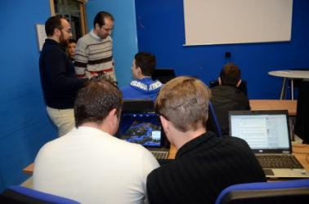

At the conclusion of the project, we can say that the young people of La Zisa, attending the youth club Centro Tau, have developed a higher civic sense towards their living context, expressing much more self-confidence in their ability to find and judge critical situations in it. In other words, they have developed a higher consciousness towards themselves and the world around them. Ultimately, our project has proven how video games can be a tool for youth empowerment inasmuch as they help increasing various specific skills at the level of either personal development or social and interpersonal relationships. Video games can also be a valid means to develop participation and a sense of active citizenship as they helped the youth in Centro Tau to think of themselves as protagonists intervening concretely in the process of change of their neighbourhood and living context

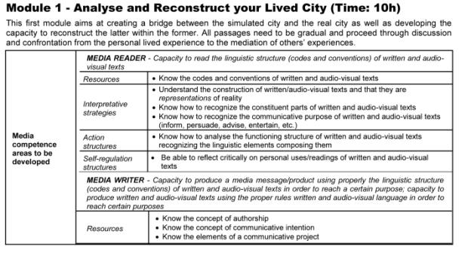

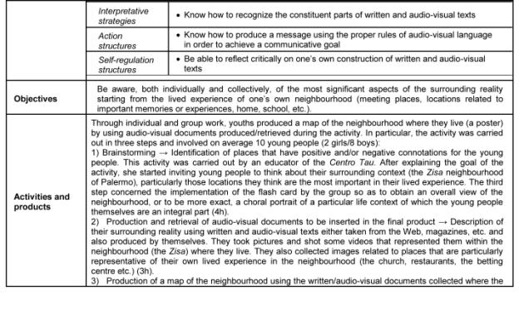

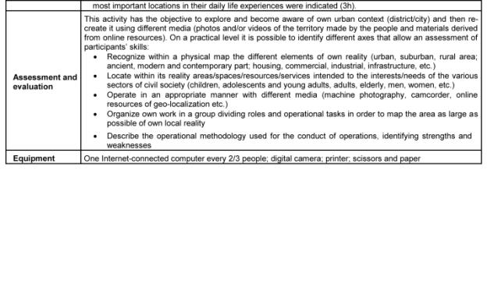

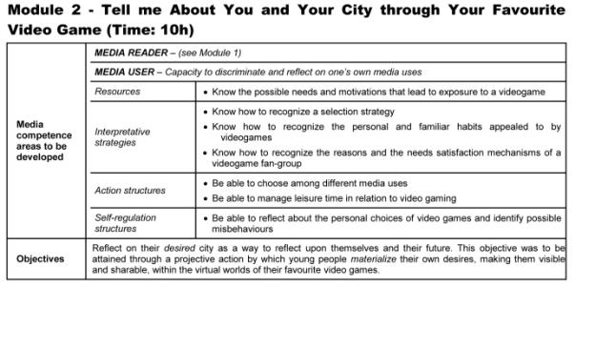

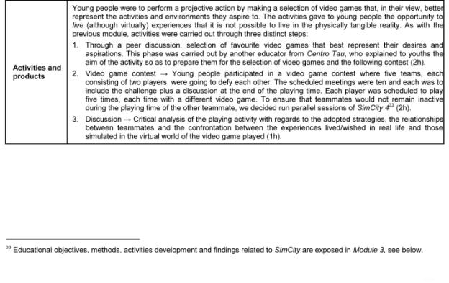

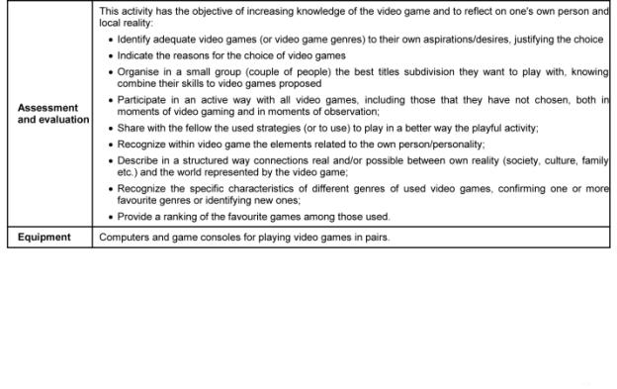

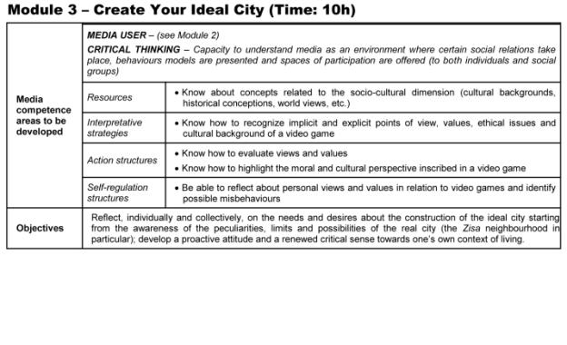

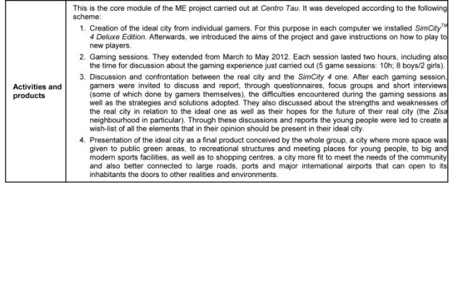
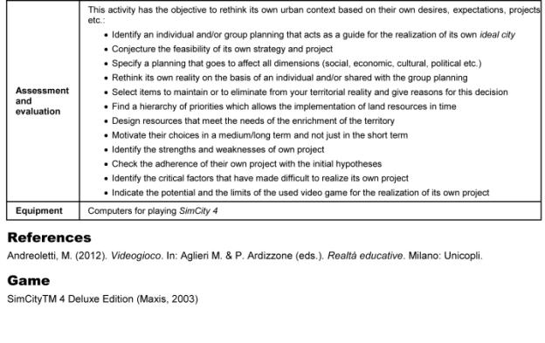
Chapter 2 - 4
EMPOWER*play (Austria)
by Michaela Anderle

For young people, gaming is a self-evident part of their daily lives in a converging media world. In our projects, we noticed a negative attitude towards games and gaming among our young participants, due to a hesitance or fear of being judged by the fact they play games. How can we encourage young people to advocate their interests and to demonstrate the importance of gaming as a modern cultural practice?
The first mission of EMPOWER*play is to address the gaming experiences of young people, to take this topic seriously and to reflect upon it: which (positive) potentials lie hidden in the act of gaming and which function does gaming serve in the daily lives of young people?
Through collective activities, the existing knowledge can be tied and made visible, so that competences and skills young people use naturally in games can be approached as a topic. Adults often rate or judge games from an observer’s point of view. The foundation for judging games is affected by media coverage about games and gamers with alarming headlines or a simple look over a gamer’s shoulder on the screen, but video games are more than one dimensional screened stories that can be judged by pure observation: playing them and trying them out by oneself are the keys to understanding games and their potential to fascinate.
To bridge this inter-generative gap, the project EMPOWER*play provokes a role switch: young participants become trainers and guides who invite adults to enter their gaming worlds pro-actively. As a highlight at the end of the project, the participants organized a gaming event and invited their significant adult others to join them. They had the chance to show their gaming expertise, as well as motivating the adults to try out chosen games and accompanying them through their first gaming attempts.

Project phases
Until now the project has been carried out twice, with similar content, but with a different time schedule.

Target group and time frame
1) The first run of the project was carried out over seven days within a period of six months with a group of ten young people between the ages of 15 and 22 from WUK m.power (a course for young people to catch up to the lowest Austrian school graduation level). The project took place on seven days with a two to three week gap in between meetings. A project day lasted 3 to 5 hours including breaks.
2) The second run of the project was carried out as a project week of five consecutive days (approximately 30 hours in total) with a group of nine young people between the ages of 15 and 23 from spacelab (a low-threshold labour-market service for youth who have a greater need for support and assistance in planning their educational and vocational future).

Trainers
two media educators (f, m) of wienXtra-medienzentrum

1) EMPOWER*play with WUK m.power
December 2011 to May 2012

Project Meeting 1: Getting to Know One Another
(Time: 2,5h incl. breaks and feedback session at the end)
The first project meeting is dedicated to getting to know one another. The participants and trainers gather information about the gaming habits of the group through partner-interviews (45 min.) and introduce each other to the group: What are currently your favourite games? Why? What is your absolute favourite game? Why? Which platforms (PC, mobile phone, console,…) and with whom do you play? What annoys you in regard to games?
The introduction offers a first opportunity to establish an open atmosphere for discourse on games and to show interest in games that were previously unknown.
Headlines from the media which condemn games and particularly their players or the public discussion on violence-promoting potentials and questions from studies serve as a basis for group discussion (1h) about how young people and adults differ in their approach to games and especially the question of the image of games and gamers that is usually conveyed in the media.
For the trainers as discussion moderators, it is especially interesting to find out how young people react to the representations in the media and what they would like to add to this image or, respectively, what they oppose to the arguments they are confronted with.
Hence, this discussion leads directly into a field of tension - namely of one’s own perception of games and gamers on one side and the public opinion on the other.
This serves also to promote a better understanding of the purpose of the closing event of the project, which is to create a common gaming session with teachers, trainers and other adults in order for them to gain more insight into digital game worlds and thus enable a more nuanced and less binary discourse.

Project Meeting 2: Gaming CV
(Time: 4,5h incl. breaks and feedback session)
The second project day is dedicated to the work on one’s own gaming CV (2h) in order to illustrate one’s own gaming experience and the existing knowledge about digital games.
In a World Café-Setting, the group collects titles of games that they have already played on a large paper tablecloth with the aim of reviving or jogging memories. This collective search for memories of childhood games offers the opportunity to initiate conversations amongst the participants and the group can discover that the experiences of each and every group member are a valuable resource as well as an aid and motivation.
We noticed that this group discussion needs time and guidance in order for the participants to perceive each other as a valuable source of experience and knowledge.
The guideline for the CV includes personal information, details of one’s gaming career and special abilities and skills in games, information on the qualities and traits of game characters,…
On the sheet, there are two empty spaces which function as place holders for photos which emerge over the course of the project, the first one being a portrait photo of oneself and the second one a picture of a game avatar or the representation of a preferred game character.
The portrait photo (2h) is taken in a subsequent photo session (here in the studio of the medienzentrum with white background, flash and digital single lens reflex camera).
After a short technical introduction to portrait photography and studio photography, the participants form teams of two and take each other’s portrait photos. Of course there is enough time to experiment and take snapshots in the studio afterward.

Project Meeting 3: Representation in the Game
(Time: 4,5h incl. breaks and feedback session)
While the preceding day centred on the questions: Who am I? How do I present myself?, this day focuses on the questions: Who am I in the game? What are my skills and abilities? What does my avatar look like?
At the beginning of the project day, all of the photos from the last project meeting are projected onto a screen and subsequently talked about. This discussion on the photos offers a basis to talk about the do’s and dont’s in the handling of photos and rights in connection to photographic images (1h).
As an introduction to the new subject, the group and trainers discuss traits and characteristics which are required in order to succeed in the game. They do so with the aid of differentiation exercises (1h).
Once a participant names a trait/characteristic, they look for like-minded people in the group. Hence, skills that the participants discover in games can be found and collected (e.g. ability to work in a team, communication skills, patience etc.).
These groups are documented photographically, so that this photographic collection of skills can be exhibited at the final gaming session at the end of the project. In this way, the collected skills become visible - in the truest sense of the word - to the visitors.
In the second photo-method (shadow theatre, 2h), the participants look into the subject of their own representation in games. For this purpose, equipped with various props and costumes, they re-enact their favourite game character or favourite avatar behind a secret curtain.

Project Meeting 4: Planning of the Closing Event
(Time: 4,5h incl. breaks and feedback session)
On the fourth day, detailed planning of the closing event (a gaming session) begins. In this first run of the project, this event took place about seven weeks later.
The World Café-tablecloth with the collection of games from the second project day is developed further (1h) by classifying and sorting the games into different colours and then assigning them to different genres. The aim is to create a discussion about the various existing game genres, age restrictions and the popularity of the individual genres within the group.
A PC was available for internet research (e.g., http://www.pegi.info). A photo of this colourful and diverse collection of games serves as an invitation to the final closing event. The rest of the day is dedicated to discussing and planning the closing event and allocating the necessary duties and responsibilities: the production of invitations; Who invites whom?; Who is willing to guide the gaming session?; Which games should be shown and played? (2h)
Since a lot of mental work is required on this day of the project, it concludes with an hour of playing games together (for example movement based games like Kinect Adventures (Xbox 360).

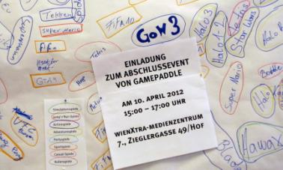

Project Meeting 5: Mobile Phone Video
(Time: 5,5h incl. breaks and feedback session)
The fifth day of the project is dedicated to the joint effort of producing a mobile phone video. There is a loose thematic guideline: games. After a brainstorming session on what would be suitable as a short clip, the group decided to shoot a video riddle that they could show their trainers at the closing event. A short clip to FIFA 12 was produced - and the challenge for the visitors of the closing event was not to guess the term football, but instead the title of the game, FIFA.
Since this is also the last meeting before the gaming session, all organisational duties are discussed again and the current situation of the different areas of responsibility are clarified and laid out.

Project Meeting 6: Closing Event
(Time: 5h incl. breaks and feedback session)
Two hours before the guests arrive, a dress rehearsal takes place with the group.
The moderators ponder and think about the welcoming words and the explanation of the events to follow. The participants who introduce and instruct a game in teams of two prepare the consoles etc. In total, four gaming stations were set up for the visitors: Need for speed most wanted (Playstation2), Mario Kart (Gamecube), Little big planet (Playstation 3) and FIFA 12 (Xbox 360).
After the welcome address or greeting, the introduction to the project, the reference to the exhibition of the gaming CVs and the skill-photographs as well as the explanation of the process of the gaming session by the moderators, the visitors were taken to the individual stations of the exhibition by the young gaming guides, where they spent about twenty minutes at any one time.
Two of the participants kept an eye on the time schedule and asked the visitors to change stations when the time was up.
Some of the visitors showed signs of mild frustration when they had to interrupt the game after twenty minutes.
After two hours, the closing event was over and the participants received great applause from their guests.

Project Meeting 7: Reflection of the Project
(Time: 2 hours incl. a break)
At the end of the project there is enough time to take another look at all the (media-)products that were created and developed over the course of the last months - and also to reflect upon impressions of the project in general and, specifically, the closing event. The participants receive their certificate of participation with individual notes from the trainers on what they contributed to the success of the project.

2) EMPOWER*play with spacelab
MO 10th - FR 14th September 2012

This run of the project run took place on five consecutive project days in the course of one school week and was completed with a short meeting of reflection after several weeks. On the basis of the experiences of the first project run of EMPOWER*play, we took the opportunity to carry out some changes in regard to content. The run of the project will only be outlined in note form if content is identical to the first project. New content or methods will be described briefly.

Project Meeting 1: Getting to Know Each Other and Gaming Biography
(Time: 6h incl. breaks and feedback session)
Partner-interviews (30 min.), Input and group discussion on the public perception of gaming and gamers (1h), discussion and collection of gaming experiences in a World Café-Setting (1h), differentiation exercises on traits, characteristics and skills in games with photo documentation (1h).
During this run of the project, we decided against form and function of a gaming CV.
A CV is strongly aimed at outwardly presenting skills and activities. However, the focus should lie in one’s own biographical reflection. Hence, work on one’s own gaming biography (1h) was taken up.
The medium that served this purpose was the free online-tool „Padlet“, through the use of which participants were able to construct a pinboard on which they could collect notes and various web sources (pictures, videos,...) to their own respective gaming biography.
The work on this gaming-bio-pinboard can be continued throughout the course of the project week.

Project Meeting 2: Gaming Biography
(Time: 6h incl. breaks and feedback session)
In order to lead up to the situation of talking about and introducing games in front of a group, a task related to the gaming-bio-pinboard is set: collecting information on a game which is particularly dear to one’s heart (the first game, the best game, the most recent game,...) and subsequentally presenting it to the group (pictures, fan art, walkthrough-videos, let’s play-videos, Information on makers and producers etc.) (2,5h).
Afterwards, as before, a portrait photo-session takes place in the photo studio to offer the opportunity of posting a photo of oneself onto the gaming-bio-pinboard. (3h)

Project Meeting 3: Planning of the Closing Event
(Time: 6h incl. breaks and feedback session)
Detailed planning of the closing event (4h), which took place two days later in this project (Who presents which game? Who is responsible for which assignment (e.g. moderation/guidance, keeping an eye on the time schedule, caring for the guests,...).
On this project day there is also the opportunity for active gaming in order to determine the computer games that will be presented at the closing event. The focus of the gaming lies on finding out how the game can best be explained. The gaming-bio-pinboard can be used as a backup and aid not only in the preparation, but also in the explaining of the game. The rest of the day (1h) served as a preparation for the next unit of the project: since the recording of an interview in the TV studio of the medienzentrum was planned for the following project day, a short briefing on the interviewee (Karina Fallent, project worker of the BuPP - “the Federal Office for the Positive Assessment of Computer and Console Games”) was carried out. In the course of the presentation of tomorrow’s interview partner, a group discussion developed and brought to light specific topics that the participants wanted to discuss with Karina Fallent the next day.

Project Meeting 4: Production of the TV Interview, Set-up for the Closing Event
(Time: 6h incl. breaks and feedback session)
The fourth day of the project is dedicated to the production of an interview programme, which has many advantages for the project: for one, it is an opportunity to invite experts with which topics concerning gaming can be discussed, and for another, a live production is a good chance for a group of young people to feel that they are all part of a team and in that, effective at putting together a project.
After a 2-hour introductory workshop about live-editing in the TV studio, where everyone has the opportunity to try out all the required positions (interview-situation in front of the camera, camera person, directing), the roles for the actual production are decided on.
In this project, there were two interviewers, two camera people, two directors who were also responsible for the video mixer, one production manager and one person who was responsible for the time schedule (the interview was limited to 15 minutes).
The interviewers raised the topic of media violence and transfer and discussed the Austrian model of positive assessment of computer and console games with Karina Fallent. The finished interview was originally only planned for internal use, but after re-watching their work with pride, the participants made the decision to show it at the next day’s closing event.

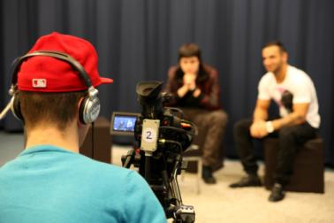

In the final two hours, the consoles are set up for the following day and the rooms are prepared.

Project Meeting 5: Closing Event - “Gaming Matinée”
(Time: 3h incl. breaks and feedback session)
Since this run of the project took place in the course of one week, we were able to send invitation flyers to spacelab in advance, so that they could be distributed to trainers and teachers. This time, we only had half an hour to prepare and rehearse before the guests arrived. The process of the closing event was identical to the one in the first run of the project: reception and welcoming words, gaming session (Minecraft, Spyro the dragon, FIFA 12, Tekken), watching the interview together, receiving feedback from the guests, celebrating - and being celebrated.

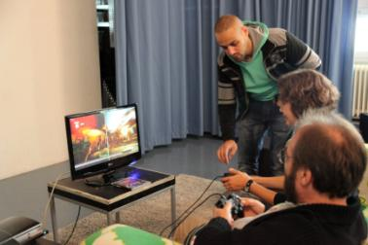

Project Meeting 6: Reflection of the Project
(Time: 1h)
Reflection of the project, certificate of participation, feedback

Reflection, Challenges, Conclusions
At the beginning of the project, the participants had some difficulty in understanding why the reflection on games and the gaming experience could be of importance to them. By the end, they had all come to the realisation that their own gaming experiences and the knowledge thereof are valuable resources for instructing and accompanying their adult guests in a competent manner.
The diversity of methods of the action-orientated media work (video, photo,...) that was used to approach the subject of computer games paid off, because the group methods proved to be important for the dynamics and the enjoyment of working creatively.
Of course, it was equally valuable for the participants to reach goals as a group - and that in the final media productions, the group’s achievement was visible as well as individual inputs. Another advantage was those participants that were not as familiar with computer and console games could also take on an active part in the project.
For many of the participants, it was their first public speaking experience in front of an adult audience. At the beginning of the project, they had little confidence in taking on this role because of speech problems and consequently, fear of speaking in front of a group etc. After the common gaming event, the participants were visibly proud to have mastered a challenge not only with regard to content, but on a personal level. It is very likely that they were able to overcome this obstacle because they spoke about games that were of importance to them and they were able to convey this in a passionate manner.
During the course of the project, the participants could partly use and activate their gaming experiences as sources of self-confidence and self-effectiveness. For them, it was especially valuable to receive attention and respect from the adults.
The participants visibly enjoyed demonstrating their expertise and were successful in giving the visitors a relaxed introduction to the gaming world. Both sides were able to profit from the role-reversal (teachers/pupils); for one, the young people had the experience of being and feeling effective, as is illustrated by the statement of one of the participants (17 years old) after the project: “I really had something to say and they listened. Everyone went home with a smile, that was the most beautiful thing!” Furthermore, an understanding and appreciation of the teacher-situation developed in the participants. They reached the limitations of what is explainable and learned that one and the same explanation is not necessarily understood in the same way by all and that an individual response to the Vis-à-vis is required: “I never knew that ‘teaching’ was so difficult.”

Media competence areas to be developed according to chapter 1.6 | Reading | - Knowing the genres of games  - Reflecting on games in connections to other media  - Being able to read up on games and to evaluate information
 | Writing | - Creating a media product with mobile phone (recording, editing, presenting)  - Creating a media product in a TV studio (Interview)
 | User/Consumer | - Reflecting on personal use of video games  - Reflecting on rights concerning photos and images (copyright, personal rights)
 | Critical/Social | - Knowing the rating systems like PEGI  - Taking part in discussions about video games  - Reflecting on the image of gamers and how it is constructed through media

Games
FIFA 12 (Electronic Arts, 2011)
Kinect Adventures (Microsoft Game Studios, 2010)
Little Big Planet (Sony Computer Entertainment, 2008)
Mario Kart (Nintendo, 2003)
Minecraft (Mojang, 2009)
Need for Speed most wanted (Electronic Arts, 2005)
Spyro, the dragon (Sony Computer Entertainment, 1998)
Tekken (Namco Bandai Games, 1994)

Chapter 2 - 5
Card Game Design. Designing a Card Game about Video games
by Sebastian Ring

The objective of this project is to collaboratively create a card game that deals with video games. There are two aspects which are especially interesting: Firstly, the project is action orientated. Young people work together in groups and create something together, which manifests their success as a team and can be presented to others. Secondly, while creating their card game the youths are reflecting on one of their main interests in a critical and creative way: video games. Thereby they have to describe to their group how their favourite games work and what makes them special. By creating an own card game the participants get insight into the iterative process of game design, especially creating artwork, defining rules, beta testing and much more.
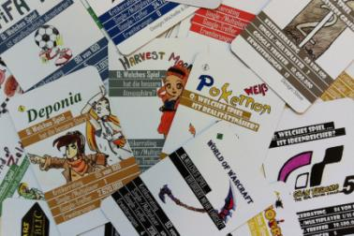
The model project took place in a lower education level school in Munich, Germany. The 25 participants were at the age of 13 to 15 years.

Prior knowledge and skills

Learners:
- Knowledge of video games
- Drawing skills
- (Using scanners or digital photo cameras, using digital image manipulation software like Photoshop or GIMP. Usually there are at least a few group members who have these skills and can share their knowledge with others; if not, the tutor has to instruct them)

Tutors:
- Moderating group work
- Knowledge of copyright laws and creative commons license
- Knowledge of online royalty-free stock image databases
- Knowledge of content rating systems like PEGI or youth protection laws
- (Using scanners or digital photo cameras, using digital image manipulation software like Photoshop or GIMP in case there are no group members who can share their skills)

Location
Depending on the size of the group there should be enough room to be able to meet all group members and discuss with them as well as enough tables and chairs for small working units of groups of maximum four people.

Time
Ca. 12 hours

Age
Depending on the kind of card game created and the video games that are to be featured in it, this project can be put into practice with children or adolescents from an age of 10 years.

Resources
- Different kinds of card games (the group members should bring their favourite card games, a great inspiration is the Metagame by game design collective Local No. 12)
- Paper and tape, post it stickers for notes (online mind mapping tools might be used alternatively)
- One laptop with internet connection for each group of four
- Drawing material (pens, crayons, paper, water colours, material for creating stencils, …)
- A scanner or digital photo cameras
- A printer and heavy weight paper (alternatively you could let the cards be printed by game card printing companies; a set will cost around 20,- EUR)
- A photo camera for documentation

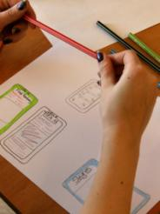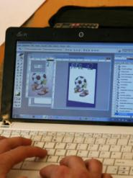

Objectives and Areas of Media Competence

General objectives
- Reflection on video games
- Learning about game design
- Working in teams

Specific objectives
- Presenting favourite video games
- Creating a card game
- Presenting the game to others and playing it

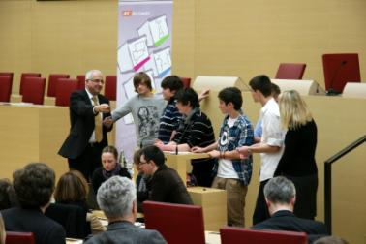

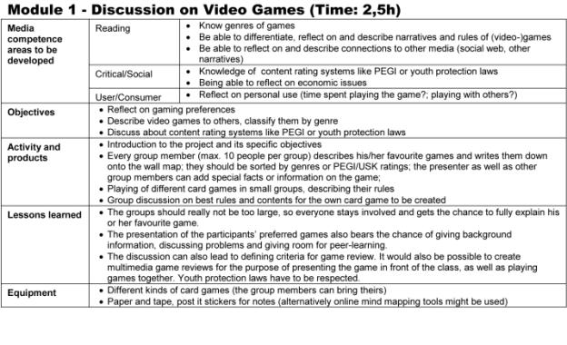

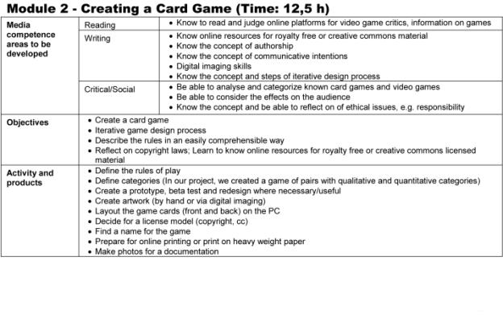
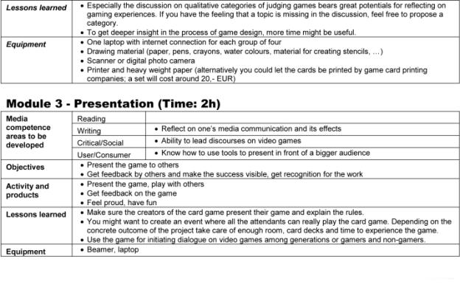

Tools

Here you can find some of the tools that were used or created within the Gamepaddle projects.

Video Game Evaluation Tool

This evaluation tool developed by Massimiliano Andreoletti provides instructions and materials for school use. It helps analyse video games, their narratives, values, characters and avatars, genres, hardware, social aspects like team play, identity-related aspects and more. The evaluation tool is published under creative commons license CC 4.0 international BY – NC – SA and can be downloaded from the www.gamepaddle.eu as .docx and .odt file.

World of Creative Cards
The card game has been created by a class of teenagers in the German project (Card Game Design). Playing it encourages the reflection and discussion about video games. The students published the game under creative commons license by-na-sa. It can be downloaded from www.gamepaddle.eu as printable .pdf.
One inspiration for creating the designed World of Creative Cards was the card game Metagame by Local No. 12, that can be purchased via www.localno12.com/games

MinecraftEdu.com
In the Swedish project (Cooperation in Minecraft) the essential tool was the indie game Minecraft by Swedish game collective Mojang. For educational purposes the website www.minecraftedu.com provides a lot of useful information.

Padlet.com/ Wallwisher
In the Austrian project (EMPOWER*play), an online pinboard tool has been used to collect online source and document ideas and the projects’ process. It can be used without cost at www.padlet.com.

CC by Brett Jordan @ flickr
Chapter 3
About the Authors

Michaela Anderle
wienXtra-medienzentrum,
Vienna, Austria, www.medienzentrum.at
Email: michaela.anderle@wienXtra.at
Twitter: @michianderle
Instagram: michaela.anderle

What makes your institution special?
The wienXtra-medienzentrum is a unique learning and experimental environment for media production. On the one hand the centre supports young people up to the age of 22 in their first media experiments, e.g. short films, photography etc. On the other hand the wienXtra-medienzentrum also offers services for youth workers and teachers who are doing media education. For both target groups the wienXtra-medienzentrum provides equipment rental, editing suits, workshops, advice and much more.

Which video game or genre describes your work best?
Action adventure, definitely! Talking to the right people at the right time to solve problems, or having hints for others to get over obstacles. Sometimes there are single-player jump-and-run passages on the way, but most of the time we’re playing in multiplayer-mode.

Which video game or genre describes you as a person best?
Adventure! You have to handle a complex, multi-layered narration, fully packed with riddles, searching for objects of desire (finding them without cheating^^) accompanied by lots of characters helping you to get to the next level.

Which institutions in fields of media and games education would you turn to in your country?
Austrian Players League (www.apl.at)
BuPP (www.bupp.at)
Game City (www.game-city.at)
Subotron (www.subotron.com)
SUPRO with the project Reflect and Act (www.supro.at)
wienXtra-spielebox (www.spielebox.at)

Which is the best literature to start (in your native language)?
Various inputs concerning games and gaming culture from different perspectives:

Mitgutsch, K. and H. Rosenstingl. (Eds.). (2008). Faszination Computerspielen. Theorie – Kultur – Erleben. Wien: Braumüller.

Vienna’s annual GamesConference, “Future and Reality of Gaming” (FROG), offers an open and international platform for leading game studies researchers and scholars, game designers, researchers and scholars from various other fields, education professionals, and gamers from around the world. Fortunately there are three books with lots of articles and text from the last Conferences:

Mitgutsch, K. and Ch. Klimmt, H. Rosenstingl. (Eds.). (2010). Exploring the Edges of Gaming. Proceedings of the Vienna Games Conference 2008-2009: Future and Reality of Gaming. Wien: Braumüller.
Swertz, Ch. and M. Wagner. (Eds.). (2010). Game Play Society. München: kopaed.
Mitgutsch, K. and H. Rosenstingl, J. Wimmer. (Eds.). (2012). Applied Playfulness. Proceedings of the Vienna Games Conference 2011: Future and Reality of Gaming. Wien: New Academic Press.
Mitgutsch, K., Huber, S., Wagner, M., Wimmer, J., & H. Rosenstingl. (Eds.). (2013). Context Matters! Exploring and Reframing Games in Context. Proceedings of the Vienna Games Conference 2013. Wien: New Academic Press.

Massimiliano Andreoletti

Università Cattolica del Sacro Cuore - Largo Gemelli 1, 20123, Milano, Italia
Email: massimiliano.andreoletti@unicatt.it
Twitter: @massimilian
Skype: briolini1113
LinkedIn: http://www.linkedin.com/in/
massimilianoandreoletti
Facebook https://www.facebook.com/
massimiliano.andreoletti

What makes your institution special?
In my università, there are several research centres that are studying the media from different perspectives: educational, sociological, semiotic, social, and economic.

Which video game or genre describes your work best?
I think that the puzzle game and the city builder simulator game are the two genres of video games that represent my job in the best way. In the last years I like to play video games on my mobile devices (tablet and smartphone) instead of playing them only on pc or console.

Which video game or genre describes you as a person best?
I think that Valve's Portal 2, Monument Valley, Framed, Ubisoft's Valiant Hearts, Minecraft, and Stacking describe me, since I am a complex person that is difficult to understand.

Which institutions in fields of media and games education would you turn to in your country?
In Italy there are different realities that deal with media on a different level and for different reasons. By reducing the scope to video games, unfortunately, it is possible to identify only the private institutions connected with the video games’ producers/distributors or single persons’ activities:
AESVI (Associazione Editori Software Videoludico Italiana): www.aesvi.it
Archivio Videoludico: www.cinetecadibologna.it/archivi/videoludico
ViGaMus (video game museum): www.vigamus.it

Which is the best literature to start (in your native language)?

Felini, D. (Ed.). (2012). Video Game Education. Milano: Unicopli.
Bittanti, M. (Ed.). (2004). Per una cultura dei videogames. Milano: Unicopli.
Bittanti, M. (Ed.). (2005). Gli strumenti del videogiocare. Milano: Unicopli.
Gee, J.P. (2013). Come un videogioco. Milano: Raffaello Cortina.
Anolli, L. & F. Mantovani. (2011). Come funziona la nostra mente. Bologna: Il Mulino.
McGonigal, J. (2011). La realtà in gioco. Milano: Apogeo.
Bartolomeo, A. & S. Caravit. (2005). Il bambino e i videogiochi. Napoli: Edizioni Carlo Amore.
Pecchinenda, G. (2010). Videogiochi e cultura della simulazione. Bari: Laterza.
Maietti, M. (2004). Semiotica dei videogiochi. Milano: Unicopli.
Loguidice, B. & M. Barton. (2009). Vintage Games. Milano: Edizioni Raganella.

Gianna Cappello
Department of Culture and Society, University of Palermo, Italy.
Email: gianna.cappello@unipa.it

What makes your institution special?
It is a place where I can teach and do research in a supportive and multifaceted environment.

Which video game or genre describes your work best?
Simulation games describe my work best. I can plan and implement my “world” together with many other people. Cooperative work and action research are my favourite working modes and simulation games are a perfect metaphor for that.

Which video game or genre describes you as a person best?
Lara Croft in Tomb Raider. I like the unexplored and the challenging, and Lara Croft is a good embodiment of that.

Which institutions in fields of media and games education would you turn to in your country?
AESVI (Associazione Editori Sviluppatori Videogiochi Italiani: www.aesvi.it/index.php)
Videogames Education (http://www.videogameducation.it/)
www.videoludica.com

Which is the best literature to start (in your native language)?
AESVI, Rapporto annuale sullo stato dell’industria videoludica italiana (www.aesvi.it/cms/attach/editor/Rapporto_Annuale_2011.pdf., 2011). The latest report on the state of the Italian video game industry
Antoniazzi, A. (2007). Labirinti elettronici. Letteratura per l’infanzia e videogame. Milano: Apogeo.
A study on the relationship between video games and children’s literature
D'Armenio E. (2014). Mondi paralleli: ripensare l'interattività nei videogiochi. Milano: Unicopli.
A study on the use and function of interactivity in video games.
Bittanti M. & H. Lowood. (Eds). (2013). Machinima! Teorie. Pratiche. Dialoghi. Milano: Unicopli.
A very good introduction to the field of machinima including the main theories and some quite interesting examples.
De Santis L. (2013). Videogaymes. Omosessualità nei videogiochi tra rappresentazione e simulazione (1975-2009). Milano: Unicopli.
A book about the representation of homosexuality in video games.
Felini, D. (Ed.). (2012). Video game education. Studi e percorsi di formazione. Milano: Unicopli.
A book about the use of video games in educational contexts.
Cavaleri, A. (Ed.). (2010). Videogiochi e marketing. Brand, strategie e identità videoludiche. Milano: Unicopli.
A book about video games, marketing and brand strategies.
Bittanti, M. (Ed.). (2008). Intermedialità. Videogiochi, cinema, televisione, fumetti. Milano: Unicopli.
A cross-media analysis of video games.

Annalisa Castronovo
MED media education – Italian Association for Media Education and Communication (Piazza Ateneo Salesiano, 1, 00139 – Roma; tel.: + 39 - 06 – 87290296, fax: + 39 - 06 - 87290698; Web Site: http://www.mediaeducationmed.it).

What makes your institution special?
MED is a kind of “bridge” that connects those who are sensitive to issues related to media education and those who want to put effort into a new quality of communication that respects the dignity of the person and open to solidarity; in addition, it promotes the study of media; it takes care of stimulating critical attention to the social structures and economic and political influence of the media; among other things, it is a laboratory of ideas and training of experts in the field of education as well as in the field of communication (see http://www.mediaeducationmed.it). Therefore, MED is – according to me – a fundamental piece in contemporary social framework to make use of the media safe and stimulating. Its contribution expands the potential use of various media by leveraging the capabilities of people involved.

Which video game or genre describes your work best?
Strategy games is the genre which best describes my work in the field of media education. In fact, when I have to move from the planning to the application field it is necessary to adapt the project to real conditions. This requires some skills that are similar to those useful in strategy games, especially when dealing with action research.

Which video game or genre describes you as a person best?
Adventure games best describe me as a person because they offer the chance to discover new “worlds”, little at a time and to evolve from game session to game session as the storyline progresses. Hence my desire to participate in new discoveries is best satisfied by that genre.

Tobias Härnvi
Karlstad International TIME Program
Älvkullegymnasiet
Karlstad municipality
Tel: +46 545401811
Mob: +46700015823
Email: tobias.harnvi@karlstad.se

What makes your institution special?
Karlstad International TIME Program is a state of the art upper secondary school developed through the co-operation between the City of Karlstad, the IT Foundation Compare Karlstad, and the University of Karlstad. The TIME-students may choose from a variety of university programs such as Media- and communication science, Computer science or Master of Science in Engineering programs.

Which video game or genre describes your work best?
Massively multiplayer online game. A lot of interaction between students and teachers, both in real life and online.

Which video game or genre describes you as a person best?
SimCity. Constantly planning, inventing and troubleshooting to build the perfect educational experience.

Which institutions in fields of media and games education would you turn to in your country?
Other schools and Statens medieråd, www.statensmedierad.se

Which is the best literature to start (in your native language)?
Att leva i World of Warcraft; a study of MMORPG (Massively Multiplayer Online Role-Playing Game)-playing teenagers. Available in English. Swedish Media Council.
Våldsamma datorspel och aggression – en översikt av forskningen 2000–2011; violent computer games and aggression – an overview of the research 2000-2011. English summary available. Swedish Media Council.

Marcello Marinisi
Centro TAU Palermo – Associazione “Inventare Insieme (onlus)” (Via Cipressi, 9 – 90134 Palermo; tel. +390916526394 - fax +390910523282; http:// www.mediatau.it; email: in_in@neomedia.it)

What makes your institution(s) you work for/represent special?
What makes the TAU Centre special is its relationship with the neighbourhood and with people. The operators of the Centre take care of the social activity of a place among the most disadvantaged of the city of Palermo and do so with dedication and diligence in spite of the great difficulties that they face every day in a rough neighbourhood and with guys with a future at risk.

Which video game or genre describes your work best? In short words: Why?
The game that best represents my work is The Sims. Almost like in the game, in fact, I need to observe the behaviour of individuals trying to understand it and explain it, within the limits of my personal perspective and having in each case a partial view of reality.

Which video game or genre describes you as a person best? In short words: Why?
Reflecting on the various games, the one that can best represent me as a person is Civilization (the entire series). What I appreciate most of Civilization is the possibility of trace the history of mankind through the great alternate events of the people who have crossed to the continuous pursuit of knowledge with an eye to the past and one in the future. This last feature is the one that most reflects me.

Ida Pöttinger
GMK Association for Mediaeducation
www.gmk-net.de
Email: gmk@medienpaed.de

What makes your institution special? The GMK Association for Mediaeducation and their members work steadily on the relation between media development, education and media literacy.

Which video game or genre describes your work best?
Forge of Empires: because it depends on the coalitions and power to reach objectives.

Which video game or genre describes you as a person best?
Hero Zero, because I am no hero

Which institutions in fields of media and games education would you turn to in your country?
JFF Institut für Medienpädagogik
SIN – Studio im Netz e.V.
www.spielbar.de (Bundeszentrale für politische Bildung)

Which is the best literature to start (in your native language)?
Medienpädagogischer Forschungsverbund Südwest: FIM 2011, Familie, Interaktion und Medien. Stuttgart 2012.
(research about media use in families)
Wagner, U., Gebel, Ch., & C. Lampert. (Eds.). (2013) Zwischen Anspruch und Alltagsbewältigung: Medienerziehung in der Familie. unter Mitarbeit von Eggert, S., Schwinge, Ch. & A. Lauber. Berlin: Vistas.
(research about media behaviour of kids and adolescents in families)

Anu Pöyskö
wienXtra-medienzentrum, Vienna, Austria, www.medienzentrum.at
Email: anu.poeyskoe@wienxtra.at
Twitter: @wienxtra_mz @anu_p

What makes your institution special?
For over 30 years, medienzentrum has been developing educational approaches and methods for how to make sense of the media. Our work has a “hands on” emphasis: getting active and doing one’s own media productions is the best way to understand, how media works.

Which video game or genre describes your work best?
An open world adventure game. Media education, basically, is about discovering new worlds and learning to make one’s own decisions there. And there is plenty of space for creativity.

Which video game or genre describes you as a person best?
If I’m having a bad day: Jump and run!

Which institutions in fields of media and games education would you turn to in your country?
Medienbildung JETZT (www.medienbildungjetzt.at) is an active network of Austrian media education in theory and practise.
Medienimpulse (www.medienimpulse.at) is the Austrian online journal on media education.
Mediamanual (www.mediamanual.at) is an interactive platform of the Austrian ministry of education, supporting teachers in the field of media education.
saferinternet.at (www.saferinternet.at) provides a wide range of up to date -information on media and delivers workshops for children and young people, teachers and parents.
At wienXtra-medienzentrum (www.medienzentrum.at), we offer advice and training for Viennese educators, who plan media educational activities with their target groups. We also have a public access library specialised on media education.
Institut für Medienbildung (www.aktionfilm.at) offers a wide range of media educational activities in the Austrian provinz Salzburg.
The community radio and television stations in Austria are all active agents of media education (www.freie-radios.at).

Which is the best literature to start (in your native language)?
Haeusler, T. & J. Haeusler. (2012). Netzgemüse. Aufzucht und Pflege der Generation Internet. München: Goldmann.
A guide for how to parent the internet generation. Actual and highly amusing, recommendable also for educators.

Rosenstingl, H. & K. Mitgutsch. (2009). Schauplatz Computerspiele. Wien: Braumüller.
A good basic guide to the culture of games and gaming.

Fritz, J. (2004). Das Spiel verstehen. Eine Einführung in die Theorie und Bedeutung. Weinheim und München: Juventa.
Fritz’ concept of “framing” offers a good way for understanding how we interact with and make sense of the media.

Rösch, E. & K. Demmler. (Eds.). (2012). Medienpädagogik Praxis Handbuch. Grundlagen, Anregungen und Konzepte für aktive Medienarbeit. München: kopaed.
A huge and inspiring collection of methods for media projects with children and young people.

Anna Ragosta
Università Cattolica del Sacro Cuore - Largo Gemelli 1, 20123, Milano, Italia
Email: anna.ragosta@unicatt.it
Twitter: @AnnaRagosta
Skype: mistura_fina1

What makes your institution special?
In my università, there are several research centers that are studying the media from different perspectives: educational, sociological, semiotic, social, and economic.

Which video game or genre describes your work best?
I think that the puzzle game and the city builder simulator game are the two genres of video games that represent my job in the best way.

Which video game or genre describes you as a person best?
I think Monument Valley and Fez, because they are elegant, profound, versatile, colourful, and fun.

Which institutions in fields of media and games education would you turn to in your country?
In Italy there are different realities that deal with media on a different level and for different reasons. By reducing the scope to video games, unfortunately, it is possible to identify only the private institutions connected with the video games’ producers/distributors or single persons’ activities:
AESVI (Associazione Editori Software Videoludico Italiana): www.aesvi.it
AIOMI (Associazione Italiana Opere Multimediali Interattive): www.aiomi.it
Archivio Videoludico: www.cinetecadibologna.it/archivi/videoludico
Game Journal: www.gamejournal.it
Ludica: www.ludica.eu
Which is the best literature to start (in your native language)?
Felini, D. (Ed.). (2012). Video Game Education. Milano: Unicopli.
Bittanti, M. (Ed.). (2004). Per una cultura dei videogames. Milano: Unicopli.
Bittanti, M. (Ed.). (2005). Gli strumenti del videogiocare. Milano: Unicopli.
Gee, J.P. (2013). Come un videogioco. Milano: Raffaello Cortina.
Ferrari, D. & L. Traini. (Eds.). (2013). Arte e videogames. Milano: Skira.
McGonigal, J. (2011). La realtà in gioco. Milano: Apogeo.
Nardone, R. (2007). I nuovi scenari educ@tivi del videogioco. Bergamo: Edizioni Junior.
Cantoia, M., Romeo, L. & S. Besana. (2011). Figli e videogiochi. Brescia: La Scuola.
Lovecchio, S. (2012). Apprendere con i videogiochi? San Cesario di Lecce: Pensa Editore.
López, X. (2010). Videogiochiamo dunque impariamo? Roma: Edizioni Nuova Cultura.

Sebastian Ring
JFF – Institute for media research and education
www.jff.de, Twitter: @ jff_de
Email: sebastian.ring@jff.de
Twitter: @s_ring
What makes your institution special?
Combining empirical research and educational practice is characteristic of the working methods of the JFF. Research results form the basis of educational schemes for educational, developmental, and cultural work with children and adolescents.
Which videogame or genre describes your work best?
That might be some realtime multiplayer strategy game that challenges in complexity, creativity and managing resources.
Which videogame or genre describes you as a person best?
A story-driven, open-world metropolitan adventure game that has yet to be finished, maybe developed by an independent studio and released online as early beta.
Which institutions in fields of media and games education would you turn to in your country?
I would point you to three networks and one association:
Gamescamp – the barcamp for young gamers (www.gamescamp.net)
FRAME – network of educational media centers
(www.frame-info.de)
Interaktiv – Munich network media competence
(www.interaktiv-muc.de)
GMK – Association for Media Education
(www.gmk-net.de)
Which is the best literature to start (in your native language)?
Demmler, K., Lutz, K. & S. Ring. (Eds.). Computerspiele und Medienpädagogik. Konzepte und Perspektiven. München: kopaed.
Geisler, M. (2009). Clans, Gilden und Gamefamilies. Soziale Prozesse in Computerspielgemeinschaften. München: Juventa.
Quandt, T., Wimmer, J. & J. Wolling (Eds.): Die Computerspieler. Studien zur Nutzung von Computergames. Wiesbaden: VS Verl. für Sozialwiss.
Schorb, B., Anfang, G., & K. Demmler. (Eds.). Grundbegriffe Medienpädagogik Praxis. München: kopaed.

Machinima an abbreviation for machine cinema or machine animation means a kind of movie that uses techniques of digital animation created with interactive video games with a 3D graphics engine. The videogame which is used for purposes different from the intentions of the game designer becomes the environment and the tool for scripting, creating and producing audiovisual products, which in some cases are true feature films. The first realizations were born in 1996 with the use of the graphics engine of Quake, but it was with the video game The Movies, published at the end of 2005, that the phenomenon has grown in importance and dissemination.
In the presented model, the terms exploration and mastery are referred to adult subjects. We are aware that Piaget’s theory intends to these terms even and especially in very young subjects (first years of life), whose acquisition of game models is related essentially to the direct experience.
The rules of most of the games may be collected in no more than two pages of text, their knowledge is not complex and the remembrance of them does not require excessive effort.
Game studies substantially are a multi- and interdisciplinary field with university professors and researchers from many branches, such as computer science, psychology, sociology, pedagogy, anthropology, arts, literature, communication etc., whose research interest is games, their players and the role they play in society and culture in general.
http://it.wikipedia.org/wiki/Videogioco.
Bittanti, M., I videogiochi e la loro filosofia. http://www.wuz.it/intervista-libro/2224/intervista-matteo-bittanti.html.
Platform Totals – VGChartz. Available at: http://www.vgchartz.com/analysis/platform_totals/ (accessed 13.09.2012).
Ibid.
See Wikipedia. The Free Encyclopedia. (2001). History of video games. Available at: http://en.wikipedia.org/wiki/History_of_video_games (accessed 13.09.2012).
About perception of meanings, the IpsosMediaCT (2012a: 14; 2012b: 18) outlined a framework of concepts associated by respondents to the media and other activities. It suggests that across Europe the word most commonly associated with gaming is entertainment (36%, in Italy it is fun, with 31%, followed by entertaining at 22% and by good at providing escapism to 21%), but films are considered most representative of this function (67%, followed by television at 63%, music 62% and Internet 49%), as well as more immersive (38%) and good at providing escapism (49%). Going out to bars and/or clubs is considered the most sociable of the activities (52%), instead of news and current affairs are the most informative and educational (66%). According to the European travelling is the activity more fun (49%) and family oriented (38%), whilst playing sports is the most competitive (38%). The latest technology (40%) as well as literature and art (44%) are considered above all information/educational activities. Instead news about celebs/famous are considered good at providing escapism (15%) and family orientated (15%).
Among the European gamers on average 81% play online and mostly with others (51.1% on average; 50% in Italy, divided as follows: 42% friends (met in real life), 37% online strangers, 31% friends (not met in real life), 30% family/relatives) (IpsosMediaCT, 2012a: 2; 2012b: 10).
The number of users of Social games in Europe ranged from 23% in Sweden to 12% in Denmark, whilst in Italy it stands at 19%, of which 31% and 33% respectively consisting of males and females between 16 and 34 years. Also in Italy, 28% of the online population have bought a game in the last 12 months (in particular, 6% bought games apps, of which around a quarter have played a game that was paid for) (IpsosMediaCT, 2012a: 8-10; 2012b: 6).
Zynga, for example, is a company which develops games for Internet browser and casual games on social networking platforms such as Facebook and MySpace. Indeed it had 306 million monthly active users, 72 million daily active users at July 2012 (Ha, 2012).
In fact, in Europe on average 26.4% of all online respondents use mobile devices to play, in Italy 25%, of which, 23% have used a smartphone to play a game in the past 12 months, more than any of the individual gaming devices (IpsosMediaCT, 2012a: 11; 2012b: 7).
Among the Net consoles, in Italy, the Wii is the most widely used among all online respondents (14%), as well as – even though computers (34% vs. 38.6% of the EU average) are the most used device amongst those gaming – it is the most used device amongst parents who play games with their children (14%) (IpsosMediaCT, 2012a: 11; 2012b: 7).
Gossip Girl (Warner Bros. Television, CBS Television Studios, Fake Empire Productions, Alloy Entertainment, College Hill Pictures, Inc., 2007-2012).
True Blood (Your Face Goes Here Entertainment, 2008-present).
Translated by the author
Translated by the author
Translated by the author
Translated by the author
Translated by the author
Translated by the author
http://www.khanacademy.org/
http://www.pegi.info
http://www.usk.de
See European Commission (2009).
The complete list of the key competences include: 1) Communication in the mother tongue; 2) Communication in foreign languages; 3) Mathematical competence and basic competences in science and technology; 4) Digital competence; 5) Learning to learn; 6) Social and civic competences; 7) Sense of initiative and entrepreneurship; and 8) Cultural awareness and expression (European Parliament and Council, 2006).
See also Perrenoud (2002) and Le Boterf (1994).
See also, Cappello, G., 2009.
Our activities have been inspired by the model developed by Andreoletti and Ragosta for their chapter S’IMpara in Parola, A. (Ed.). (2012). (forthcoming). MediaLand. Secondi Passi in Media Education. Trento: Erickson.
For more details, see Andreoletti and Ragosta (ibidem).
http://mpower.wuk.at
http://www.spacelab.cc
http://padlet.com
www.bupp.at (german) http://bupp.at/en (english)
http://www.bupp.at
http://www.frogvienna.at/en/home

